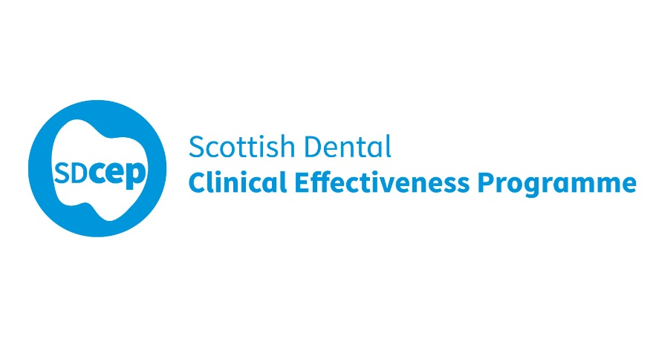

Prevention and Management of Dental Caries in Children

## Guidance in Brief

Second Edition

Full guidance also available at www.sdcep.org.uk

May 2018

The Scottish Dental Clinical Effectiveness Programme (SDCEP) is an initiative of the National Dental Advisory Committee (NDAC) in partnership with NHS Education for Scotland. The Programme provides user-friendly, evidence-based guidance on topics identified as priorities for oral health care.

SDCEP guidance aims to support improvements in patient care by bringing together, in a structured manner, the best available information that is relevant to the topic and presenting this information in a form that can be interpreted easily and implemented.

Supporting the provision of safe, effective, person-centred care

**List of logos:**

NHS Education for Scotland

NDAC

University of Aberdeen

University of Dundee

The University of Edinburgh

University of Glasgow

The Royal College of Surgeons of Edinburgh

RCS Faculty of Dental Surgery

Royal College of Physicians and Surgeons of Glasgow

British Society of Paediatric Dentistry

Childsmile

**NICE** Accreditation – NICE has accredited the process used by the **Scottish Dental Clinical Effectiveness Programme** to produce its Prevention and Management of Dental Caries in Children guidance. Accreditation is valid for 5 years from 15 March 2016. More information on accreditation can be viewed at [www.nice.org.uk/accreditation](http://www.nice.org.uk/accreditation).

For further information about SDCEP’s accreditation, visit [www.sdcep.org.uk/how-we-work/nice-accreditation](http://www.sdcep.org.uk/how-we-work/nice-accreditation).

© **Scottish Dental Clinical Effectiveness Programme**

SDCEP operates within NHS Education for Scotland. You may copy  
or reproduce the information in this document for use within NHS  
Scotland and for non-commercial educational purposes.

Use of this document for commercial purposes is permitted only with  
written permission.

ISBN 978 1 905829 33 0

First published 2010

Second Edition published 2018

**Scottish Dental Clinical Effectiveness Programme**

Dundee Dental Education Centre, Frankland Building, Small’s Wynd, Dundee DD1 4HN

**Email**  [scottishdental.cep@nes.scot.nhs.uk](mailto:scottishdental.cep@nes.scot.nhs.uk)

**Tel** 01382 425751 / 425771

Website [www.sdcep.org.uk](http://www.sdcep.org.uk)

## Introduction

**Prevention and Management of Dental Caries in Children** is designed to assist and support primary care practitioners and their teams in improving and maintaining the oral health of their young patients from birth up to the age of 16 years. It aims to provide clear up-to-date guidance on what to do, when to do it and how to do it. It includes advice on:

* assessing the child and family
* helping the family and child manage dental care
* delivery of preventive care based on caries risk
* choosing from the range of caries management options available
* delivery of restorative care, including how to carry out specific treatments
* referral and recall
* management of suspected dental neglect
* working with other agencies to support and safeguard the wellbeing of children and young people

The second edition of the full guidance has been updated to take account of recent evidence. Recommendations for caries prevention in children are primarily based on the evidence on which the Scottish Intercollegiate Guideline Network (SIGN) guideline 138 **Dental Interventions to Prevent Caries in Children** is based. Recommendations on the management of dental caries have been expanded, with a more comprehensive approach to management of children’s primary and permanent teeth and management techniques presented in a separate section. Further details about SDCEP and the development of this guidance are available at www.sdcep.org.uk.

This **Guidance in Brief** summarises the main recommendations and clinical practice advice within the full guidance. For more detailed advice about these recommendations and how to put them into practice, refer to the full guidance available at www.sdcep.org.uk.

As guidance, the information presented here does not override the clinician’s right, and duty, to make decisions appropriate to each patient with their valid consent. It is advised that significant departures from this guidance, and the reasons for this, are documented in the patient’s clinical record.

## Overarching Principles

* While at all times safeguarding the wellbeing of the child, the aims when providing dental care for children are:
* to prevent disease in the primary and permanent dentition;
* to reduce the risk of the child experiencing pain or infection or acquiring treatment-induced dental anxiety if dental caries does occur;
* for the child to grow up feeling positive about their oral health and with the skills and motivation to maintain it.

To achieve these aims, the priorities for the dental team are:

* to involve both the child and their parent/carer in decisions regarding the child’s oral health care;
* to encourage the child’s parent/carer to take responsibility for their child’s oral health, implement preventive advice at home and meet their responsibilities to bring their child for dental care;
* to ensure that valid consent for planned treatment is obtained from the child and/or their parent/carer;
* to relieve pain or infection, if present;
* to apply preventive measures to the highest standard possible informed by an assessment of the child’s risk of developing caries;
* to focus on prevention of caries in the permanent dentition before management of any caries in the primary dentition;
* if caries in the permanent dentition does occur, to diagnose it early, and manage it appropriately;
* to manage caries in the primary dentition using an appropriate technique that maximises the chance of the tooth exfoliating without causing pain or infection, while minimising the risk of treatment-induced anxiety;
* to identify as early as possible those children where there is concern about a parent/carer’s ability to comply with dental health preventive advice, support or treatment uptake, and to contact and work collaboratively with other professionals (e.g. school nurse, general medical practitioner, Childsmile dental health support worker, health visitor or social worker).

In practice, the prevention and management of dental caries in children comprises several elements as illustrated on page 5. This **Guidance in Brief** outlines each element. For a full appreciation of the recommendations and practical advice on how to follow them, refer to the sections of the full guidance that are cited.

**Overview of the prevention and management of dental caries in children**

Sections of the full guidance that are concerned with each element of the prevention and management of dental caries in children are as indicated.

## Assessing the Child and Family

Refer to full guidance Section 3

* Gain rapport with the parent/carer and discuss how they can support and encourage the child in the surgery.
* Communicate effectively with the child and parent/carer, and avoid ‘talking over’ the child.

### Parent/Carer Motivation and Ability to Take Responsibility

* Confirm the reason for attendance and begin to assess the oral health expectations and motivation of the child and parent/carer.
* Take a thorough medical, dental and social history that includes asking about current brushing practice, dietary habits and previous experience of dental treatment.
* Use the information gathered to inform your assessment of the child and/or parent/carer’s attitude towards oral health and their ability and motivation to take responsibility for it.
* Provide appropriate information and support to enable the parent/carer to maintain and improve the child’s ongoing oral health and be prepared to tailor preventive care and treatment to encourage compliance.
* Contact other professionals (e.g. the child’s health visitor, school nurse) if multidisciplinary support is required.
* If dental neglect is a concern, act to provide additional support measures for the child and parent/carer.

### Clinical Assessment

* Assess the child’s plaque levels and their, or the parent/carer’s, toothbrushing skills/knowledge and discuss this with the child and parent/carer.
* Assess the child’s primary and permanent dentition, including visual examination for the presence of caries on clean and dry teeth using a tooth-by-tooth approach.
* Consider taking bitewing radiographs to accurately diagnose the extent of any caries, including proximity to the pulp.
* A lesion classification is provided on page 8.
* Assess the activity of each carious lesion clinically and use radiographs to assess progression over time. Assume that all carious lesions are active, unless there is evidence that they are arrested.
* For the primary dentition, assess the risk or any carious lesions causing pain or infection prior to exfoliation to inform a suitable management strategy.
* Assess any hypomineralised molars independently to determine the extent of disease and likely prognoses.
* Discuss the findings of the clinical assessment with the child and their parent/carer.

##### Classification of carious lesions in primary and permanent teeth

|  |  |  |
| --- | --- | --- |
|  | **Primary teeth** | |
| **Occlusal** | **Initial** | Noncavitated, dentine shadow or minimal enamel cavitation  Radiograph: outer third dentine |
| **Advanced** | Dentine shadow or cavitation with visible dentine  Radiograph: middle or inner third dentine |
| **Proximal** | **Initial** | White spot lesions or shadow  Radiograph: lesion confined to enamel |
| **Advanced** | Enamel cavitation and dentine shadow or cavity with visible dentine  Radiograph: may extend into inner third dentine |
| **Anterior** | **Initial** | White spot lesions but no dentinal caries |
| **Advanced** | Cavitation or dentine shadow |
| **Special Cases** | **Pulpal involvement** | Any tooth with clinical pulpal exposure or no clear separation between carious lesion and dental pulp radiographically |
| **Near to exfoliation** | Clinically mobile  Radiograph: root resorption |
| **Arrested caries** | Any tooth with arrested caries and where aesthetics is not a priority |
| **Unrestorable** | Crown destroyed by caries or fractured, or pulp exposed with pulp polyp (pain/infection free) |
|  | **Permanent Teeth** | |
| **Occlusal** | **Initial** | Noncavitated enamel carious lesions: white spot lesions; discoloured or stained fissures  Radiograph: up to the enamel-dentine junction or not visible |
| **Moderate** | Enamel cavitation and dentine shadow or cavity with visible dentine  Radiograph: up to and including middle third dentine |
| **Extensive** | Cavitation with visible dentine or widespread dentine shadow  Radiograph: inner third dentine |
| **Proximal** | **Initial** | White spot lesions or dentine shadow. Enamel intact  Radiograph: outer third dentine |
| **Moderate** | Enamel cavitation or dentine shadow  Radiograph: outer or middle third dentine |
| **Extensive** | Cavitation with visible dentine or widespread dentine shadow  Radiograph: inner third dentine |
| **Anterior** | **Initial** | White spot lesions but no dentinal caries |
| **Advanced** | Cavitation or dentine shadow |
| **Special Cases** | **Pulpal involvement** | Any tooth with clinical pulpal exposure or no clear separation between carious lesion and dental pulp radiographically |
| **Unrestorable** | Crown destroyed by caries or fractured, or pulp exposed with pulp polyp (pain/infection free) |

## Caries Risk Assessment

* Assess whether or not the child is at increased risk of developing caries (patient history, resident in an area of relative disadvantage or has decayed, missing due to caries or filled teeth) and use this caries risk assessment to inform the frequency of review radiographs, provision of preventive interventions and frequency of recall.
* Reassess the child’s caries risk at each assessment.

## Helping the Family Accept Dental Care

Refer to full guidance Section 4

* Consider the child’s anxiety level when planning care and the use of one or a combination of the following behaviour management strategies to facilitate provision of both preventive care and treatment.

Communication; Enhanced control; Tel, show, do; Behaviour shaping and positive reinforcement; Structured time; Distraction; Relaxation; Systematic desensitisation.

## Defining Needs and Developing a Personal Care Plan

Refer to full guidance Section 5

* Plan to provide care in the following order: manage pain (if present), provide caries prevention, manage caries/asymptomatic infection (if present).
* Devise and agree a care plan with the child and parent/carer, which includes the expected number, content and duration of appointments. This can be modified if necessary.
* Having carefully explained the child’s oral health needs and any proposed treatment options, obtain valid consent for the agreed care plan from the child where possible and/or the parent/carer.
* If a child is pre-cooperative, unable to cooperate or has multiple affected teeth, consider referral to assess suitability for treatment under sedation or general anaesthesia.
* If required, include in the care plan collaboration with other professionals to offer and provide additional home and community support for preventive interventions and to encourage attendance for treatment.

## Diagnosing and Managing Dental Pain or Infection

Refer to full guidance Section 6

* Diagnose pain or infection and determine a suitable management strategy (see flow diagram on page 13).
* Do not leave dental infection untreated.
* Avoid dental extractions on a child’s first visit if at all possible.

Note that each patient should receive an oral health assessment which may be carried out before or after diagnosis and management of pain, depending on its severity.

Diagnosis and management of caries-related dental pain or infection in a child with no medical complications   
† Antibiotics should only be prescribed if there is evidence of spreading infection (swelling, cellulitis, lymph node involvement) or systemic involvement (fever, malaise).

*Refer to the SDCEP **Drug Prescribing for Dentistry** guidance.  
Abbreviation: GA General anaesthesia.

## Caries Prevention

Refer to full guidance Section 7

**KEY RECOMMENDATIONS**

Provide all children with personalised oral health promotion advice.

(Strong recommendation; moderate quality evidence)

Encourage and support all children to brush their teeth, or to have their teeth brushed for them, at least twice a day using fluoride toothpaste, including recommending:

* the use of both an amount of toothpaste and a fluoride concentration appropriate for the child’s age and caries risk level;
* supervised brushing until the child can brush his/her teeth effectively;
* that children do not rinse their mouths after toothbrushing (‘spit, don’t rinse’).

(Strong recommendation; high quality evidence)

Advise all children and their parent/carers about how a healthy diet can help prevent caries, at intervals determined by their risk of developing dental caries.

(Strong recommendation; moderate quality evidence)

For all children, place fissure sealants on the permanent molars as early as possible after eruption.

(Strong recommendation; moderate quality evidence)

For all children aged 2 years and over, apply sodium fluoride varnish at least twice per year.

(Strong recommendation; moderate quality evidence)

* Ensure that all children receive **Standard Prevention** appropriate to their age.
* If the child is at increased risk of developing caries, in addition to Standard Prevention, ensure they receive **Enhanced Prevention**, unless there is valid reason not to. In this case, ensure this is documented in the patient’s notes.
* Consider the use of action planning to encourage compliance with preventive advice.
* For children at increased risk, utilise community/home support for toothbrushing and dietary advice and to encourage attendance for dental care.

Fluoride toothpaste use based on age and caries risk



Based on Recommendations on the use of fluoride toothpaste and fluoride supplements in Scotland 2017

Standard Prevention for all children

* **Give toothbrushing advice at least once a year.**

Brush thoroughly twice daily, including last thing at night.

Use the age-appropriate amount of a toothpaste containing 1000 to 1500 ppm fluoride (see diagram on page 15 for details).

‘Spit, don’t rinse’.

Supervise children until they can brush their teeth effectively.

* **Demonstrate brushing** on the child (~3 minutes) annually.
* **Give dietary advice** at least once a year, advise or remind the child and/or parent/carer about how a healthy diet can help prevent caries, including the following points.

Limit consumption of food and drinks containing sugar

Drink only water or milk between meals

Snack on healthier foods, which are low in sugar, such as fresh fruit, carrot, peppers, breadsticks, oatcakes and occasionally a small amount of lower fat cheese.

Do not place sugary drinks, fruit juices, sweetened milk or soy formula milk in feeding bottles or pacifiers

Do not eat or drink, apart from tap water, after brushing at night

Be aware of hidden sugars in food and of the acid content of drinks

* **Place sealants** in all pits and fissures of permanent molars as soon as possible after eruption.

Resin-based sealants are the first choice of material.

Ensure the buccal pits of lower first permanent molars and the palatal fissures of upper first permanent molars are sealed.

On fully erupted teeth where the child is uncooperative, use glass ionomer fissure sealants and ensure that fluoride varnish application is optimal.

* **Check existing sealants** for wear and integrity/leakage at every recall visit.
* **‘Top up’ worn or damaged sealants.**
* **Apply sodium fluoride varnish** (5%) twice a year to children aged 2 years and over (see note on page18).

Enhanced Prevention for children at increased risk of caries

**In addition to Standard Prevention**

* **At each recall visit**, give hands-on brushing instruction (~3 minutes) to the child and parent/carer.
* **At each recall visit**, provide dietary advice as described for standard prevention.
* Consider providing additional preventive interventions depending on the child’s circumstances, for example:

Recommending the use of 1350-1500 ppm fluoride toothpaste for children up to 10 years of age.

Prescribing 2800 ppm fluoride toothpaste for children aged 10 - 16 years for a limited period. Regular review is required (see diagram on page 15).

Keeping a food and drink diary, which is reviewed in practice and advice offered.

Keeping a toothbrushing chart to record each time teeth are brushed as a reminder.

Action planning to encourage change.

* Consider using glass ionomer as a temporary sealant on partially erupted first and second permanent molars until the tooth is fully erupted.
* Fissure seal palatal pits on upper lateral permanent incisors, and the occlusal and palatal surfaces of Ds, Es, first and second permanent molars, if assessed as likely to be beneficial.
* **If unable to provide fissure sealants** (e.g. due to the child being pre-cooperative or having a learning disability) **then ensure that fluoride varnish application is optimal** and attempt again as cooperation improves.
* **Ensure that sodium fluoride varnish is applied 4 times per year** to children aged 2 years and over (see note below). Some applications may be provided through Childsmile.
* **Utilise any community/home support** for preventive interventions that is available locally (e.g. health visitor, school nurse, Childsmile dental health support worker).

**Note** Many varnishes contain colophony (e.g. Duraphat®). A child who has been hospitalised due to severe asthma or allergy in the last 12 months or who is allergic to sticking plaster may be at risk of an allergic reaction to colophony. In these cases, consider using a colophony-free varnish (licenced for caries prevention in the UK) or suggest the use of alternative age-appropriate fluoride preparations (e.g. fluoride mouthwash or higher concentration fluoride toothpaste).

## Management of Caries in Primary Teeth

Refer to full guidance Sections 8 and 10

**KEY RECOMMENDATIONS**

For a child with a carious lesion in a primary tooth, choose the least invasive, feasible caries management strategy, taking into account: the time to exfoliation, the site and extent of the lesion, the risk of pain or infection, the absence or presence of infection, preservation of tooth structure, the number of teeth affected, avoidance of treatment-induced anxiety.

(Strong recommendation; low quality evidence)

For a child in pain due to pulpitis in a vital primary tooth with irreversible symptoms and no evidence of dental abscess, consider carrying out a pulpotomy to preserve the tooth and to avoid the need for an extraction.

(Conditional recommendation; low quality evidence)

* Taking all relevant factors into account, establish which management options are appropriate and in the best interests of the child.

The flow diagram on page 22 and table on page 23 can be used to inform management decisions for caries in the primary dentition.

Use of dental amalgam in primary teeth should be avoided.

* Consider using bitewing radiographs for treatment planning.
* Discuss potential management options with the child and the parent/carer.
* Agree a caries treatment plan, staging care as necessary.
* Avoid operative interventions involving local anaesthetic until the child can cope.
* Use a minimally invasive approach to caries management whenever possible.
* Manage a primary tooth which is associated with infection (signs or symptoms of abscess, sinus, inter-radicular radiolucency, non-physiological mobility) either by extraction or, in certain circumstances consider referral for pulpectomy.

In some cases, local measures to bring infection under control may be appropriate.

* Avoid iatrogenic damage to the proximal surface of the adjacent tooth when preparing multi-surface cavities. When restorations involve the distal of Es, take particular care to avoid damage to the first permanent molar. The Hall Technique may be indicated.
* Obtain valid consent from the child or their parent/carer, depending on the age of the child.
* Do not leave infection or caries in primary teeth unmanaged.

**Decision-making for managing the carious primary tooth in a child with no medical complications**

This flow diagram illustrates the key decisions to be made in forming an appropriate caries management plan that takes into account the factors that influence treatment provision. If a child is pre-cooperative or unable to co-operate (due to young age, a learning disability or where behaviour management techniques have been unsuccessful) or has multiple affected teeth, referral to assess suitability for extractions under sedation or general anaesthesia may be necessary.

For descriptions of initial and advanced lesions in primary teeth, see page 8. Refer to the full guidance for more detailed advice on individual management techniques.

**Management options for carious primary teeth when there are no clinical or radiographic signs of pulpal involvement**

In a child with no medical complications, for each type of lesion when there are no clinical or radiographic signs of pulpal involvement, the preferred treatment option(s) are indicated ✓. Alternative options that may be appropriate in certain circumstances are indicated (✓) with explanation in the footnotes. Section 10 of the full guidance provides further details on each caries treatment technique. For a description of each lesion type see page 8.



a Caries is considered to have arrested when there is demonstrable evidence of non-progression of lesions over several months using a recording system, such as photographs or ICDAS codes.

b For these lesions, other options are considered preferable.

c Due to a lack of supporting evidence, this approach is only appropriate for these types of lesions if no alternative is feasible. Document the use of this approach and rationale in the patient’s record.

d An emerging technique with a developing supporting evidence base.

## Management of Caries in Permanent Teeth

Refer to full guidance Section 9 and 10

**KEY RECOMMENDATION**

For a child with a carious lesion in a permanent tooth, choose the least invasive, feasible caries management strategy taking into account: the site and extent of the lesion, the risk of pain or infection, preservation of tooth structure and the health of the dental pulp, avoidance of treatment-induced anxiety lifetime prognosis of the tooth, orthodontic considerations and occlusal development.

(Strong recommendation; low quality evidence)

The permanent teeth most vulnerable to decay in childhood and adolescence are the permanent molars. Caries most commonly develops at just two sites on permanent molars: at the base of pits and fissures, and on the proximal surfaces, just below the contact point. Both these sites present challenges to the clinician in terms of caries diagnosis and caries management.

Children may present with first permanent molars with advanced caries. In addition, approximately 15% of children will be affected by molar incisor hypomineralisation (MIH) to some degree. If a first permanent molar is assessed as having a poor life-time prognosis (whether from caries or MIH), and the second permanent molar second permanent molar is not yet erupted, then it may be in the child’s best long term interests to extract the first permanent molar, allowing the second permanent molars to erupt into its place.

* Develop the child’s personal care plan to prioritise keeping permanent teeth caries free.
* With a high index of suspicion for caries, thoroughly examine all first and second permanent molars, focusing on the base of pits and fissures and the proximal surfaces just below the contact points.
* Taking all relevant factors into account, establish which treatment options are appropriate and which are in the best interests of the child.

The flow diagram on page 26 and the table on page 27 can be used to inform management decisions for caries in the permanent dentition.

Dental amalgam should not be used in the permanent teeth of a child or young person under 15 years of age unless exceptional circumstances can be justified.

* Avoid iatrogenic damage to the proximal surface of the adjacent tooth when preparing multi-surface cavities.
* When managing a dentinal lesion, choose a technique that reduces the likelihood of pulpal exposure and maintains tooth structural integrity.
* When caries or MIH involves the first permanent molars, consider prognosis and planned loss.
* If a first permanent molar is assessed as needing a restoration, consider temporising it until prevention is established and the child’s cooperation is sufficient to cope with the planned treatment.
* For first permanent molars with MIH:

if there are carious lesions which are not severe, are not sensitive, do not require restoration and are unlikely to in the future, provide enhanced prevention, including fissure sealants, and monitor.

if there is good quality enamel with small defects that require restoration, use adhesive restorative materials. Indirect restorations extending onto sound enamel have better longevity, and it may be necessary to modify the cavity shape to achieve this.

if the molars are sensitive, use glass ionomer cement as a fissure sealant.

* Discuss the potential management options with the child and the parent/carer.
* Agree a caries treatment plan, staging care as necessary.
* Obtain valid consent from the child or their parent/carer depending on the age of the child.
* When restoring permanent teeth in children, ensure this is done to the same high standard as for adults to maximize the longevity of restorations and to minimise the amount of treatment required later in life.
* Do not leave infection or caries in permanent teeth unmanaged.

Decision-making for managing the carious permanent tooth in a child with no medical complications

This flow diagram illustrates the key decisions to be made in forming an appropriate caries management plan that takes into account the factors that influence treatment provision.

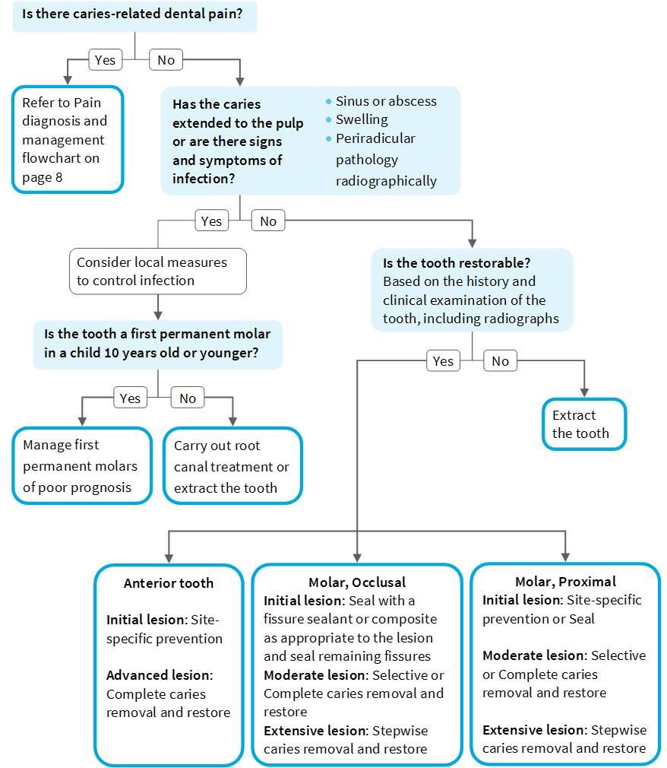

For descriptions of initial, moderate and extensive lesions in permanent posterior teeth and initial and advanced lesions in permanent anterior teeth, see page 8. Refer to the full guidance for more detailed advice on individual management techniques.

Management options for carious permanent teeth when there are no clinical or radiographic signs of pulpal involvement

In a child with no medical complications, for each type of lesion when there are no clinical or radiographic signs of pulpal involvement the preferred treatment option(s) are indicated ✓. Alternative options that may be appropriate in certain circumstances are indicated (✓) with explanation in the footnote. Further details on each caries treatment technique are provided in Section 10 of the full guidance. For a description of each lesion type, see page 8.



a May be appropriate in some circumstances for anterior teeth, although evidence derived from studies on posterior teeth.

## Referral for Care

Refer to full guidance Section 11

* Be aware of the referral options available locally and the agreed referral procedures.
* Before referring a child for treatment, first relieve pain, provide prevention and attempt caries treatment using behavioural management techniques and local anaesthesia if indicated.
* Consider the need for temporary dressings to reduce the chance of further pain.
* For children who live in a different locality than your practice, beware that you should refer to the service local to the child. This may be different to the service you routinely refer too.
* Ensure all the relevant information is included in the referral communication (electronic or letter). A checklist provided in the full guidance can be used as a reminder.
* If referring a child for sedation or general anaesthesia (GA), follow your local protocol if there is one in place.

The flow diagram below may be helpful in deciding whether or not to refer a child for treatment under sedation or GA.

* If a child is referred for care, ensure that you provide their continued dental care.

**Assessing management options for the child with carious primary teeth**

This diagram illustrates decisions to be made when considering referral for treatment after first attempting to provide care using good behavioural management techniques.

## Recall

Refer to full guidance

* Assign a recall interval that is based on caries risk and specific to the oral health needs of the child.

At each recall visit:

* Carry out a focused oral health review, including:

asking again about toothbrushing practice and dietary habits;

asking about compliance with any agreed action plans;

checking the condition of fissure sealants;

monitoring any lesions managed with prevention alone;

reassessing the child’s caries control and caries risk.

* Provide Standard Prevention to all children and additionally Enhanced Prevention if the child is assessed as at increased risk of developing caries.
* If caries is not being effectively controlled, consider alternative management options and the need for additional community/home support.
* Create a new personal care plan as required and maintain comprehensive records.

## Providing Additional Support

Refer to full guidance Section 13

* Ensure that local additional support contacts and child protection procedures are in place to address any immediate concerns for a child’s welfare or safety.
* If you have concerns about compliance or attendance, or if you suspect dental neglect or have any other concerns about the child’s wellbeing, act to provide additional support measures for the child and parent/carer.
* Gather information and keep accurate records.
* Raise concern with parent/carers and explain what changes are required.
* Continue to offer and provide the child or young person with appropriate prevention, advice and treatment and continue to liaise with parent/carers.
* Monitor progress.
* Consider contacting other professionals (e.g. the child’s health visitor, school nurse, general medical practitioner, Childsmile dental health support worker, social worker) for advice and support in the future dental health management of the child.
* If concerns for a child or young person’s wellbeing continue or increase, or there is concern about immediate safety or that he/she is suffering significant harm, follow local procedures to make a child protection referral.

The Scottish Dental Clinical Effectiveness Programme (SDCEP) is an initiative of the National Dental Advisory Committee (NDAC) and operates within NHS Education for Scotland. The Programme provides user-friendly, evidence-based guidance on topics identified as priorities for oral health care.

SDCEP guidance supports improvements in patient care by bringing together, in a structured manner, the best available information that is relevant to the topic, and presenting this information in a form that can be interpreted easily and implemented.

The second edition of **Prevention and Management of Dental Caries in Children** aims to support dental teams to improve and maintain the oral health of their younger patients through the delivery of preventive care and, when necessary, effective management of dental caries.

This **Guidance in Brief** summarises the main recommendations and clinical practice advice within the full guidance. For more detailed advice about these recommendations and how to put them into practice, refer to the full guidance.

Scottish Dental Clinical Effectiveness Programme

Dundee Dental Education Centre, Frankland Building, Small’s Wynd, Dundee DD1 4HN

Email [scottishdental.cep@nes.scot.nhs.uk](mailto:scottishdental.cep@nes.scot.nhs.uk)

Tel 01382 425751 / 425771

Website [www.sdcep.org.uk](http://www.sdcep.org.uk)

This resource may be made available, in full or in summary form, in alternative formats and community languages.   
Please contact NHS Education for Scotland on 0131 656 3200 or email altformats@nes.scot.nhs.uk to discuss how we can best meet your requirements.