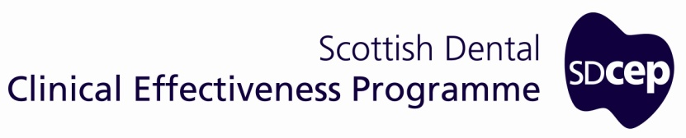
Scottish Dental
Clinical Effectiveness Programme

Decontamination Into Practice

Appendices and Reference List

Last reviewed January 2016
No substantive changes to the legislation, regulations or generic national guidance on which the current SDCEP Decontamination Into Practice
is based were found. This guidance remains unchanged and extant until the next review.

October 2014

© Scottish Dental Clinical Effectiveness Programme
SDCEP operates within NHS Education for Scotland. You may copy or reproduce
the information in this document for use within NHS Scotland and for non-commercial educational purposes.
Use of this document for commercial purpose is permitted only with written permission.
ISBN 978 1 905829 21 7
First published 2007
Updated October 2014

Scottish Dental Clinical Effectiveness Programme
Dundee Dental Education Centre, Frankland Building, Small’s Wynd, Dundee DD1 4HN

Email scottishdental.cep@nes.scot.nhs.uk
Tel 01382 425751 / 425771
Website www.sdcep.org.uk

Appendix 1

Guidance Development

The Scottish Dental Clinical Effectiveness Programme
The Scottish Dental Clinical Effectiveness Programme (SDCEP) is an initiative of the National Dental Advisory Committee (NDAC) and operates within NHS Education for Scotland (NES).

The NDAC comprises representatives of all branches of the dental profession and acts in an advisory capacity to the Chief Dental Officer. It considers issues that are of national importance in Scottish dentistry and also provides feedback to other bodies within the Scottish Government on related, relevant healthcare matters.

SDCEP was established in 2004 under the direction of the NDAC to give a structured approach to providing clinical guidance for the dental profession. Since then, SDCEP has become established within the Dental Directorate of NES and provides an important link between best practice guidance and dental education and training. The programme’s primary aim is to develop guidance that supports
dental teams to provide quality patient care. SDCEP brings together the best available information that is relevant to priority areas in dentistry, and presents guidance on best practice in a form that can be interpreted easily and implemented. The guidance recommendations may be based on a variety of sources of information, including research evidence, guidelines, legislation, policies and expert opinion as appropriate to the subject. SDCEP guidance takes a variety of forms to suit the diverse topics being addressed.

Recognising that publication of guidance alone is likely to have a limited influence on practice, SDCEP also contributes to the research and development of interventions to enhance the translation of guidance recommendations into practice through its participation in the TRiaDS (Translation Research in a Dental Setting) collaboration (www.triads.org.uk).

SDCEP is funded by the NHS Education for Scotland and has made important contributions to the implementation of the Scottish Government’s Dental Action Plan, which aims to both modernise dental services and improve oral health in Scotland.

The Guidance Development Group
Guidance Development Group (GDG) for Decontamination Into Practice comprised individuals from across the dental profession with particular interest and experience in decontamination. Since it was first convened in 2004, the group’s composition has varied as noted below.

Alice Miller  (Chairperson) | General Dental Practitioner, Duns, Borders; VT Advisor, NHS Education for Scotland
Dawn Adams ^{b} | Clinical Director of Community Dental Services, NHS Fife
Jeremy Bagg ^{c} | Head of Glasgow Dental School and Professor of Clinical Microbiology, University of Glasgow
Irene Black | General Dental Practitioner; Dental Practice Advisor, Greater Glasgow and Clyde Health Board; Dental Advisor for Decontamination, NHS Education for Scotland
Iris Green ^{c} | Dental Nurse Manager, Tayside University Hospital Trust, Dundee Dental Hospital
Irene Hanevy ^{b} | Dental Practice Co-ordinator, NHS Fife
Gillian Irvine ª | Senior Infection Control Nurse, Health Protection Scotland (on secondment to University of Glasgow Dental School 2004-7)
Margaret Leggate | General Dental Practitioner, Aberdeen; Clinical Effectiveness Advisor, NHS Grampian
Christine Young ^{d} | Infection Control Nurse Advisor, NHS Education for Scotland
Fiona Zinkewycz ^{b} | Senior Dental Nurse, General Dental Service, Fife

ª Part 1 only; ^{b} Part 2 only; ^{c} Parts 1 and 2; ^{d} Parts 2 and 3. Individuals’ roles at the time of their most recent participation in the GDG are shown.

Expert advice was provided by the Health Facilities Scotland Decontamination Team. SDCEP also thanks Dr Andrew Smith of Glasgow Dental School who chaired the group until July 2005.

The Programme Development Team
The Programme Development Team operates within NHS Education for Scotland. The team provides project management and administrative support and is responsible for the methodology of guidance development and editing the guidance. For up-to-date membership of the Programme Development Team, refer to the SDCEP website.

Steering Group
The Steering Group oversees all the activities of SDCEP and includes representatives of guidance development groups and dental institutions in Scotland. For up-to-date membership of the Steering Group, refer to the SDCEP website.

Guidance Development Methodology
The advice presented within this guidance is drawn from existing decontamination standards and generic decontamination guidance. This information is distilled and presented in a practical, user-friendly manner to facilitate efforts to improve the standard of decontamination specifically within primary care dental practice.

Consultation and peer review was conducted prior to publication of parts 1, Cleaning of Dental Instruments and 2, Sterilization of Dental Instruments. The consultation drafts were made available on the SDCEP website and copies were circulated to individuals and bodies with a specific interest in decontamination. All dentists in Scotland were notified and invited to comment. All comments received through the consultation were considered and the guidance amended accordingly prior to peer review. Further amendments were made in response to comments from peer reviewers before publication.

Part 3, Managing Decontamination in Dental Practice was subject to piloting in general dental practice in Scotland in 2013 and refined in light of feedback received.

In 2014, the Guidance Development Group reviewed and updated part 1, Cleaning of Dental Instruments. Changes reflect requirements that have been introduced since the first publication, including the need for a separate Local Decontamination Unit and use of a Washer Disinfector as the preferred cleaning method for primary care dental practice. The technical requirements for the use of cleaning equipment are unchanged. The updated version was subject to peer review.

The Introduction and Appendices were also updated in 2014.

Declarations of interest are made by all contributors to SDCEP. Details are available on request.

Further information about SDCEP guidance is available on our website: www.sdcep.org.uk.

Appendix 1
Guidance Development

Appendix 2

Hand Hygiene
Advice on all aspects of Infection Control is under regular review and therefore periodically subject to change. For advice on hand hygiene, consult the latest guidance provided by Health Protection Scotland via their website: www.hps.scot.nhs.uk/haiic/ic/.

Practice
Appendix 3
D

Appendix 3

Detergents for Cleaning Dental Instruments
For all detergents, consult the Material Safety Data Sheet and put in place appropriate measures for the safety of staff (COSHH) before bringing any product into use.

Always use detergents specified by the manufacturer as suitable for the intended use.

For manual and ultrasonic cleaning, use neutral or mild detergents that are low-foaming, dispensed in a measured dose in a measured volume of water. A neutral detergent is regarded as one that has a pH within the approximate range of pH 5–9 when diluted in accordance with the manufacturer’s in-use specification. A mild alkaline detergent is regarded as one that has a pH within the approximate
range of pH 8–10.5 when diluted in accordance with the manufacturer’s in-use specification. High pH detergents (i.e. greater than pH 10.5 at the in-use dilution) are unsuitable for use on devices made of aluminium.

When using a washer-disinfector or ultrasonic cleaner, follow the equipment manufacturer’s instructions regarding which detergent to use.

Appendix 4

Key Roles in a Safe Decontamination Service
Personnel involved in the delivery of an effective decontamination service are listed below. In general dental practices, the members of the team who are likely to fulfil some of these roles are indicated.

MANAGEMENT e.g. practice principal
The person who is accountable for the operation of the premises such as the owner, occupier, employer or general manager.

USER e.g. practice manager or practice principal
The person designated by management to be responsible for the day-to-day management of the sterilizer or washer-disinfector (WD). Their duties include appointing operators and ensuring that the sterilizer/WD:
- is certified fit for use;
- is subject to periodic testing and maintenance;
- is operated by adequately trained staff;
- has the correct documentation available, including the names of all other key personnel and up-to-date production records.

OPERATOR e.g. dental nurse
A person with the authority to operate a sterilizer or WD. Their duties can include:
- noting instrument readings;
- replenishing consumables such as detergent;
- simple housekeeping duties.

COMPETENT PERSON (Pressure Vessels)
The person or organisation designated by management to exercise certain legal responsibilities with regard to the written scheme of examination of any pressure vessel associated with a sterilizer or WD. Refer to SHTM 2010 and SHTM 2030 for further details.

TEST PERSON (Sterilizers/WDs)
The person designated by management who has the appropriate experience and/or qualifications to carry out the validation and periodic testing of sterilizers/WDs. This involves:
- advising on programmes of periodic testing and periodic maintenance;
- advising on operational procedures for routine production;
- liaising as necessary with the Authorising Engineer (Decontamination);
- conducting the validation tests specified in SHTM 2010 and/or SHTM 2030;
- preparing the validation report;
- conducting the periodic tests specified in SHTM2010 and or SHTM 2030; note that an adequately experienced and suitably qualified Maintenance Person may also be able to conduct some of these tests;
- preparing reports as required by the User.

MAINTENANCE PERSON (Sterilizers/WDs)
The person (e.g. fitter or electrician) designated by management to carry out:
- maintenance duties on sterilizers and/or WDs;
- additional maintenance and repair work requested by the User.

MICROBIOLOGIST (Decontamination)
The appropriately qualified person designated by management to advise the User on microbiological aspects of disinfection and sterilization. Their duties also include:
- providing general and impartial advice on all matters concerned with washing and disinfection;
- arranging for the culturing of biological indicators used in microbiological tests;
- auditing the documentation from all sterilizers and WDs that have been tested by microbiological methods.

AUTHORISING ENGINEER (Decontamination)
The person who provides independent auditing and advice on washing, disinfection and sterilization of re-usable instruments and the use of WDs and sterilizers. He/she should have direct contact with the User and other key personnel. Their duties include:
- advising on programmes of validation;
- reviewing and witnessing validation processes of WDs and sterilizers;
- auditing reports on validation, re-validation and yearly tests prepared by the Test Person;
- advising on programmes of periodic tests and periodic maintenance;
- advising on operational procedures for routine production.

Appendix 5

Useful Sources of Information

(Updated October 2014)

Scottish Dental website
The Scottish Dental website (www.scottishdental.org) enables easy access to a range of web-based information to support and develop the dental team in Scotland. The Decontamination section provides links to various resources, advice and organizations that are particularly relevant to decontamination in dental practices.

Although the weblinks cited below might change, up-to-date links will be maintained on the ScottishDental website.

NHS Education for Scotland
NHS Education for Scotland (NES) develops and provides education and training for those who work in NHSScotland. Access to the range of educational resources provided is via the NES Portal for which users are required to have their own account. To create a new account or login, go to www.portal.scot.nhs.uk/.

NES supports improvements in decontamination in dental practices through a variety of educational activities, including continuing professional development courses, online e-Learning modules, on-site training and user-friendly guidance.

In-Practice Decontamination Training
NES has an infection control support team that visits practices to provide on-site training in decontamination. The primary aim of these training sessions is to enable the practice to look at its existing processes and to consider any changes required to improve and so bring the practice closer to current requirements. Formulating an agreed action plan that details timescales and responsibilities is an essential component of the training.

Further details about the in-practice training and other decontamination support provided by NES are provided at: http://www.nes.scot.nhs.uk/education-and-training/by-discipline/dentistry/areas-of-education/infection-control-and-decontamination.aspx or call: 0141 531 2642.

Health Facilities Scotland
Health Facilities Scotland (HFS) is a division of NHS National Services Scotland (NSS) and provides operational guidance to NHSScotland bodies on a range of healthcare facilities topics. The HFS Decontamination Team leads the national decontamination agenda for reusable medical devices, including dental instruments, by standard setting, providing guidance and advice, audit, monitoring and support training programmes. HFS also provides validation and authorising engineering services for decontamination equipment.

Health Facilities Scotland  3rd Floor Meridian Court  5 Cadogan Street  Glasgow G2 6QE  Tel: 0141 207 1600  Fax: 0141 221 5122  Email: nss.hfsenquiries@nhs.net  Website: www.hfs.scot.nhs.uk | HFS Decontamination Team  Tel: 0141 207 1857  E-mail: nss.hfsdeconteam@nhs.net  HFS Decontamination services  Website: www.hfs.scot.nhs.uk/about/engineering-and-environment/decontamination-services

Health Protection Scotland
Health Protection Scotland (HPS) is the principal organisation providing advice on health protection in Scotland including healthcare associated infections and infection control.

Health Protection Scotland  Meridian Court  5 Cadogan Street  Glasgow G2 6QE  Tel: 0141 300 1100  Fax: 0141 300 1170  Email: nss.hpsenquiries@nhs.net  Website: www.hps.scot.nhs.uk | Infection Control Team  Health Protection Scotland  Tel: 0141 282 2919  Email: nss.hpsinfectioncontrol@nhs.net  Website: www.hps.scot.nhs.uk/haiic/ic/

National Procurement
National Procurement is a division of NHS National Services Scotland (NSS). It is responsible for establishing and maintaining the NHS national contract for local decontamination unit equipment.

National Procurement
Gyle Square,
1 South Gyle Crescent,
Edinburgh EH12 9EB
Tel: 0131 275 7780 (NP Switchboard)
Fax: 0131 314 0731
Email: nss.np@nhs.net
Website: www.NHSScotlandprocurement.scot.nhs.uk

The Scottish Environmental Protection Agency
The Scottish Environmental Protection Agency (SEPA) is Scotland’s environmental regulator and adviser, and provides third-party and legal advice on environmental issues.

SEPA Corporate Office
Erskine Court,
Castle Business Park,
Stirling FK9 4TR
Tel: 01786 457700
Fax: 01786 446885
Website: www.sepa.org.uk

The NHSScotland Decontamination Training Programme
This is an online educational resource provided jointly by NHS Education for Scotland (NES) and Health Protection Scotland (HPS). It is designed for staff working in a variety of primary care settings with modules on all aspects of decontamination within healthcare that cover procurement of medical
devices, protection of yourself and others (including hand hygiene and personal protective equipment) instrument cleaning and sterilization.

The programme can be accessed at www.decontamination.scot.nhs.uk/
with further information available at http://www.nes.scot.nhs.uk/education-and-training/by-theme-initiative/healthcare-associated-infections/educational-programmes/decontamination-for-primary-care.aspx.

Local Decontamination Unit (LDU) Advice
LDU advice can be sought from Health Facilities Scotland (email: nss.hfsdeconteam@nhs.net). Specific guidance on LDUs can be found in:

- Scottish Health Planning Note13 Part 2, Local Decontamination Units www.hfs.scot.nhs.uk/online-services/publications/decontamination/

- Local Decontamination Units: Guidance on the Requirements for Equipment, Facilities and Management www.documents.hps.scot.nhs.uk/hai/decontamination/publications/ldu-001-02-v1-2.pdf)

- Compliant Dental Local Decontamination Units in Scotland (Primary Care) Health Facilities Scotland
- (www.hfs.scot.nhs.uk/services/decontamination-services/guidance/)

Infection Control: Standard Infection Control Precautions
Health Protection Scotland publishes the National Infection Prevention and Control Manual that covers application of Standard Infection Control Precautions (SICPs) for a range of activities, including
- Hand Hygiene
- Control of the Environment
- Management of Blood and Body Fluid Spillages
- Occupational Exposure Management, including Sharps
- Personal Protective Equipment

Infection control policy is periodically updated. The latest information is available at: www.hps.scot.nhs.uk/haiic/ic/.

Obtaining a Validation Certificate for Washer-disinfectors and

Sterilizers
To contact an HFS Authorising Engineer (Decontamination) [previously known as Authorised Person (Sterilizers)] about obtaining a validation certificate for a washer-disinfector or sterilizer, contact the HFS Decontamination Team as above.

The Department of Health and NHS Estates has delegated authority to the Institute of Healthcare Engineering and Estate Management (IHEEM) to maintain a register of personnel eligible to be Authorised Persons (Sterilizers) (who are required to sign validation certificates).

A list of Authorising Engineer (Decontamination) is provided at www.iheem.org.uk/Find-an-expert.

Appendix 6

Accessing the NHSScotland National Contract for LDU Equipment
The national contract for Local Decontamination Unit equipment is now accessed via the Catalogue Content Management (CMM) (https://scot-ccm.eurodyn.com/ccm/.
All GDC registered dentists in Scotland can view this contract. To request login details, email ScottishProcurement-CCM@scotland.gsi.gov.uk.

The suppliers listed on the national contract need to be contacted directly to purchase equipment. Health Facilities Scotland and the Chief Dental Officer recommend that all decontamination equipment (sterilizers, ultrasonic cleaners, and washer-disinfectors) is purchased using the national contract as a guide. Purchase of the additional installation, commissioning, testing and maintenance package will
ensure that current specifications are met.

National contracts for handpieces and other dental equipment may also be available via CMM.

Appendix 7

Examples of Logbook Test Record Pages
Examples of logbook test record pages can be downloaded from the SDCEP website: www.sdcep.org.uk. These pages can be adapted to record other information recommended by the equipment manufacturer.
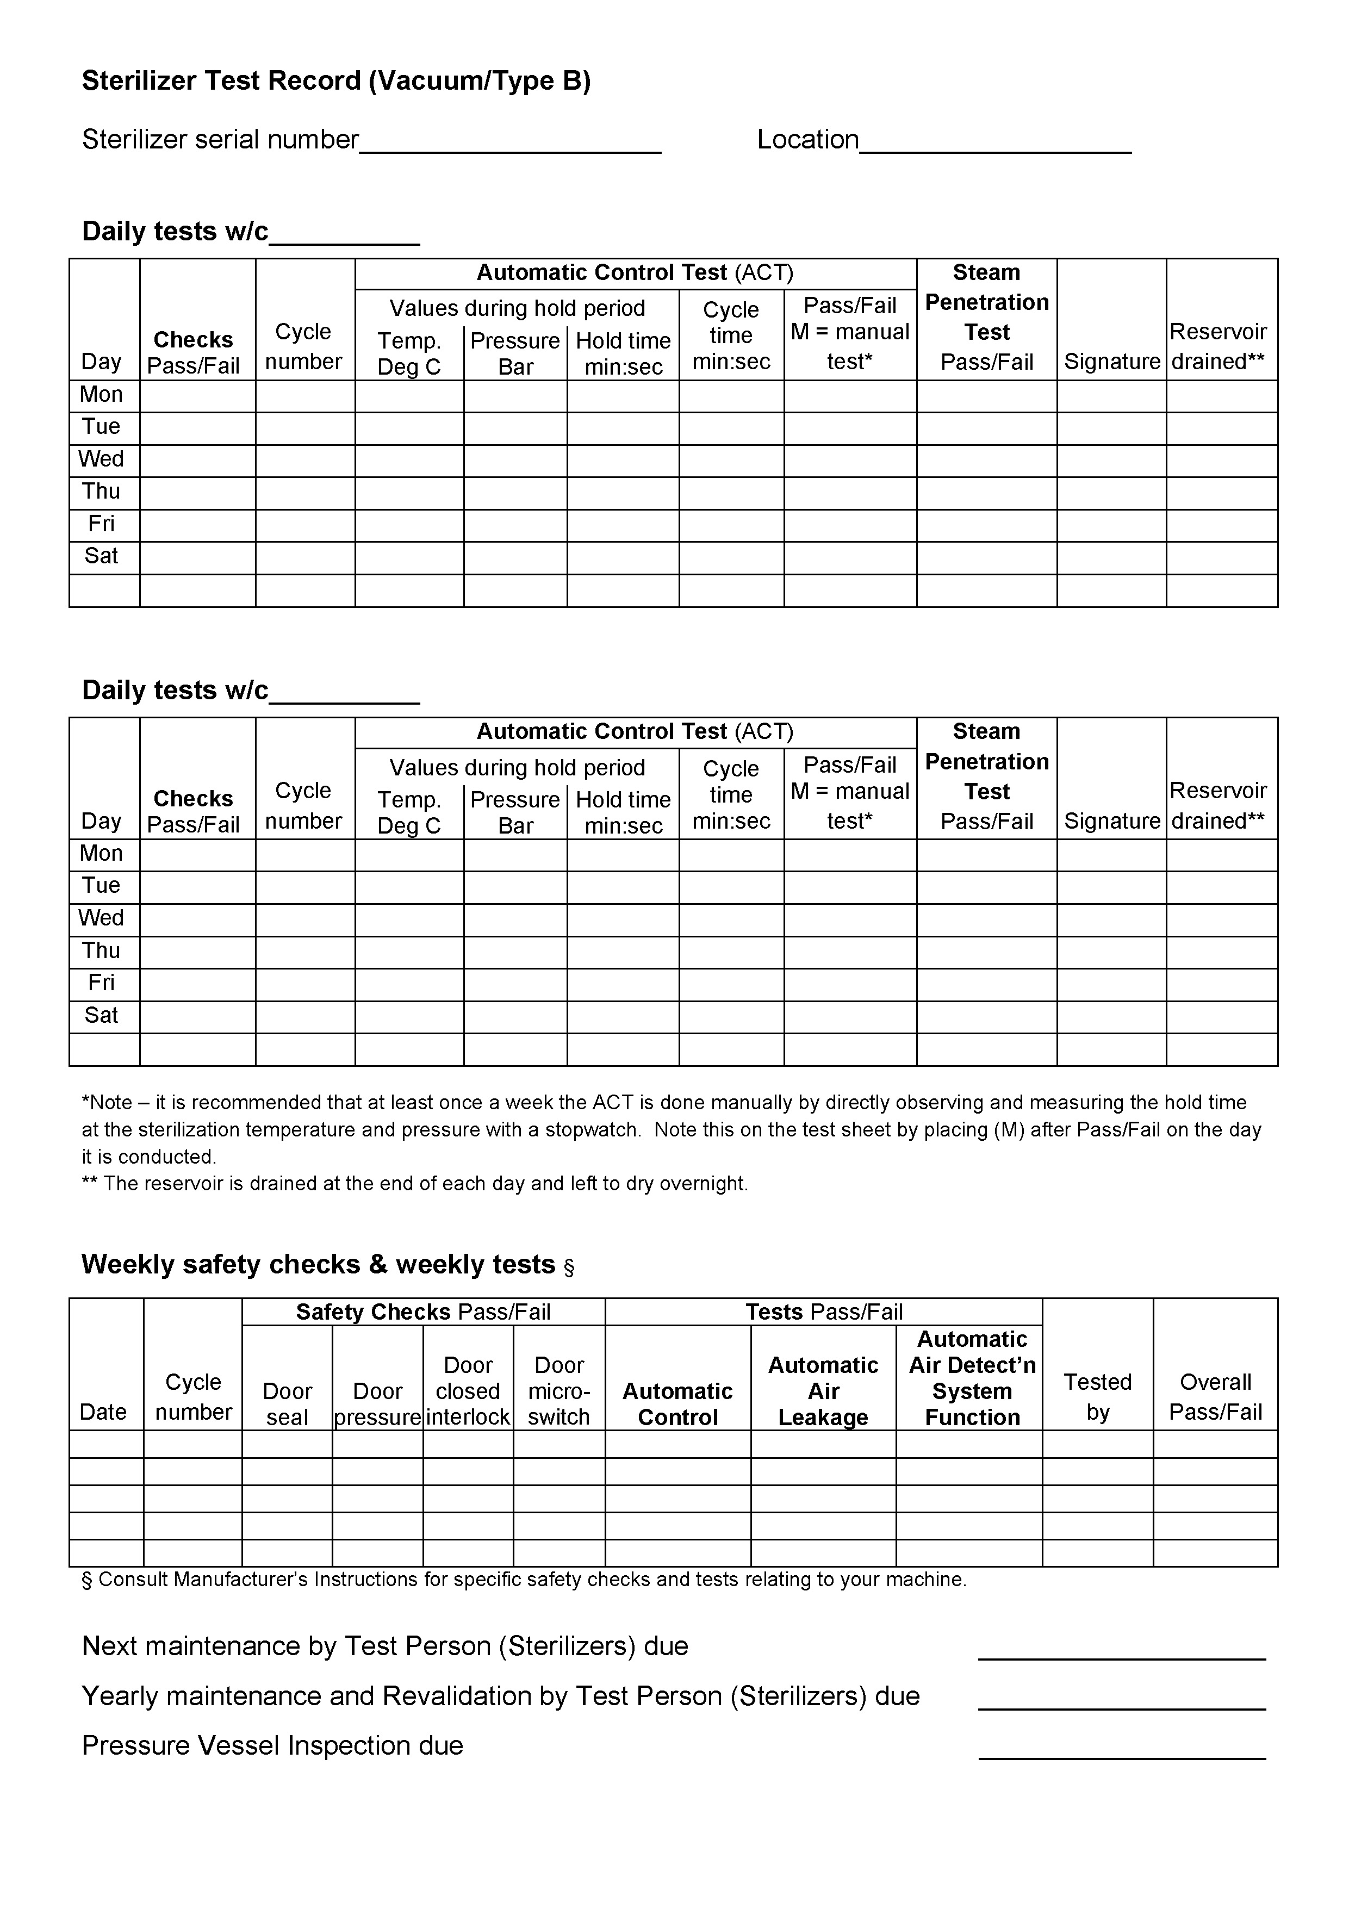
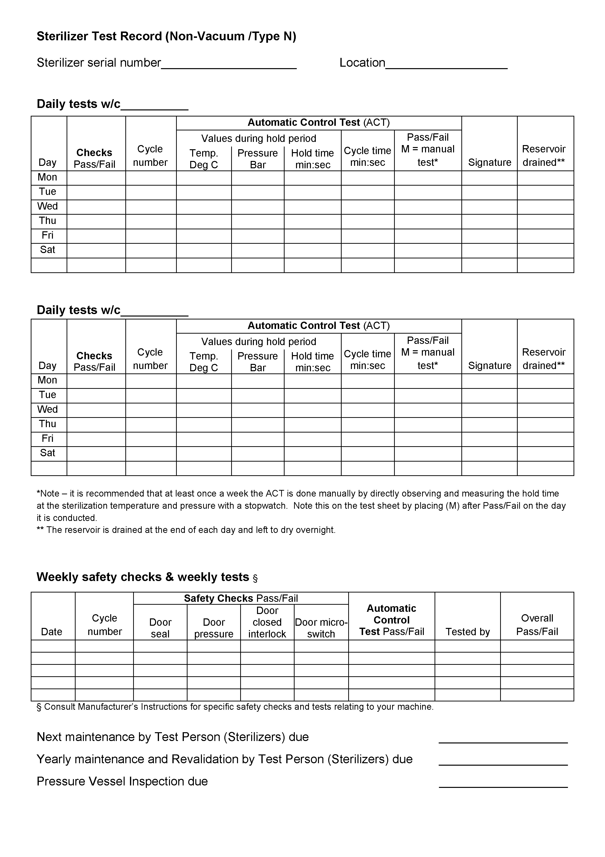

Record sheets may also be available from your equipment supplier.

Health Facilities Scotland (formerly Scottish Healthcare Supplies) supply standard logbooks for various types of sterilizer, washer-disinfectors and ultrasonic cleaners. These are available online at: http://www.hfs.scot.nhs.uk/services/decontamination-services/guidance/.

References
1st Report – The Glennie Framework. Sterile Services Provision Review Group, NHSScotland (2001) (www.show.scot.nhs.uk/sehd/publications/sspr/sspr.pdf)

Benchtop steam sterilisers in primary care dental services. Advice Statement 003/11. Scottish Health Technologies Group, Health Improvement Scotland (2011)
(www.healthcareimprovementscotland.org/programmes/clinical__cost_effectiveness/shtg/advice_statements/advices/advice_statement_003-11.aspx)

BS EN 13060:2004+A2:2010 Small steam sterilizers. British Standards Institution (2005)

BS EN ISO 11140-1:2009 Sterilization of healthcare product. Chemical indicators. General Requirements British Standards Institution (2009)

BS EN ISO 11607-1:2009 Packaging for terminally sterilized medical devices. Requirements for materials, sterile barrier systems and packaging systems. British Standards Institution (2010)

BS EN ISO 11607-2:2006 Packaging for terminally sterilized medical devices. Validation requirements for forming, sealing and assembly processes British Standards Institution (2006)

BS EN ISO 15883-1:2009 Washer-Disinfectors – General Requirements, Terms and Definitions and Tests. British Standards Institution (2009)

Compliant Dental Local Decontamination Units in Scotland (Primary Care) Health Facilities Scotland (2013) (www.hfs.scot.nhs.uk/services/decontamination-services/guidance/)

Control of Substances Hazardous to Health – COSHH. Health & Safety Executive
(www.hse.gov.uk/coshh/)

Decontamination of Reusable Medical Devices: Control of Aqueous Solutions in Ultrasonic Cleaners. NHSScotland Safety Action Notice SAN(SC) 03/11. NHSScotland (February 2003)

Decontamination – Compliance in Primary Care. NHS HDL (2005) 1. Performance Management and Finance Directorate, Scottish Executive Health Department (January 2005) (www.show.scot.nhs.uk/sehd/mels/HDL2005_01.pdf)

Decontamination – Testing, Maintenance and Revalidation of Equipment, CDO(2010)2. Chief Dental Officer. Scottish Government Health Directorates (2010)
(http://www.sehd.scot.nhs.uk/publications/CDO(2010)02.pdf)

Important Information for all General Medical and Dental Practitioners and Others Engaged in Local Decontamination of Surgical Instruments, SEHD/CMO(2004)21. Chief Medical Officer and Chief Dental Officer, Scottish Executive Health Department (2004)
(http://www.sehd.scot.nhs.uk/cmo/CMO(2004)21.pdf)

Local Decontamination Units: Guidance on the Requirements form Equipment, Facilities and Management. Health Protection Scotland, NHS National Services Scotland (2005 – amended 2007) (www.documents.hps.scot.nhs.uk/hai/decontamination/publications/ldu-001-02-v1-2.pdf)

National Infection Prevention and Control Manual. Health Protection Scotland, NHS National Services Scotland (2014) (www.hps.scot.nhs.uk/haiic/ic/standardinfectioncontrolprecautions-sicps.aspx)

NHS Model Engineering Specification C30 – Washer-Disinfectors for Surgical Instruments. Department of Health (2001)

Notification of Revised Board Responsibilities for the Management and Funding of Dental Clinical and Special Wastes. Directorate of Primary Care and Community Care, PCA(D)5, Scottish Executive Health Department (2006) http://www.sehd.scot.nhs.uk/pca/PCA2006(D)05.pdf

Personal Protective Equipment at Work Regulations 1992. Health and Safety Executive (1992) (www.opsi.gov.uk/SI/si1992/Uksi_19922966_en_1.htm)

Practice Support Manual. Scottish Dental Clinical Effectiveness Programme
(www.psm.sdcep.org.uk)

Pressure systems – safety and you. Health and Safety Executive (2001).
(www.hse.gov.uk/pubns/indg261.pdf)

Pressure Systems Safety Regulations 2000, Health and Safety Executive (2000)
(www.opsi.gov.uk/si/si2000/20000128.htm)

Provision and Use of Work Equipment Regulations 1998. Health and Safety Executive (1998) (www.opsi.gov.uk/si/si1998/19982306.htm)

SHTN 3 NHSScotland Waste Management Guidance – Part A Best Practice Overview, and Part B Waste Management Policy Template. Health Facilities Scotland, NHS National Services Scotland (2010) (www.hfs.scot.nhs.uk/online-services/publications/environment/shtns/)

SHTN 3 NHSScotland Waste Management Guidance – Part C Waste Management Procedures Template. Health Facilities Scotland, NHS National Services Scotland (2010)

SHTM 2010 Sterilization, SHTM 2030 Washer-disinfectors, SHTM 2031 Clean Steam for Sterilization. NHSScotland Property and Environment Forum, NHSScotland (2001) (www.hfs.scot.nhs.uk/services/decontamination-services/guidance/)
SHPN 13: Part 2, Decontamination Facilities: Local Decontamination Units, Health Facilities Scotland, NHS National; Services Scotland (2008) (www.hfs.scot.nhs.uk/services/decontamination-services/guidance/)

Single-use Medical Devices: Implications and Consequences of Reuse. Medicines and Healthcare products Regulatory Agency, Department of Health (2013)
https://www.gov.uk/government/uploads/system/uploads/attachment_data/file/403442/Single-use_medical_devices__implications_and_consequences_of_reuse.pdf

Survey of Decontamination in General Dental Practice in Scotland. Sterile Services Provision Review Group, NHSScotland (2004) (www.sehd.scot.nhs.uk/publications/DC20041202Dental.pdf)

Workplace (Health Safety and Welfare) Regulations 1992. Health and Safety Executive (1992) (www.opsi.gov.uk/SI/si1992/Uksi_19923004_en_1.htm)

Wrapping Dental Instruments. Advice Statement 002/10. Scottish Health Technologies Group Health Improvement Scotland (2010) (www.healthcareimprovementscotland.org/our_work/technologies_and_medicines/earlier_advice_statements/advice_statement_002-10.aspx)

Written schemes of examination. Pressure Systems Safety Regulations 2000. Health and Safety Executive (2002) (www.hse.gov.uk/pubns/indg178.pdf)

References

