Prevention and Treatment of Periodontal Diseases in Primary Care
Dental Clinical Guidance

June 2014

© Scottish Dental Clinical Effectiveness Programme
SDCEP operates within NHS Education for Scotland. You may copy or reproduce the information in this document for use within NHS Scotland and for non-commercial educational purposes.
Use of this document for commercial purpose is permitted only with written permission.
Published June 2014
Scottish Dental Clinical Effectiveness Programme
Dundee Dental Education Centre, Frankland Building, Small’s Wynd, Dundee DD1 4HN

Email scottishdental.cep@nes.scot.nhs.uk
Tel 01382 425751 / 425771
Website www.sdcep.org.uk
1 Introduction 1
1.1 Why this guidance has been developed 1
1.2 Why follow this guidance? 2
1.3 Scope of this guidance 2
1.4 Who should use this guidance? 3
1.5 How the guidance is presented 3
1.6 Supporting tools 4
1.7 Statement of Intent 5
2 Assessment and Diagnosis 6
2.1 Classification of Periodontal Diseases 6
2.2 Risk Factors 8
2.3 Screening 10
2.4 Full Periodontal Examination 16
2.5 Use of Radiographs 23
2.6 Treatment Planning 26
3 Changing Patient Behaviour 30
3.1 Changing Patient Behaviour 30
3.2 Oral Hygiene TIPPS 31
3.3 Smoking Cessation 35
3.4 Other Lifestyle Factors 37
4 Treatment of Gingival Conditions 39
4.1 Plaque-Induced Gingivitis 39
4.2 Drug-induced Gingival Enlargement 40
4.3 Pregnancy-associated Gingivitis 42
4.4 Puberty-associated Gingivitis 42
4.5 Unexplained Gingivitis and Gingival Enlargement 43

5 Treatment of Periodontal Conditions 45
5.1 Non-surgical Periodontal Therapy 45
5.2 Management of Local Plaque-retentive Factors 52
5.3 Antimicrobial Medication 53
5.4 Host Modulation Therapy 55
5.5 Anti-plaque Mouthwashes 55
5.6 Management of Dentine Sensitivity Following RSI 56
5.7 Management of Occlusal Trauma 57
5.8 Management of Acute Conditions 57
6 Long Term Maintenance 62
6.1 Long Term Maintenance 62
6.2 Dental Prophylaxis 63
6.3 Supportive Periodontal Therapy 64
7 Management of Patients with Dental Implants 68
7.1 General Care of Dental Implants 68
7.2 Implant-specific Oral Hygiene Methods 72
7.3 Treatment of Peri-implant Mucositis 72
7.4 Treatment of Peri-implantitis 75
8 Referral 79
8.1 Referral Criteria 79
8.2 Formal Referral 80
8.3 Continuing Care of Referred Patients 82
9 Record Keeping 83
9.1 General Principles 83
9.2 Information Specific to Periodontal Diseases 84
10 Evidence into Practice 87
11 Recommendations for Future Research 103
Appendix 1 Guidance Development 105
The Scottish Dental Clinical Effectiveness Programme 105
The Programme Development Team 106
The Guidance Development Group 107
Guidance Development Methodology 108
Review and Updating 110
Steering Group 111
Appendix 2 Treatment Prescription for Hygienists and Therapists 113
Appendix 3 Brief Intervention Flowchart 114
Appendix 4 Points to Cover in Smoking Cessation Discussion 116
Appendix 5 Alcohol Units and Questionnaires 118
Appendix 6 Patients with Diabetes 119
Appendix 7 Advice For Medical Practitioners 120
Appendix 8 Assessment of Risk and Modifying Factors 122
References 124

Summary
This summary outlines the areas where recommendations have been made within the guidance. The summary is not comprehensive and for a thorough appreciation of all recommendations and the basis for making them it is necessary to read the guidance in full. All of the recommendations in the guidance are considered important for the provision of high-quality dental care.
Assessment and Diagnosis [for full guidance refer to Section 2]
- Assess and explain risk factors for periodontal diseases to patients.
- Screen all patients for periodontal diseases at every routine examination.
- Carry out a full periodontal examination for patients with BPE scores 3, 4 and *.
Changing Patient Behaviour [for full guidance refer to Section 3]
- Use the Oral Hygiene TIPPS behaviour change strategy to address inadequate plaque removal.
- Raise the issue of smoking cessation where appropriate.
- Encourage patients to modify other lifestyle factors that may impact on their oral health.
Providing Treatment [for full guidance refer to Sections 4 and 5]
- Ensure that all patients are able to perform optimal plaque removal.
- For patients with gingivitis, remove supra-gingival plaque, calculus and stain and sub-gingival deposits and, if possible, correct any local plaque retentive factors.
- For patients with periodontitis, remove supra-gingival plaque, calculus and stain and, if possible, correct any local plaque retentive factors. Carry out root surface instrumentation at sites ≥4 mm probing depth where sub-gingival deposits are present or which bleed on probing.
- Do not use antimicrobial medication to treat chronic periodontitis.

Long Term Maintenance [for full guidance refer to Section 6]
- Ensure that patients are enrolled in the appropriate programme of long term maintenance: dental prophylaxis for patients with no history of periodontitis and supportive periodontal therapy for those with a history of periodontitis.
- For all patients, carry out an oral examination and use Oral Hygiene TIPPS to address inadequate plaque removal.
- For patients receiving dental prophylaxis, remove supra-gingival plaque, calculus and stain and sub-gingival deposits if necessary.
- For patients receiving supportive periodontal therapy, carry out root surface instrumentation at sites ≥4 mm probing depth where sub-gingival deposits are present or which bleed on probing. Ensure that full mouth periodontal charting is performed annually in these patients.
- Assign an individual risk level based on the patient’s medical history and oral health status and schedule recall appointments accordingly.
Maintaining Dental Implants [for full guidance refer to Section 7]
- Ensure the patient is able to perform optimal plaque removal around the dental implant(s).
- Examine peri-implant tissues for signs of inflammation and bleeding on probing and/or suppuration and remove supra- and sub-mucosal plaque and calculus deposits and excess residual cement. Perform radiographic examination only where clinically indicated.
Referral [for full guidance refer to Section 8]
- Consult any locally produced referral guidelines and the BSP ‘Referral Policy and Parameters of Care’ to determine if the patient is a suitable candidate for referral.
- Prior to referral, carry out initial therapy to address inadequate plaque removal, smoking status (if applicable) and to remove supra- and sub-gingival deposits.
- Provide supportive periodontal therapy and monitoring for patients who have been discharged from specialist or secondary care.

Record Keeping [for full guidance refer to Section 9]
- Record the results of the periodontal examinations (basic and/or full) carried out and the current standard of oral hygiene.
- Record the diagnosis, suggested treatment plan and details of costs.
- Document any discussions you have with the patient regarding, for example, treatment options, risks and benefits of treatment, oral hygiene advice, smoking cessation, alcohol consumption and/or other lifestyle factors.

The main elements of the Prevention and Treatment of Periodontal Diseases in Primary Care are illustrated in the diagram below, which also indicates the sections of the guidance which describe each element in detail.

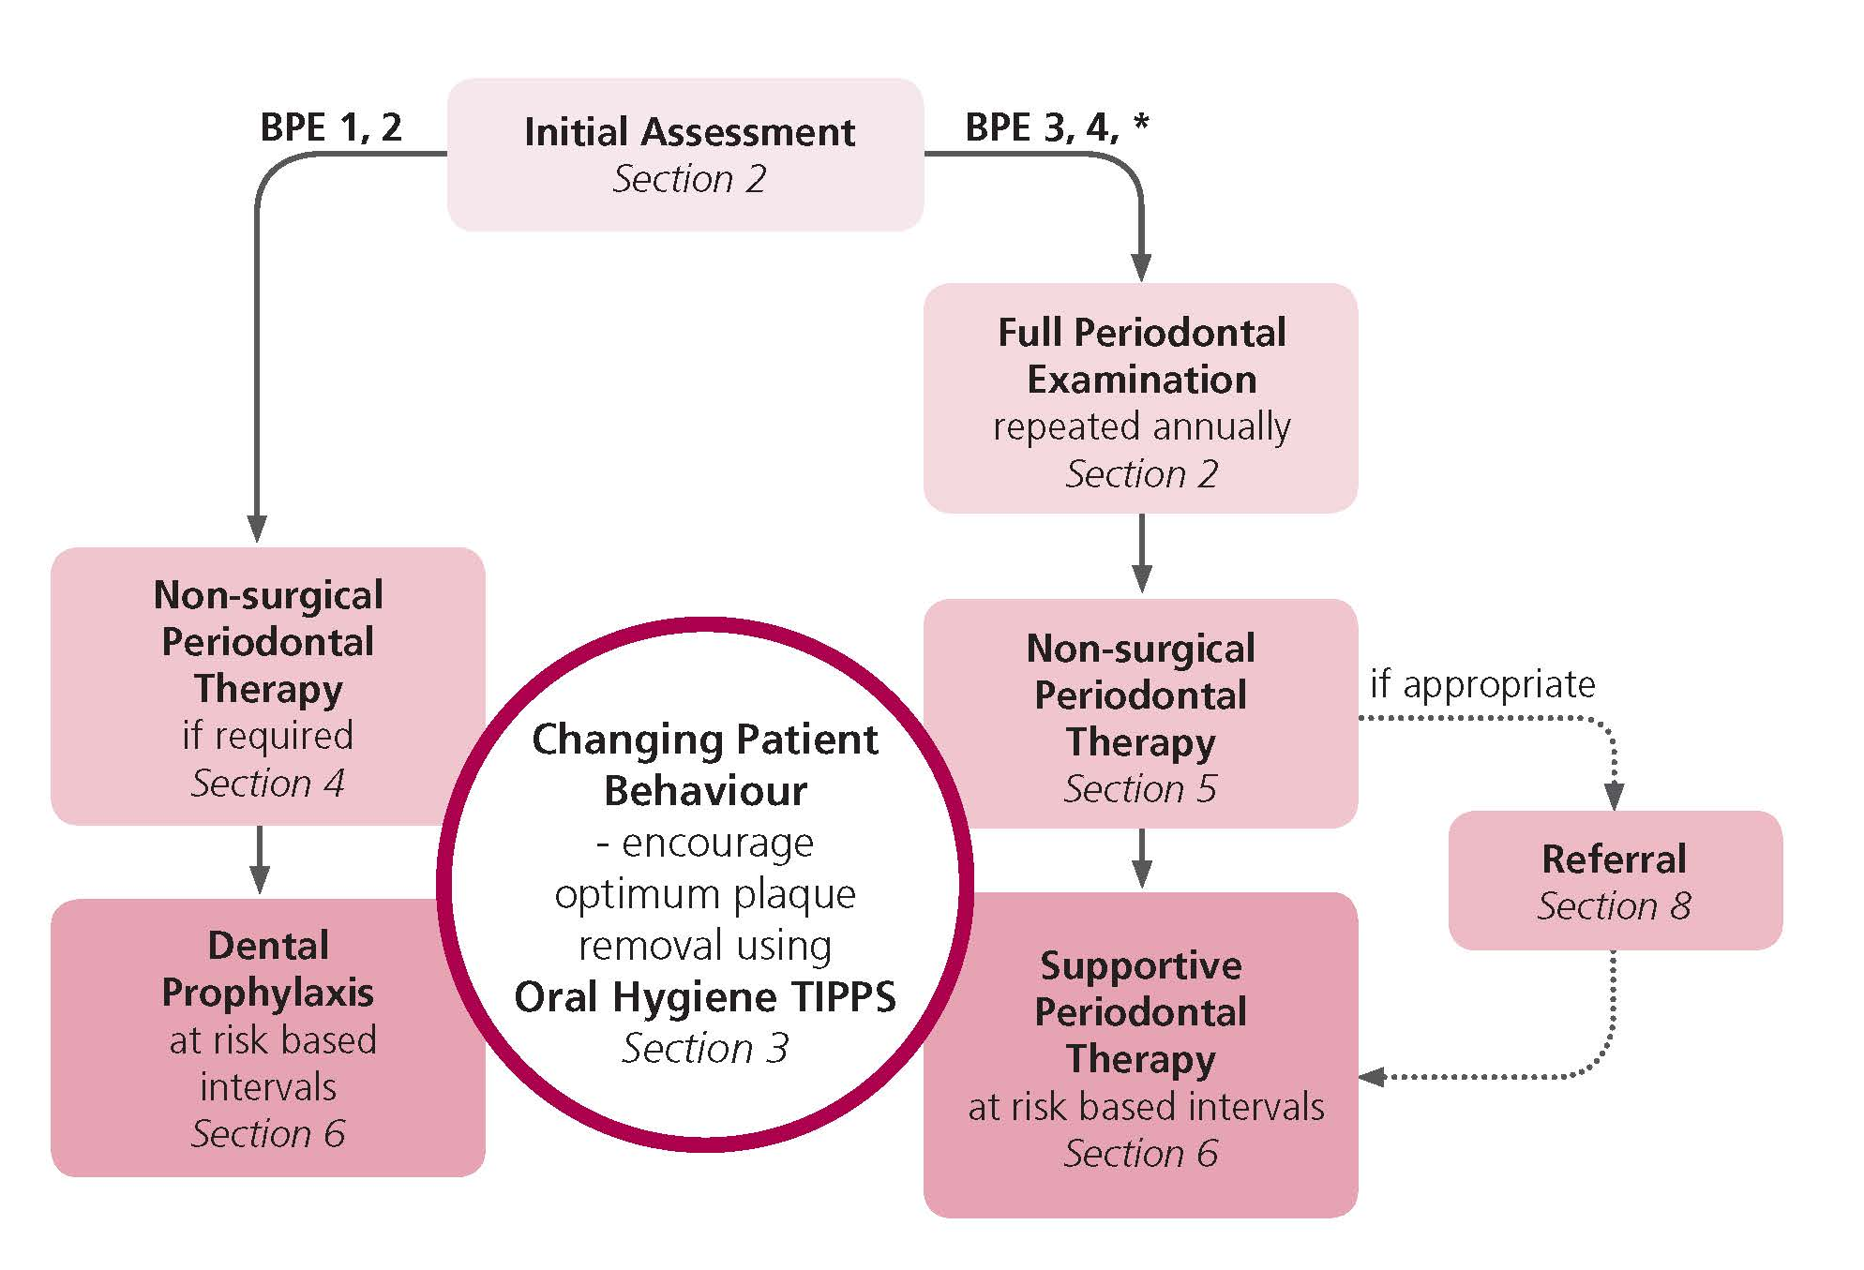

1 Introduction

1.1 Why this guidance has been developed
Periodontal health is the foundation of good preventive and restorative dentistry. However, periodontal disease is prevalent in a large proportion of the Scottish population, with epidemiological studies^{1,2} suggesting that around half of dentate adults have evidence of gingivitis and/or periodontitis, including a significant minority who display signs of advanced disease. One of the most frequent dental procedures carried out in Scotland is the simple supra-gingival scale and polish.³ However, less than 10% of patients receive the more intensive categories of care designated for managing patients with moderate to severe periodontal disease, with considerable variation evident across Health Boards. The reasons for this are multi-factorial and complex but may include both practitioner and patient factors.
Most patients with moderate to severe periodontal disease can be adequately managed in primary care. Referral to a specialist or to secondary care is an appropriate pathway for the most severe cases of periodontal disease. However, there is concern that an apparent reluctance to treat advanced disease in primary care has resulted in an increase in inappropriate referrals. Interviews with clinicians suggest that drivers to referral include a lack of confidence amongst general dental practitioners (GDPs) in performing periodontal treatment, the time necessary to treat periodontal diseases effectively and the need to rely on the patient to be an active partner in the treatment process.⁴ The medico-legal defence unions report that an increasing number of claims relate to allegations of failure to diagnose and treat periodontitis.⁵
Recognising the need for accessible guidance in this area, the Scottish Dental Clinical Effectiveness Programme (SDCEP) convened a Guidance Development Group to provide clinical guidance on best practice for the prevention and treatment of periodontal diseases in primary care. The guidance development group comprised individuals from a range of branches of the dental profession with an interest in the management of periodontal diseases and also included a patient representative. Further details about the Guidance Development Group, SDCEP and the development of this guidance are given in Appendix 1.
This guidance seeks to present clear and consistent advice to support dental professionals to deliver preventive care and, where necessary, to treat periodontal diseases in primary care.

1.2 Why follow this guidance?
Many of the recommendations in this guidance are based on research evidence. If the prevention and treatment strategies presented in this guidance are followed by the dental team, patients at risk of developing periodontal diseases can be recognised early and appropriate care (both preventive and treatment-based) can be provided to improve the oral health, and in some cases general health, of the patient population in Scotland.

1.3 Scope of this guidance
Prevention and Treatment of Periodontal Diseases in Primary Care is designed to assist and support primary care dental teams in providing appropriate care for patients both at risk of and with periodontal diseases. The guidance aims to support the dental team to:
- manage patients with periodontal diseases in primary care appropriately;
- improve the quality of decision making for referral to secondary care;
- improve the overall oral health of the population.
The guidance focuses on the prevention and non-surgical treatment of periodontal diseases and implant diseases in primary care. Advice on the assessment, diagnosis and management of periodontal and implant diseases, adequate record keeping and appropriate referral is included. The surgical treatment of periodontal and implant diseases and the management of patients by periodontal specialists or in a secondary care setting are outwith the scope of this guidance and are not discussed in detail.
The guidance is based on existing guidelines, including those from the British Society of Periodontology, relevant systematic reviews, research evidence and the opinion of experts and experienced practitioners.
The guidance is applicable to patients of all ages in all population groups in primary care.

1.4 Who should use this guidance?
This guidance is designed for use by all clinicians who are involved in the prevention and treatment of periodontal diseases in primary care. These include dentists, dental therapists, dental hygienists and oral health educators in general dental practice, and the public dental service. The guidance is also of relevance to the hospital dental service, those involved in dental education and undergraduate trainees. General medical practitioners and medical specialists such as diabetologists and diabetic nurses will also find parts of the guidance relevant.
Direct Access
With the introduction of Direct Access in May 2013, dental hygienists and therapists can diagnose and treat patients, within their scope of practice, without a prescription from a dentist. However, individual dental hygienists and therapists must be aware of their limitations and put in place referral pathways for patients. Direct access is optional and dental hygienists and therapists can continue to provide treatment in line with a treatment plan prescribed by a dentist if they wish. The General Dental Council (GDC) website provides more information on aspects of working under direct access.

1.5 How the guidance is presented
Evidence-based practice makes use of the best current research evidence, taking into account clinical expertise and the preferences of the patient, to inform decisions about patient care. The recommendations in this guidance have been developed to assist in clinical decision making and are based on critical evaluation of the available body of evidence and expert opinion. Each recommendation is considered important for the provision of high-quality dental care.
The guidance is presented in several sections. Sections 2 – 9 each address a specific aspect of the prevention and treatment of periodontal and implant diseases in primary care. Section 10 presents an overview of the evidence appraisal which underpins the guidance recommendations. Section 11 briefly discusses recommendations for future research.
Throughout the text, specific types of information are included as follows.
Key recommendations - presented at the beginning of sections 2 - 9 to communicate the core messages within the section.
Evidence summary - an overview of the evidence which informs the recommendations within Sections 2 – 9; more detailed evidence summaries for each key clinical question are presented in Section 10.
Considered judgement and guidance recommendation – the Guidance Development Group’s evaluation of the available evidence for each key clinical question in Section 10 and the resulting recommendation.

1.6 Supporting tools
Tools to support the implementation of Prevention and Treatment of Periodontal Diseases in Primary Care are provided and include:
- advice on treatment prescriptions for referral to dental hygienists and therapists (Appendix 2);
- advice on raising the issue of smoking cessation (Appendices 3 and 4) and alcohol consumption (Appendix 5) with patients;
- information to assist in the care of patients with diabetes (Appendix 6);
- information for other healthcare professionals, e.g. General Medical Practitioners (GMPs), diabetologists and diabetic nurses, on the most common medical conditions and medications associated with the development of periodontal diseases (Appendix 7);
- information on the assignment of risk (Appendix 8);
Guidance in Brief, a summary version of this guidance is provided separately.
Other tools to support the implementation of this guidance include:
- a video to illustrate the use of the Oral Hygiene TIPPS behaviour change intervention;
- a visual aid for use when discussing the importance of good oral hygiene with patients (included at the rear of this publication);
- an information leaflet explaining the symptoms of periodontal diseases and advice on plaque removal;
- an information leaflet relevant to patients with diabetes.
All of the above materials, as well as a pdf of the full guidance, are available via the SDCEP website, www.sdcep.org.uk.

1.7 Statement of Intent
This guidance has resulted from a careful consideration of available evidence, expert opinion, current legislation and professional regulations. It should be taken into account when making decisions regarding treatment in discussion with the patient and/or carer.
As guidance, the information presented here does not override the clinician’s right, and duty, to make decisions appropriate to each patient with his/her consent. However it is advised that significant departures from this guidance, and the reason for this, are fully documented in the patient’s clinical record.

2 Assessment and Diagnosis

KEY RECOMMENDATIONS
- Assess and explain risk factors for periodontal diseases to patients.
- Screen all patients for periodontal diseases at every routine examination.
- Carry out a full periodontal examination for patients with BPE scores 3, 4 and *.

2.1 Classification of Periodontal Diseases
Periodontal diseases comprise a group of related conditions, both acute and chronic, characterised by inflammation of the periodontal tissues in response to the presence of dental plaque.
Table 2.1 The classification of periodontal diseases
Classification | Description
Gingivitis | Plaque-induced inflammation of the gingivae characterised by red, swollen tissues which bleed on brushing or probing.
Chronic periodontitis | Characterised by the destruction of the junctional epithelium and connective tissue attachment of the tooth, together with bone destruction and formation of periodontal pockets. The disease progresses slowly and the amount of bone loss tends to reflect the age of the patient over time (see figure 2.1).
Aggressive periodontitis | A severe condition usually found in a younger cohort of patients, which may be associated with a familial history of aggressive periodontitis. Disease progression is rapid and the degree of destruction of the connective tissue attachment and bone is severe, considering the age of the patient. Plaque levels may be inconsistent with the level of disease seen.
Necrotising ulcerative gingivitis (NUG) | Painful ulceration of the tips of the interdental papillae. Grey necrotic tissue is visible and there is an associated halitosis. The condition is termed necrotising ulcerative periodontitis (NUP) in the presence of connective tissue attachment loss and bone destruction.
Periodontal abscess | Infection in a periodontal pocket which can be acute or chronic and asymptomatic if freely draining.
Perio-endo lesions | Lesions may be independent or coalescing and the bacterial source originates either in the periodontium or the root canal system
Gingival enlargement | Thickening of the gingivae which can occur as a response to irritation caused by plaque or calculus, repeated friction or trauma, fluctuations in hormone levels or the use of some medications.

The classification of periodontal diseases is discussed further in the British Society of Periodontology publication Young Practitioners’ Guide to Periodontology.⁶
Figure 2.1 Generalised severe chronic periodontitis
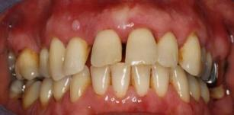
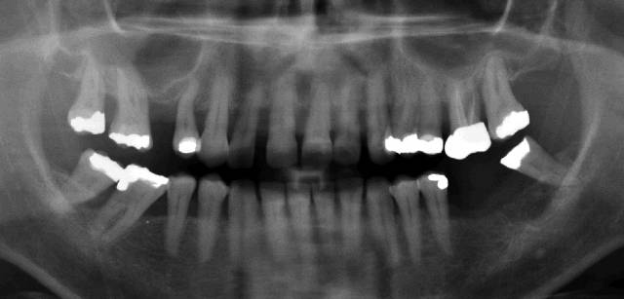
Note the small fibroepithelial polyp on the attached gingiva adjacent to 12. The panoramic radiograph shows a heavily restored dentition with a failed root canal treatment 26. Severe generalised horizontal bone loss between 50% and 80% of root length is present around the upper teeth; in the lower jaw horizontal bone loss is between 10% and 50% of root length on the premolars and molars; infrabony defects are present on 16M, 14D and on 48M and 47M, which are tilted mesially.

2.2 Risk Factors
Patient care is evolving from a mainly restorative approach to a more preventive and long term approach which is risk-based and meets the specific needs of individual patients. This model of care requires assessment of each individual patient’s risk of developing oral disease, including periodontal diseases. Risk assessment involves the use of clinical judgement and knowledge of the patient to assess risk factors identified in the patient’s history that may affect the development of oral disease. This information is integrated with the level of disease identified during the clinical examination and used to assign a risk level. The risk level is used to determine the level of ongoing care required by the patient. More information on risk assessment can be found in the SDCEP Oral Health Assessment and Review⁷ guidance and in Appendix 8.
Although for most patients periodontal diseases are preventable with good oral hygiene, there are many factors which increase the probability of a patient developing periodontal disease. Smoking and diabetes are significant risk factors for periodontitis. Smoking is thought to reduce gingival blood flow (thereby suppressing the signs and symptoms of gingivitis), impair wound healing and increase production of inflammation-mediating cytokines. Patients who smoke do not respond to periodontal treatment as well as non-smokers⁸ and are also more likely to lose teeth.
Patients with diabetes also have an increased risk of developing periodontal diseases. Poorly controlled diabetes enhances the signs and symptoms of gingivitis and periodontitis and has an adverse effect on wound healing, making treatment of these patients more difficult. However, there is some evidence that successful non-surgical periodontal treatment can improve glycaemic control.⁹
There is a body of evidence indicating an association between periodontitis and cardiovascular disease. This may be due to shared risk factors and there is, as yet, no evidence from large scale prospective clinical trials that treatment of periodontal disease can improve cardiovascular outcomes.
A family history may predispose a patient to developing periodontitis but unravelling the genetic background to the disease is a complex process which so far remains unclear. Other factors which may increase severity of periodontitis are stress, diet, obesity, osteoporosis and rheumatoid arthritis but currently the scientific evidence is weak.
Patients taking certain medications for existing conditions such as calcium channel blockers for hypertension, phenytoin for epilepsy and ciclosporin, an anti-rejection drug, which can also be prescribed for some autoimmune disorders, may be at risk of gingival enlargement. In addition, the hormonal changes associated with adolescence and pregnancy have been implicated in the development of gingivitis and gingival enlargement.
Local risk factors, such as calculus, malpositioned teeth, overhanging restorations and partial dentures may also increase the risk of periodontal diseases (see Section 5.2).
RECOMMENDATIONS
- Ensure you have an up to date medical history for all patients.
- Explain to patients who smoke the effect smoking can have on their oral health and general health. Direct patients who express a desire to stop smoking to smoking cessation services (see Section 3.3 and Appendices 3 and 4).
- Explain to patients who have diabetes that poorly controlled blood sugar levels increase the risk of developing periodontal disease or worsening existing periodontal disease. Consider communicating with their GMP if necessary (see Appendices 6 and 7).
- Explain to all patients the benefits of a healthy, balanced diet to their overall health and oral health in particular (see Section 3.4).
- Ensure that patients who are pregnant are aware of their increased risk of developing pregnancy gingivitis. Highlight the need for more frequent visits for dental prophylaxis or, if required, supportive periodontal therapy during pregnancy.

2.3 Screening
All dentate patients should be screened for periodontal disease at every routine examination. The exception is patients who are currently receiving supportive periodontal therapy (see Section 6.3); these patients will require annual full mouth periodontal charting (see Section 2.4). Screening involves probing of the periodontal tissues to assess the presence of bleeding on probing, plaque and calculus deposits and the depth of any gingival or periodontal pockets which may be present.
Probing force
A light probing force of 25 g, equivalent to the force required to blanch a fingernail, is used when probing the periodontal tissues (see figure 2.2).
Figure 2.2 Probing force
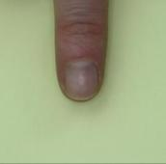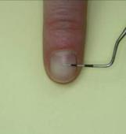
Bleeding on Probing (BOP)
Inflammation of the periodontal tissues occurs in response to the presence of dental plaque microorganisms and results in bleeding on probing, except in smokers where the inflammatory response is suppressed. In non-smokers, an absence of bleeding on probing suggests that the periodontal tissues are healthy. In patients with a history of periodontitis, an absence of bleeding on probing suggests that the tissues are now stable.
Basic Periodontal Examination (BPE)
The Basic Periodontal Examination (BPE), developed by the British Society of Periodontology in 1986 and revised in 2011, is a simple and rapid screening tool for the assessment of adult patients.¹⁰ A modified BPE is used to screen children and adolescents.¹¹ The BPE does not itself provide a diagnosis of periodontal disease but indicates what further assessment and periodontal treatment, if any, the patient requires. The BPE was developed from the Community Periodontal Index of Treatment Need (CPITN) and is performed using a WHO CPITN probe (see figure. 2.3). The probe should be ‘walked’ around the gingival margin (see figure 2.10).
Figure 2.3 WHO CPITN probe
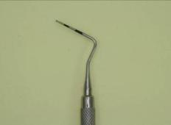
The WHO CPITN probe has a 0.5 mm diameter ball end and black banding between 3.5 and 5.5 mm and between 8.5 and 11.5 mm.
The BPE is not suitable for reassessment following treatment as it does not provide information about how individual sites respond to treatment. It is also not suitable for the screening of dental implants (see Section 7).
Screening of Adults
Before carrying out screening, it is important to ask the patient if he/she is aware of any symptoms, such as bleeding gums, drifted or loose teeth or a complaint by others of bad breath, which may indicate the presence of periodontal disease.
RECOMMENDATIONS
- Explain to the patient the reason for the examination.
- Divide the dentition into 6 sextants i.e. 17-14, 13-23, 24-27, 47-44, 43-33, 34-37.
- Examine all teeth in each sextant (excluding third molars) using a WHO CPITN probe (see figures 2.3 and 2.4) and light probing force equivalent to the force required to blanch a fingernail (see figure 2.2).
  - ‘Walk’ the probe around the gingival margin of each tooth in the sextant (see figure 2.10).
N.B. A sextant must include at least two teeth; if only one is present then include it with the neighbouring sextant.
- Record the highest score for each sextant, including any furcation involvement, as illustrated in table 2.2.
  - For example, a sextant with a maximum probing depth of 3.5 – 5.5 mm plus furcation involvement would be scored 3*. If any tooth in a sextant is given the score 4, it is sufficient to record this and move on to the next sextant, although it is good practice to screen all teeth within a sextant.
- Consider also recording plaque scores for patients with significant plaque levels (see Section 2.4).
Table 2.2 Basic periodontal examination scoring codes
Probing depth | Observation | BPE Score
Black band completely visible | No probing depths >3.5 mm, no calculus/overhangs, no bleeding after probing | 0
Black band completely visible | No probing depths >3.5 mm, no calculus/overhangs, but bleeding after probing | 1
Black band completely visible | No probing depths >3.5 mm, but supra- or sub-gingival calculus/overhangs present | 2
Black band partially visible | Probing depth(s) of 3.5 – 5.5 mm present | 3
Black band entirely within the pocket | Probing depth(s) of 6 mm or more present | 4
N/A | Furcation involvement | *

Figure 2.4 Probing depths observed at sites with BPE scores 0, 1, 2, 3, 4 and *
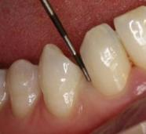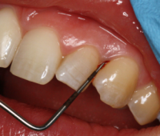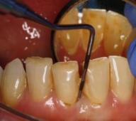
BPE 0 BPE 1 BPE2
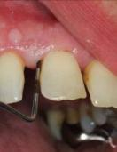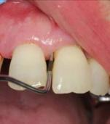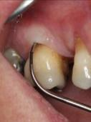
BPE 3 BPE 4 *Furcation
Note the small fibroepithelial polyp on the attached gingiva adjacent to tooth 12 in the BPE 3 image.
The score for each sextant is recorded in a 2 x 3 box chart, with any missing sextant denoted by an X, as shown in figure 2.5.
Figure 2.5 Box chart with charting of adult BPE scores.
Screening of Children and Adolescents <18 years
Periodontal screening for children and adolescents aged 7 to 17 years assesses six index teeth using a simplified BPE to avoid the problem of false pocketing.¹¹

RECOMMENDATIONS
- Explain to the patient the reason for the examination.
- Examine UR6, UR1, UL6, LL6, LL1 and LR6 using a WHO CPITN probe and light probing force equivalent to the force required to blanch a fingernail (see figure 2.2).
- Record the highest score for each tooth as illustrated in table 2.2.
  - BPE codes 0 – 2 are used for 7 to 11 year olds (mixed dentition stage) to screen for bleeding and the presence of local plaque retentive factors. The full range of codes, including any furcation involvement, can be used in 12 to 17 year olds (permanent teeth erupted).
- Consider also recording plaque scores for patients with poor oral hygiene (see Section 2.4).
- Immediately refer any child with evidence of periodontitis or unexplained gingival enlargement to a consultant in paediatric dentistry, consultant in restorative dentistry or specialist periodontist.

The score for each tooth is recorded in a 2 x 3 box chart, with a missing tooth denoted by an X, as shown in figure 2.6.
Figure 2.6 Box chart with charting of BPE scores for children.
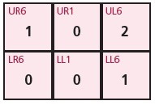
Interpretation of BPE Scores
The BPE score for each sextant gives an indication of the care required. Advice on the interpretation of BPE scores, based on guidance from the British Society of Periodontology,¹⁰ is given in Table 2.3. In addition, individual factors unique to each patient may influence the treatment required.

Table 2.3 Interpretation of BPE scores
BPE Score | Guidance on Further Assessment and Treatment
0 | Periodontal treatment is not required
1 | Plaque and gingivitis charting and oral hygiene demonstration.
2 | As for code 1 plus remove supra-gingival plaque, calculus and stain, and if necessary sub-gingival plaque and calculus, using an appropriate method.
3 | As for code 2 plus full periodontal examination of all teeth and root surface instrumentation where necessary (N.B. Where code 3 is observed in only one sextant, carry out full periodontal examination and root surface instrumentation of affected teeth in that sextant only).
4 | As for code 2 plus full periodontal examination of all teeth and root surface instrumentation where necessary (more time is required for root surface instrumentation than for score 3). Assess the need for more complex treatment and consider referral to a specialist.
* | Treatment need will depend on the BPE scores of 0 to 4 for that sextant. Assess the need for more complex treatment and consider referral to a specialist.

RECOMMENDATIONS
- Assign a risk level, based on the patient’s medical history, an assessment of risk factors and the outcome of the BPE, to inform future treatment and recall.
- For patients where the BPE score indicates periodontitis (BPE score of 3, 4 or *), carry out a full periodontal examination, as directed by table 2.3, and record the findings in the patient’s clinical notes.

2.4 Full Periodontal Examination
A full periodontal examination involves the charting of recession, probing depths, bleeding on probing and mobility for every tooth and is recorded in the patient’s clinical notes. This information can be used to educate the patient, inform your treatment choice, monitor treatment outcomes and, from a medico-legal standpoint, show that you have diagnosed and treated the condition appropriately.
The full periodontal examination is carried out using a calibrated periodontal probe (see figure 2.7), such as the 15 mm University of North Carolina (UNC) probe, PCP 12 mm (or 15 mm) probe or the Williams (10 mm) probe, with results recorded in the patient’s clinical notes.
Figure 2.7 Calibrated periodontal probes
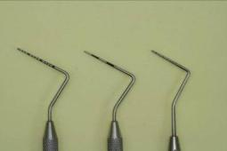
The UNC 15 probe (left) has markings at 1, 2, 3, 4, 5, 6, 7, 8, 9, 10, 11, 12, 13, 14, and 15 mm; the PCP 12 probe (centre) has colour bandings between 3 to 6 mm and 9 to 12 mm; the William's probe (right) has markings at 1, 2, 3, 5, 7, 8, 9 and 10 mm.
Due to the difficulty of accurately measuring the position of the gingival margin in relation to the cementoenamel junction (CEJ), it is recommended, as a minimum, that at least one measure of the greatest extent of gingival recession is recorded for both the buccal and lingual surfaces of the tooth.

Figure 2.8 Simplified longitudinal section through a periodontal pocket.
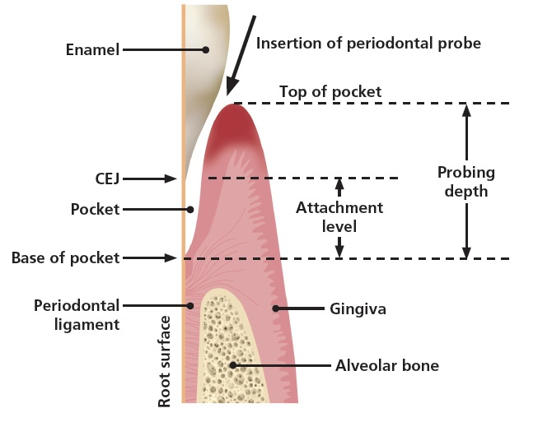
Gingival Margin Position
The normal position of the gingival margin is at the cementoenamel junction (CEJ) however in healthy young patients or in cases where the gingival margin is swollen it may be coronal to the CEJ (see figure 2.8). Where the gingival margin is apical to the CEJ it is described as gingival recession. Patients may be concerned by the aesthetic implications of ‘receding gums’; also exposed root surfaces may be sensitive. These can be the main drivers for them to seek treatment.
Probing Depth
Probing depth is the distance from the gingival margin to the base of the pocket (see figure 2.9). The position of the gingival margin can change due to swelling or recession therefore this measurement is not recommended for assessment of changes in remaining periodontal support over time. However, changes in probing depth give a good indication of response to periodontal treatment in the short term.
The probe should be inserted parallel to the root surface and ‘walked’ around the gingival margin (see figure 2.10). Probing depth should be measured at six sites per tooth.

Figure 2.9 Measurement of probing depth
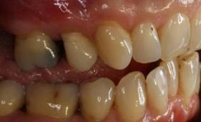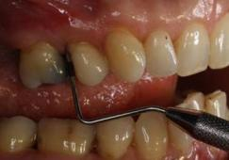
This mirror view shows measurement of probing depth (7 mm on distobuccal of 25) using a PCP 12 probe inserted parallel to the root surface. Note that on first inspection the periodontal tissues look healthy.
Figure 2.10 ‘Walking’ the probe
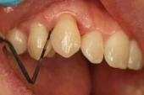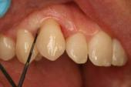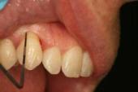
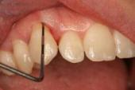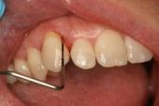
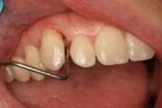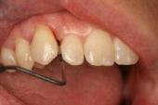
A PCP 12 probe is ‘walked’ around the gingival margin of the tooth.
Clinical Attachment Level
The clinical attachment level (CAL) is measured from a fixed point, usually the CEJ, to the base of the periodontal pocket. This is considered the best measure of changes in remaining periodontal support over time. If the CEJ is obscured, by for example a restoration margin, then another fixed reference point can be used to measure the relative clinical attachment level. Where there is recession, the CAL can be calculated by measuring the position of the gingival margin in relation to the CEJ and adding this value to the probing depth. Where the gingival margin is coronal to the CEJ, the CAL can be calculated by measuring the distance between the gingival margin and the CEJ and subtracting this value from the probing depth. Most computerised clinical systems will calculate CAL automatically if the other measurements are keyed in.
Bleeding from Gingival Margin/Base of Pocket
Bleeding from the gingival margin indicates the presence of gingivitis. Bleeding from the base of the pocket may indicate that active disease is present though it is unclear whether this can be used to predict subsequent increase in probing depth or loss of attachment.
Measurements of Furcation Involvement
Damage from periodontal disease can lead to furcation involvement of multi-rooted teeth. This is measured using a furcation probe (see figure 2.11) and graded depending on the severity of the furcation involvement¹² (see table 2.4).
Figure 2.11 Nabers furcation probes
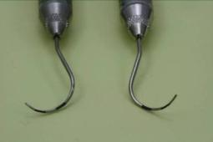
The Nabers furcation probe has colour banding between 3 to 6 mm and 9 to 12 mm.

Table 2.4 Grading of furcation involvement
Grade | Description
1 | Initial furcation involvement. The furcation opening can be felt on probing but the involvement is less than one third of the tooth width.
2 | Partial furcation involvement. Loss of support exceeds one third of the tooth width but does not include the total width of the furcation.
3 | Through-and-through involvement. The probe can pass through the entire furcation.

Abnormal Tooth Mobility
Loss of alveolar bone from periodontitis is a major cause of abnormal tooth mobility. Patients may complain that their teeth feel loose or that they have difficulty eating certain foods. It is assessed both horizontally and vertically. Horizontal mobility is measured by applying gentle pressure in a buccal-lingual direction, using two rigid instrument handles, or the index finger and an instrument handle if preferred, on either side of the tooth, and assessing the level of displacement (see figure 2.12). Vertical mobility is measured by applying gentle pressure on the crown of the tooth with a rigid instrument handle in a vertical direction.
Figure 2.12 Measuring horizontal tooth mobility
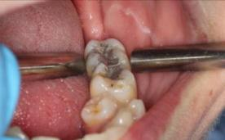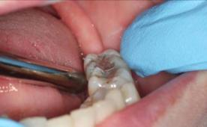
A B
Horizontal tooth mobility can be measured using two rigid instrument handles (A) or the index finger and an instrument handle (B).
Mobility is graded¹³ as shown in table 2.5.
Table 2.5 Grading of tooth mobility
Grade | Description
0 | ‘Physiological’ mobility measured at the crown level. The tooth is mobile within the alveolus to approximately 0.1 – 0.2 mm in a horizontal direction.
1 | Increased mobility of the crown of the tooth to at the most 1 mm in a horizontal direction.
2 | Visually increased mobility of the crown of the tooth exceeding 1 mm in a horizontal direction.
3 | Severe mobility of the crown of the tooth in both horizontal and vertical directions impinging on the function of the tooth.

Occlusal Trauma
Occlusal trauma does not cause periodontitis. The first line of treatment is always non-surgical therapy. In certain situations occlusal trauma may exacerbate periodontitis. For example, a mobile tooth with attachment loss and bone loss may overerupt or drift as a result of occlusal trauma.
RECOMMENDATIONS
- Record any missing teeth.
- Record at least one measure of the greatest extent of gingival recession observed, in millimetres, for both the buccal and lingual surfaces of each tooth.
- Measure probing depth, in millimetres, at six sites around each tooth (i.e. mesiobuccal, buccal, distobuccal, mesiolingual, lingual and distolingual).
  - Use a light probing force, equivalent to the force required to blanch a fingernail (see figure 2.2).
  - ‘Walk’ the probe around the gingival margin of each tooth (see figure 2.10) and record measurements for the greatest probing depth at each of the six sites for each tooth.
- Record the absence or presence (0 or 1) of bleeding on probing from the base of the pocket observed at each site in a quadrant, before moving on to the next quadrant.
- Record any furcation involvement for multi-rooted teeth, with an indication of the severity (see table 2.4).
- Record any tooth mobility (see table 2.5).
- Record any other observations, such as presence of dental caries, occlusal discrepancies and problems with restorations.
- Consider whether a radiographic examination to assess alveolar bone levels is appropriate.
Plaque and Gingivitis Charting
Providing charts detailing plaque and bleeding levels can be a very useful way of motivating patients and monitoring their response to oral hygiene demonstration.
RECOMMENDATIONS
- Assess the presence of plaque by running a probe gently around the entrance to the gingival sulcus, giving a score of 1 if plaque is present and 0 if absent, at four sites per tooth (distal, buccal, mesial and lingual).
  - A percentage score for the whole mouth is obtained by adding together the values for all teeth, dividing by the number of teeth and multiplying the result by 100 as follows:
- After assessing each quadrant for plaque, observe each tooth at the four sites for the presence or absence of bleeding, before moving on to the next quadrant, and calculate a percentage score for the whole mouth as follows:
N.B. Both of these indices can be expressed as bleeding-free or plaque-free scores. Patients can then be encouraged to achieve high scores, which may be more meaningful for them.
Plaque disclosing tablets or solutions can aid in the detection of plaque and act as a visual demonstration of plaque levels for patients. Following the recording of plaque and bleeding indices, these can be used to assist with toothbrushing instruction.
Other Diagnostic Tools
Study models may be appropriate in the monitoring of gingival recession, particularly where the CEJ is obscured. Clinical photographs, calibrated by the inclusion of a probe, can also be a useful way of monitoring gingival recession (see figure 2.13).
Figure 2.13 Measurement of recession
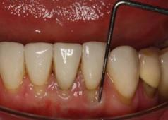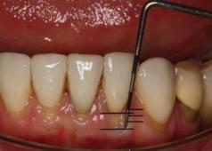
The markings on the PCP 12 probe show that the recession is 2.5 mm.
Vitality testing using an electric pulp tester may be appropriate where a perio-endo lesion is suspected (see Section 5.8).

2.5 Use of Radiographs
The main purpose of radiographic examination in periodontology is to provide information for diagnosis and treatment planning. Radiographs allow the practitioner to assess the level of alveolar bone, to view the periodontal ligament space and periapical region and to identify sub-gingival calculus and defective restorations. Radiographs are also useful in assessing the root length and morphology and the remaining bone support of periodontally involved teeth, including assessment of furcation involvement of molar teeth (see figures 2.14 and 2.15).

Figure 2.14 Use of periapical radiographs
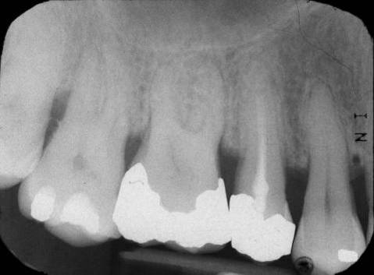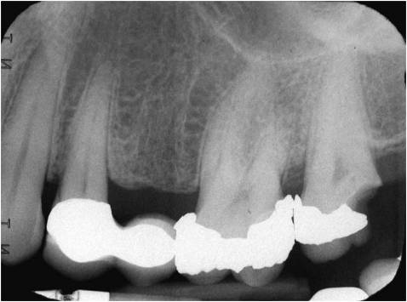
A B
These periapical radiographs, taken using the long cone paralleling technique, show:
A. horizontal bone loss of up to 50% of root length; calculus on root surfaces 17D/18M; inadequate root canal treatment 15;
B. horizontal bone loss 26D/27M of 15% of root length; overhanging restorations 26M, 26D, 27M; fractured restoration/secondary caries 27D.
As with all radiographic examinations, radiographs taken for the purpose of assessing periodontal disease must be clinically justified (with the information required unable to be obtained by other lower-risk methods), must follow a full clinical examination and must provide clearly defined benefits to the patient. In some cases, the clinical examination alone is sufficient for diagnosis and treatment planning, and existing radiographs, including those taken for caries assessment, can often provide sufficient information on the alveolar bone level such that further radiographs are not required.
Figure 2.15 Use of panoramic radiographs
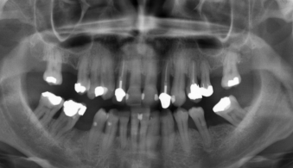
This good quality panoramic radiograph shows a heavily restored dentition with generalised horizontal bone loss of up to 50% of root length; multiple infrabony defects; furcation involvement of the lower molars; periapical area 24 and widened periodontal ligament space 35.
In the Faculty of General Dental Practice (UK) [FGDP(UK)] good practice guideline Selection Criteria for Dental Radiography,¹⁴ the expert panel acknowledged that there was a lack of research evidence to allow them to make robust, evidence-based recommendations on radiographic selection criteria for periodontology. The recommendations in the FGDP(UK) guideline are therefore based on expert opinion.
RECOMMENDATIONS
Based on the 2013 FGDP(UK) guideline,¹⁴ if radiographs are indicated:
- For uniform probing depths ≥4 and <6 mm and little or no recession, take horizontal bitewing radiographs. If the anterior teeth are affected, take intra-oral periapical views using the long cone paralleling technique.
- For probing depths ≥6 mm, take intra-oral periapical views of all affected teeth using the long cone paralleling technique.
- For irregular probing depths, take horizontal bitewing radiographs and supplement these with intra-oral periapical radiographs taken using the long cone paralleling technique.
- If a perio-endo lesion is suspected, take an intra-oral periapical radiograph using the long cone paralleling technique.
- Where large numbers of intra-oral periapical radiographs are required, consider taking a panoramic radiograph if there is access to a good quality/low dose panoramic machine.
Note that cone beam computed tomography (CBCT) is not indicated as a routine method of imaging periodontal bone support.
Radiographic Periodontal Assessment
From a medico-legal standpoint, it is important to record in the patient’s clinical record a thorough assessment of any radiographs. From a periodontal perspective this will include:
- the degree of bone loss - if the apex is visible this should be recorded as a percentage;
- the type of bone loss - horizontal or angular infrabony defects;
- the presence of any furcation defects;
- the presence of sub-gingival calculus;
- other features including perio-endo lesions, widened periodontal ligament spaces, abnormal root length or morphology, overhanging restorations, caries.
The SDCEP Practice Support Manual¹⁵ provides further information on the use of radiography in dental practice.

2.6 Treatment Planning
Once the level of periodontal disease has been diagnosed, a treatment plan with defined therapeutic goals is required. The management of periodontal disease is a continuous process of re-assessment and treatment plans can change depending on patient motivation and response to treatment.
RECOMMENDATIONS
- Take into account the results of the basic periodontal examination, any further in-depth periodontal examination and patient-specific factors.
- Consider consulting a colleague or a specialist for advice to assist with diagnosis and treatment planning.
- Ensure the treatment plan has defined therapeutic goals.
- Explain to the patient what treatment you wish to provide, what this involves and the potential benefits of successful treatment; stabilisation of the disease and reduced risk of tooth loss. Also explain what the consequences of no treatment may be.
  - Using outcomes such as non-bleeding gums, fresher breath and retained teeth may mean more to some patients than a discussion of probing depths and bone loss.
- Explain to the patient his/her role in improving periodontal health.
  - Make clear that periodontitis is a chronic condition that needs to be managed.
  - Emphasise that management of the disease is a partnership between patient and clinician and requires a life-long commitment.
- If treatment involves referral to another healthcare professional, for example, referral to secondary care:
  - Carry out initial therapy, including oral hygiene demonstration (see Section 3.2), supra-gingival debridement and root surface instrumentation (see Section 5.1);
  - Ensure that the patient is motivated to achieve and maintain effective plaque removal;
  - Ensure that if the patient smokes you have addressed this with him/her.
Section 8 provides further information on referral.
- Ensure that the patient is periodontally stable before any advanced or complex procedures are planned (e.g. implant placement).
- Ensure that patients with a history of periodontitis who are considering dental implants are fully informed about the increased risk of complications due to their oral health history.
Providing Treatment on Prescription From a Dentist
With the introduction of Direct Access, dental hygienists and therapists may provide a diagnosis and treatment plan for a patient if competent to do so. They may therefore provide treatment for patients without a prescription from a dentist. However, some dental hygienists and therapists may choose to continue to provide treatment on prescription from a dentist (more information is provided in Appendix 2). In this situation, the key to a successful clinical partnership is excellent communication. It is vital that the referring dentist communicates in detail to the dental hygienist or therapist the level of treatment required for each referred patient. Accordingly, the dental hygienist or therapist should provide feedback about the patient’s response to treatment and compliance with oral hygiene behaviour change intervention. Thorough record keeping will facilitate this (see Section 9). Good communication with the patient about the role of the dental hygienist or therapist in his/her care is also important.
Prescribing Local Anaesthesia
Local anaesthesia may be beneficial for some patients during non-surgical periodontal therapy. However, unless a Patient Group Direction (PGD)§ is in place, a Patient Specific Direction (PSD) is required from a suitably qualified prescriber (usually a doctor or dentist) if local anaesthesia is to be administered by a dental hygienist or dental therapist. This includes those dental hygienists and therapists providing treatment under direct access. The PSD should include:
- type of anaesthesia;
- maximum dosage;
- site specificity.
RECOMMENDATIONS
Dentist
- Ensure you are familiar with the most recent scope of practice for both dental hygienists and dental therapists.
- Provide an individualised treatment prescription (see Appendix 2) that is specific to the patient.
- Ensure that the patient is aware why he/she has been referred to the dental hygienist or therapist and what to expect during treatment (e.g. whether local anaesthesia will be given).
Dental Hygienist or Therapist
- Carry out treatment according to the treatment prescription (see Appendix 2). Should treatment needs differ from the original treatment prescription, liaise with the referring dentist.
- Record in the patient’s clinical notes a detailed account of the treatment carried out and any advice given, an indication of the clinical response to any previous treatment and the level of compliance with oral hygiene behaviour change intervention.
- Arrange a review appointment with the referring dentist.

3 Changing Patient Behaviour

KEY RECOMMENDATIONS
- Use the Oral Hygiene TIPPS behaviour change strategy to address inadequate plaque removal.
- Raise the issue of smoking cessation where appropriate.
- Encourage patients to modify other lifestyle factors that may impact on their oral health.

3.1 Changing Patient Behaviour
Both the prevention of periodontal diseases and the maintenance of the periodontal tissues following initial treatment rely on the ability and willingness of the patient to perform and maintain effective plaque removal. This may require a change in the patient’s behaviour in terms of brushing, interdental cleaning and other oral hygiene techniques, as well as other lifestyle behaviours such as tobacco use and diet.
EVIDENCE SUMMARY
There has been much research into the best way to induce patient behaviour change with regards to oral hygiene.¹⁶⁻²¹ Advice which is individualised, with the content tailored to suit each patient, has been shown to be effective²² and the use of action plans can also help the patient change his/her oral hygiene behaviour.²³ Further discussion of the evidence relevant to this topic is provided in Section 10.1.
It is important to appreciate that the motivation to change behaviour has to originate from the patient; patients must want to improve their oral hygiene and must feel that they have the skills required to do this. It is the role of the dentist, dental hygienist or dental therapist to encourage the patient to change and to teach the required plaque removal skills using communication techniques that engage and stimulate.

3.2 Oral Hygiene TIPPS
Oral Hygiene TIPPS is modelled on patient behaviour change strategies which have been shown to be effective at improving oral hygiene behaviour when carried out in primary care.²⁴
This intervention is based on behavioural theory and aims to make patients feel more confident in their ability to perform effective plaque removal and help them plan how and when they will look after their teeth and gums. This may involve identifying a trigger which will remind patients to perform oral hygiene tasks, for example, to brush their teeth and to floss before going to bed. The intervention can be delivered by any suitably qualified member of the dental team and should be followed up and built upon at each return appointment.
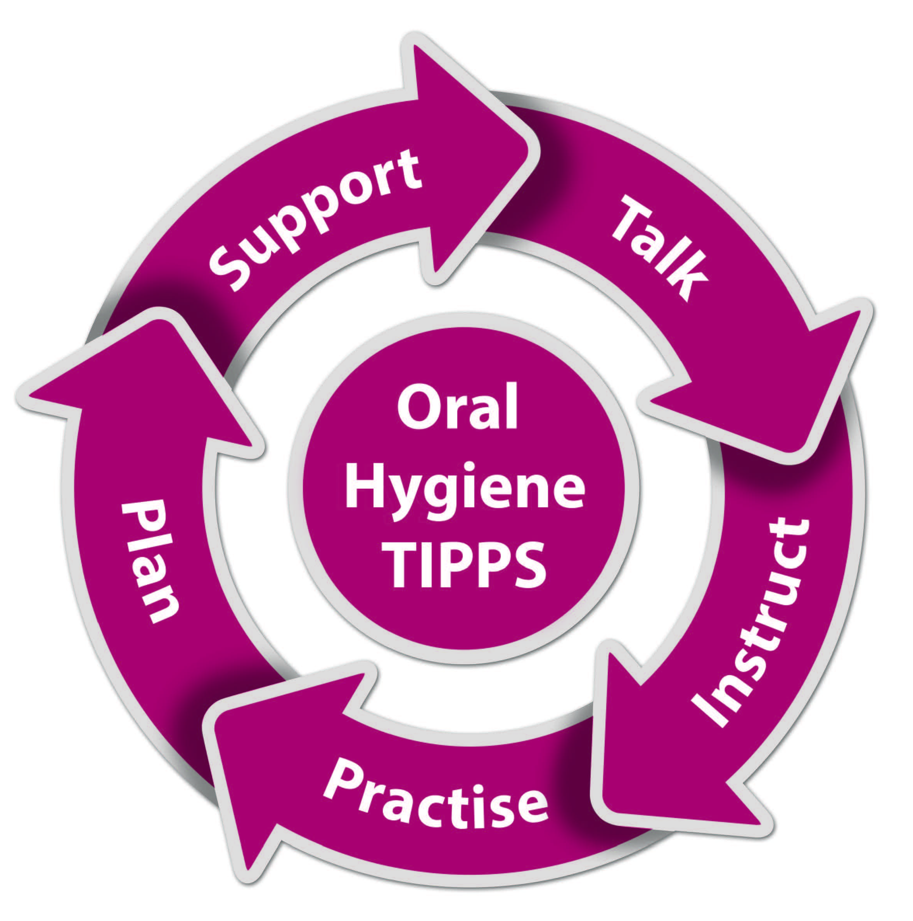
The goal of the intervention is to:
- talk with the patient about the causes of periodontal disease and discuss any barriers to effective plaque removal;
- instruct the patient on the best ways to perform effective plaque removal;
- ask the patient to practise cleaning his/her teeth and to use the interdental cleaning aids whilst in the dental surgery;
- put in place a plan which specifies how the patient will incorporate oral hygiene into daily life;
- provide support to the patient by following up at subsequent visits.
Each session of advice will take several minutes to deliver, depending on the patient. It is important to gauge the level of understanding of the patient and adjust your communication style and method to suit him/her. The best way of delivering the advice is to include a ‘hands-on’ demonstration of plaque removal techniques and for the patient to practise in front of the clinician. However, it is important to ensure that you have the patient’s consent to proceed.

Oral Hygiene Aids/Tools
Talking with patients about plaque removal may involve a discussion about interdental cleaning aids, toothbrushes and toothpaste. Studies have been performed to assess the efficacy of such oral hygiene tools.
EVIDENCE SUMMARY
A Cochrane Review²⁵ found evidence that flossing in addition to toothbrushing reduces gingivitis compared with toothbrushing alone, although the effect of flossing on plaque levels is less clear. There is also evidence that using interdental brushes in addition to toothbrushing is more effective at reducing plaque and gingivitis than using floss.²⁶⁻²⁸ There is evidence that rechargeable powered toothbrushes reduce plaque and gingivitis indices more than manual toothbrushes^{29,30} and that fluoride toothpastes which also contain triclosan and a co-polymer are more effective at reducing plaque and gingivitis indices.³¹ However, the clinical relevance of all these reductions is unclear. Further discussion of the evidence relevant to this topic is provided in Sections 10.2, 10.3 and 10.4.
RECOMMENDATIONS
Where a patient’s oral hygiene requires improvement, the following Oral Hygiene TIPPS behaviour change strategy should be used.
TALK
- Talk with the patient about the causes of periodontal disease and why good oral hygiene is important.
  - Use of a visual aid may help patients understand the disease process and the effects of plaque on the periodontal tissues.
- Talk with the patient about what he/she has to do to achieve good plaque removal.
  - Brush regularly using an effective technique.
    - Brushing twice a day for at least 2 minutes will ensure that all tooth surfaces are adequately cleaned.
    - Both manual and rechargeable powered toothbrushes are effective for plaque removal when used correctly. Evidence suggests that rechargeable powered toothbrushes are better than manual toothbrushes at reducing plaque and gingivitis indices but the clinical relevance of these reductions is unclear.
    - Manual and rechargeable powered toothbrush heads should be small and of a medium texture and should be changed when obvious signs of wear appear.
  - Use a fluoride-containing toothpaste and ‘spit don’t rinse’ during tooth cleaning.
    - Evidence suggests that fluoride toothpastes which also contain triclosan and a co-polymer are more effective at reducing plaque and gingivitis indices but the clinical relevance of these reductions is unclear.
  - Clean interdentally once a day.
    - Evidence suggests that flossing in combination with toothbrushing may reduce gingivitis indices more than toothbrushing alone but the clinical relevance of these reductions is unclear.
    - Evidence suggests that interdental brushes may be more effective than floss at reducing plaque and gingivitis indices in sites where the interdental space allows their use but the clinical relevance of these reductions is unclear.
    - To be effective, the brush should fit snugly into the interdental space without the wire rubbing against the tooth. More than one size of interdental brush may be required depending on the sizes of the interdental spaces present.
INSTRUCT
- Instruct the patient in the use of the oral hygiene tools.
- Demonstrate, in the patient’s mouth while he/she holds a mirror, how to systematically clean each tooth using a toothbrush (manual or rechargeable powered) as well as how to use floss and/or interdental brushes. If appropriate, advise the patient to wear his/her spectacles (including reading glasses) while cleaning his/her teeth.
- Confirm that the patient knows what to do. If he/she does not, show the patient again.
PRACTISE
- Ask the patient to practise i.e. to clean his/her teeth in front of you.
  - This provides an opportunity to correct the patient’s technique if required and ensures that the patient has really understood what he/she needs to do.
  - Confirming that the patient is doing the task well will boost confidence and also help him/her to remember when at home.
- Ask the patient for some feedback.
  - Ask how his/her teeth feel, as clean teeth should feel smooth to the tongue.
  - Address any concerns the patient has if there is bleeding after brushing or interdental cleaning.
    - Gums may bleed more than normal in the first few days of using the correct oral hygiene technique and in patients who have recently stopped smoking.
PLAN
- Help the patient plan how to make effective plaque removal a habit.
  - Ask the patient when would be the best time for him/her to brush and clean interdentally. Suggest using another regular activity as a reminder – such as immediately before going to bed and after getting up.
- To act as an incentive for the patient, tell him/her that you will ask at the next visit, for example:
  - “Have you tried using interdental cleaning aids?”
  - “How did your action plan work?”
SUPPORT
- Ensure you support the patient to achieve effective plaque removal by following-up on the advice at subsequent appointments.
It is important that the intervention does not become a lecture but is an empathetic and non-judgemental conversation between two adults. The intervention is not intended to be a once only delivery of advice but an ongoing discussion between you and your patient throughout the time he/she attends your practice. The oral hygiene advice delivered in the intervention can also be adapted to each individual patient, for example where a patient appears to be an effective brusher but rarely or never uses interdental cleaning aids the advice can be tailored to specifically discuss these points.
A video which demonstrates the Oral Hygiene TIPPS behaviour change intervention is available to view at www.sdcep.org.uk. A visual aid illustrating the stages of periodontal diseases from health to severe periodontitis, which may be useful when discussing the importance of good oral hygiene with patients, is included at the rear of this publication and can also be accessed at www.sdcep.org.uk.

3.3 Smoking Cessation
Smoking is a widely-accepted risk factor for periodontitis and patients who smoke do not respond to periodontal treatment as well as non-smokers and are also more likely to lose teeth. Tobacco use is also a risk factor for oral cancer and is related to a number of other medical problems. The NHS Health Scotland publication A Guide to Smoking Cessation in Scotland 2010³² states that:
“All health and health-related staff should raise the issue of stopping smoking in their day-to-day work with patients and clients and, where appropriate, refer them on to local services to help them stop.”
Dentists and dental care professionals have been identified as being well-placed to help patients stop smoking due to the large proportion of the population who visit for regular check-ups, including key groups such as teenagers and pregnant women. Dental professionals are not expected to provide detailed specialist support, as this is best delivered by trained smoking cessation counsellors, but should encourage patients who smoke to consider the risks of smoking and the benefits of stopping. Smokeless oral tobacco products, widely used by some minority ethnic groups, are also harmful to health therefore patients who use these products should be encouraged to quit (see Oral Health and Trans-cultural Tobacco, an audio-visual resource available at www.ashscotland.org.uk/ash/8210). Offer advice to stop smoking that is sensitive to the patient’s preferences, needs and circumstances.
Taking a few minutes to raise the issue of smoking and tobacco use with your patients may trigger a successful attempt at quitting.
A Brief Intervention Flowchart which details the structure of a brief intervention to encourage smoking cessation is provided in Appendix 3.
RECOMMENDATIONS
- Ask the patient if he/she (still) smokes (or uses smokeless tobacco) and record the response.
  - If the patient states that he/she has given up, congratulate this achievement. Remind the patient that stop smoking services are always available if he/she is finding it difficult to remain a non-smoker.
- Ask if the patient has considered the effect smoking has on his/her oral health and general health and the benefits of stopping.
  - Inform the patient that stopping smoking is the single most important thing he/she can do to improve not only oral health but general health as well. Appendix 4 gives further advice on points you may wish to cover.
  - Offer a copy of ‘Aspire’ magazine and any other relevant health promotion material. ‘Aspire’, is available to download at www.healthscotland.com/documents/313.aspx.
- Ask if the patient is interested in stopping smoking.
  - Some patients may not wish to stop smoking; accept this in a non-judgemental way, but leave the offer of future help open if the patient changes his/her mind.
- Offer patients who are interested in stopping smoking information on local smoking cessation services as these increase their chances of a successful quit attempt.
Smoking cessation services are available from every community pharmacy in Scotland and specialist services are also offered by smoking cessation advisors throughout Scottish health board areas. Details and information about the services available in your local area can be found at www.canstopsmoking.com.

3.4 Other Lifestyle Factors
There is convincing evidence that a high sugar diet is a risk factor for dental caries and that a high level of alcohol consumption is a risk factor for cancers of the mouth, larynx, pharynx and oesophagus, as well as many other chronic diseases. Emerging evidence also suggests that diet, obesity and level of physical activity are associated with periodontitis and that diet may influence the outcome of periodontal therapy.
Patients should be encouraged to eat a healthy balanced diet which is high in vegetables, fruit and starchy foods and low in sugar, salt and fat, to drink adequate water and to take regular exercise. SIGN Guideline 74³³ recommends the delivery of brief interventions for harmful and hazardous drinkers in primary care as evidence suggests these are effective in reducing alcohol consumption. Recent guidance published by NHS Health Scotland³⁴ details how the issue of alcohol can be raised with patients in a dental setting.
Addressing such issues with a patient requires sensitivity and it may be useful to deliver advice in the context of how changes to their diet and/or alcohol consumption will help the patient care for his/her oral tissues.
RECOMMENDATIONS
- Encourage your patient to eat healthily by including plenty of vegetables and fruit in his/her diet every day and to base meals on wholegrain, starchy foods.
  - Further guidance on healthy eating is covered in the NHS Health Scotland publication Oral Health and Nutrition Guidance for Professionals published in 2012.³⁵
- Include in your discussion the benefits of regular exercise.
- Assess your patient’s alcohol consumption. Ask about his/her average weekly alcohol consumption and maximum daily consumption in the last week and convert into units.
  - The recommended limit for men is 21 units of alcohol per week, with no more than 4 units in any one day; the recommended limit for women is 14 units of alcohol per week, with no more than 3 units in any one day (see Appendix 5 for alcohol unit definitions; an online alcohol unit calculator is available at www.drinkaware.co.uk).
- If a patient is drinking alcohol excessively and is willing to discuss this with you, outline the possible harmful effects of excessive alcohol consumption and advise the patient to see his/her general medical practitioner and/or to visit the Alcohol Focus Scotland website (www.alcohol-focus-scotland.org.uk) for further advice and help.

4 Treatment of Gingival Conditions

KEY RECOMMENDATIONS
- Ensure the patient is able to perform optimal plaque removal.
- Remove supra-gingival plaque, calculus and stain and sub-gingival deposits.
- Ensure that local plaque retentive factors are corrected.

4.1 Plaque-Induced Gingivitis
Gingivitis is plaque-induced inflammation of the gingivae characterised by red, swollen tissues that bleed on brushing or probing. Oedema or hyperplasia of the gingival tissues can result in false pocketing. However, the condition is not associated with apical migration of the junctional epithelium or connective tissue attachment loss and alveolar bone destruction. Clinical signs are visible after around seven days of undisturbed plaque accumulation and the severity of the inflammatory response is greater in older people than in the young. The condition is reversible after the establishment of effective plaque removal (see figure 4.1).
EVIDENCE SUMMARY
A review of current evidence suggests that routine supra-gingival instrumentation may result in a reduction in plaque levels and gingival bleeding.^{36,37} There is evidence that simultaneous oral hygiene instruction increases the effectiveness of the treatment.³⁶ Further discussion of the evidence relevant to this topic is provided in Section 10.5.
The majority of gingival conditions can be treated using non-surgical periodontal therapy (see Section 5.1). The most appropriate methods for removal of plaque and calculus deposits will depend both on the nature and location of the deposits as well as clinician and patient preferences. Supra-gingival soft deposits (plaque) can be removed by brushing (see Section 3.2). Both supra-gingival and sub-gingival hard deposits (calculus) and sub-gingival plaque can be removed using hand instruments or a powered scaler (sonic or ultrasonic).
Figure 4.1 Gingivitis
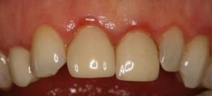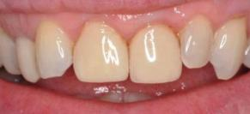
A B
This patient developed gingivitis due to poor plaque removal (A). Following treatment, the inflammation almost completely resolved although slight residual inflammation was observed around the veneers 11/21 which had a poor marginal fit (B).
RECOMMENDATIONS
- Explain to the patient that untreated gingivitis is a risk factor for periodontitis, which can lead to tooth loss, but that he/she can reduce this risk with good oral hygiene.
- Use the Oral Hygiene TIPPS behaviour change strategy to highlight the importance of effective plaque removal and to show the patient how he/she can achieve this (see Section 3.2). Where applicable, give smoking cessation advice (see Section 3.3).
- Remove supra-gingival plaque, calculus and stain and sub-gingival deposits using an appropriate method (see Section 5.1). Highlight to the patient areas where supra-gingival deposits are detected.
- Ensure that local plaque retentive factors are corrected - for example, remove overhanging restorations or alter denture design (see Section 5.2).
- Re-assess at a future visit to determine whether the gingivitis has resolved.

4.2 Drug-induced Gingival Enlargement
Patients taking certain drugs for existing conditions such as calcium channel blockers for hypertension, phenytoin for epilepsy and ciclosporin, an anti-rejection drug which can also be prescribed for some autoimmune disorders, may be at risk of drug-induced gingival enlargement (see figure 4.2). In many cases, the condition will respond to non-surgical treatment but in more severe cases modification of the drug regimen by the patient's physician may be considered. Periodontal surgery may also be required to reduce and recontour the gingival enlargement. However, the condition may recur in susceptible individuals and the surgery may need to be repeated.
Figure 4.2 Examples of drug-induced gingival enlargement
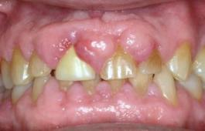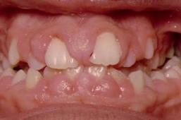
RECOMMENDATIONS
- Ensure you have an up to date medical history for all patients.
- Where there is mild gingival enlargement, use the Oral Hygiene TIPPS behaviour change strategy to highlight the importance of effective plaque removal and to show the patient how he/she can achieve this (see Section 3.2). Where applicable, give smoking cessation advice (see Section 3.3).
- Remove supra-gingival plaque, calculus and stain and sub-gingival deposits using an appropriate method (see Section 5.1). Highlight to the patient the areas where supra-gingival deposits are detected.
- Ensure that local plaque retentive factors are corrected - for example, remove overhanging restorations or alter denture design (see Section 5.2).
- Where the gingival enlargement hinders adequate plaque removal or interferes with the normal function of the oral cavity, consider consulting the patient’s physician or referring for specialist periodontal care.
- Re-assess at a future visit to determine whether the gingival enlargement has resolved.

4.3 Pregnancy-associated Gingivitis
The changes in hormone levels and to the immune response associated with pregnancy have been implicated in the development or worsening of gingivitis. In most patients this can be managed with adequate oral hygiene but more severe cases of gingival enlargement may require further professional care. Most cases will resolve after delivery of the baby, although breastfeeding can extend the duration of the condition.
RECOMMENDATIONS
- Where the condition is mild, use the Oral Hygiene TIPPS behaviour change strategy to highlight the importance of effective plaque removal and to show the patient how she can achieve this (see Section 3.2). Where applicable, give smoking cessation advice (see Section 3.3).
- Where the condition is severe, give oral hygiene and smoking cessation advice as detailed above. Remove supra-gingival plaque, calculus and stain and sub-gingival deposits using an appropriate method (see Section 5.1). Highlight to the patient areas where supra-gingival deposits are detected. These patients may require more frequent recall visits during pregnancy and additional care.
- Ensure that local plaque retentive factors are corrected - for example, remove overhanging restorations or alter denture design (see Section 5.2).
- Explain to the patient that the condition is likely to resolve once her baby is born or following the cessation of breastfeeding, assuming her oral hygiene is adequate.
- Re-assess at a future visit to determine whether the gingivitis has resolved.

4.4 Puberty-associated Gingivitis
Gingivitis is commonly observed in pre-teens and young teenagers where the increased inflammatory response to plaque is thought to be aggravated by the hormonal changes associated with puberty. As with pregnancy gingivitis, the presentation may vary between individuals and in some cases marked gingival enlargement can occur.
RECOMMENDATIONS
- In cases of puberty gingivitis and mild gingival enlargement associated with puberty, use the Oral Hygiene TIPPS behaviour change strategy to highlight the importance of effective plaque removal and to show the patient how he/she can achieve this (see Section 3.2). Where applicable, give smoking cessation advice (see Section 3.3).
- Remove supra-gingival plaque, calculus and stain and sub-gingival deposits using an appropriate method (see Section 5.1). Highlight to the patient areas where supra-gingival deposits are detected.
- Ensure that local plaque retentive factors which may hinder oral hygiene efforts, such as overhanging restorations, are corrected (see Section 5.2). Ensure patients are able to clean effectively around fixed orthodontic appliances.
- Where the gingival enlargement hinders adequate oral hygiene or interferes with the normal function of the oral cavity, consider referring to a consultant in paediatric dentistry, consultant in restorative dentistry or specialist periodontist.
- Re-assess at a future visit to determine whether the gingivitis or gingival enlargement has resolved.

4.5 Unexplained Gingivitis and Gingival Enlargement
Unexplained gingival enlargement, inflammation and bleeding can be a sign of undiagnosed leukaemia in both children and adults (see figure 4.3). In cases where gingivitis or gingival enlargement does not respond to treatment as expected or the extent of the condition is inconsistent with the level of oral hygiene observed, consider urgent referral to a physician.

Figure 4.3 Unexplained gingival enlargement and gingivitis
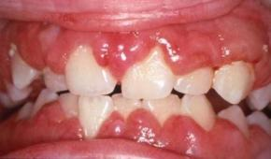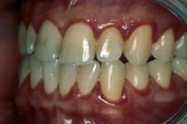
A B
Image A shows gingival enlargement as a result of acute myeloid leukaemia. Image B shows marginal gingivitis, due to neutropenia, in a leukaemia patient awaiting bone marrow transplant. The patient had scrupulous oral hygiene. (Images kindly provided by Prof. Richard Welbury)

5 Treatment of Periodontal Conditions

KEY RECOMMENDATIONS
- Ensure the patient is able to perform optimal plaque removal.
- Remove supra-gingival plaque, calculus and stain and correct any local plaque retentive factors. Carry out root surface instrumentation at sites ≥4 mm probing depth where sub-gingival deposits are present or which bleed on probing.
- Do not use antimicrobial medication to treat chronic periodontitis.

5.1 Non-surgical Periodontal Therapy
Non-surgical periodontal therapy begins by motivating and instructing the patient in adequate self care, followed by re-evaluation of his/her level of oral hygiene. Non-surgical instrumentation to disrupt the plaque biofilm and remove calculus to give a clean, smooth tooth/root surface can then be completed both supra- and sub-gingivally. However, it is not the intention to deliberately remove tooth substance. Other plaque retentive factors, such as stain and overhanging restorations, also need to be removed or adjusted (see Section 5.2). Removal of stain, such as that caused by tobacco, can often motivate patients to improve their oral hygiene. If the patient can achieve good personal oral hygiene, then non-surgical therapy can be highly effective in stabilising periodontal health (see figure 5.1).
Figure 5.1 Generalised aggressive periodontitis
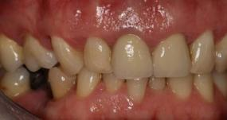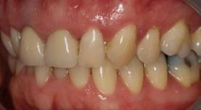
A B
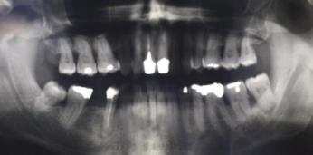
C
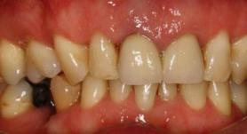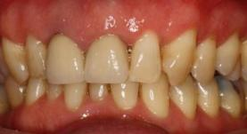
D E
Images A and B show a patient with generalised aggressive periodontitis before treatment. The panoramic radiograph (C) shows severe generalised horizontal bone loss of up to 50% of root length with an infrabony defect 48M, failed root canal treatment 45, pulp stones, perio-endo lesion 38 and calculus on the root surfaces between the molar teeth. Images D and E show the patient following treatment. Note the improvement in the appearance of the gingivae with a reduction in inflammation, redness and swelling.
EVIDENCE SUMMARY
Key to the success of non-surgical periodontal therapy is regular re-enforcement of oral hygiene advice, regular, effective removal of the plaque biofilm³⁸⁻⁴¹ and, where applicable, smoking cessation advice to bring about a life-long change in patient behaviour. Further discussion of the evidence relevant to this topic is provided in Section 10.6.
The goal of non-surgical periodontal treatment is to achieve signs of periodontal stability which are easy to sustain. Optimal outcomes are plaque scores of below 15%,^{42,43} bleeding scores of below 10%^{42,43,44} and probing depths of less than 4 mm.^{45,46} However, it is recognised that this level of improvement may not be achievable for all patients. Patients with significantly improved oral hygiene, reduced bleeding on probing and a considerable reduction in probing depths from baseline can be considered to have responded successfully to treatment and may progress to supportive periodontal therapy (see Section 6).
RECOMMENDATIONS
- Explain to the patient the potential benefits of successful treatment: stabilisation of the disease and reduced risk of tooth loss.
- Explain to the patient his/her role in improving periodontal health.
  - Make clear that periodontal disease is a chronic condition that needs to be managed.
  - Emphasise that management of the disease is a partnership between patient and clinician and requires a life-long commitment.
- Use the Oral Hygiene TIPPS behaviour change strategy to highlight the importance of effective plaque removal and to show the patient how he/she can achieve this (see Section 3.2). Where applicable, give smoking cessation advice (see Section 3.3). Emphasise that due to the patient’s history of periodontitis, he/she is highly susceptible to even very small amounts of plaque.
- Remove supra-gingival plaque, calculus and stain using an appropriate method. Ensure that local plaque retentive factors are corrected (see Section 5.2). Highlight to the patient areas where supra-gingival deposits are detected.
- Carry out root surface instrumentation at sites of ≥4 mm probing depth where sub-gingival deposits are present or which bleed on probing. Local anaesthesia may be required for this.
- Advise the patient that he/she may experience some discomfort and sensitivity following treatment and to expect some gingival recession as a result of healing.
- Carry out a full periodontal examination (see Section 2.4) a minimum of eight weeks after treatment.
Nomenclature
In this guidance, the cleaning of the sub-gingival root surface is termed root surface instrumentation (RSI). It can equally be called root surface debridement (RSD). This technique aims to mechanically remove microbial plaque and calculus without any intentional removal of the root surface. However, it is accepted that since root surface instrumentation is conducted blind, some removal of the root surface cementum may inadvertently occur.
Instrumentation
Root surface instrumentation (RSI) can be performed using either hand instruments or powered scalers (sonic or ultrasonic) (see figure 5.2). Successful utilisation of these instruments requires a thorough understanding of root anatomy and knowledge of which instrument works best in a particular area.
Figure 5.2 Periodontal instruments
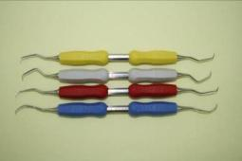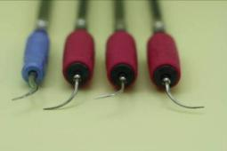
A B
Image A shows site-specific Gracey curettes. Image B shows various ultrasonic scaler inserts; a blue universal supra-gingival scaler tip and pink fine scaler tips for sub-gingival instrumentation, including curved furcation tips.
EVIDENCE SUMMARY
There is no evidence of a difference in the quality of debridement achieved by using hand instruments or powered scalers if both methods are performed effectively. Although effective instrumentation by either method takes time, powered RSI can be more efficient, taking 36% less time than debridement using hand instruments.⁴⁷ Further discussion of the evidence relevant to this topic is provided in Section 10.7.
- Ensure that all instruments are used appropriately and that site-specific instruments are used where required (see figure 5.3).
- Do not apply the pointed end of sonic and ultrasonic tips to the root surface; use only the sides of the working tip for debridement without applying lateral pressure.
- Use overlapping strokes to instrument all of the affected root surface.
Figure 5.3 Removal of sub-gingival calculus using a curette
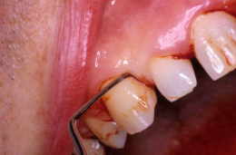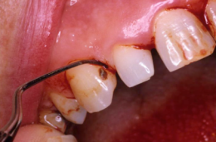
Images kindly provided by Dr Bill Jenkins.
Instrument Maintenance
The effective removal of calculus using hand instruments results in a dulling of the cutting edge of the blade. Studies have shown that this can result in a less effective cutting edge after relatively few strokes. Hand instruments, therefore, require meticulous maintenance to ensure they remain fit for purpose (see figure 5.4). Sharpening of such instruments requires both skill and knowledge of the design characteristics of each type of instrument. Instruments can only be sharpened a finite number of times before they must be replaced due to the risk of fracture of the blade.
Powered scalers also require frequent maintenance to ensure optimum performance (e.g. tuning). The tips of powered instruments also wear with use and should be inspected regularly. It is estimated that approximately 2 mm of wear equates to around a 50% loss of performance.⁴⁸

Figure 5.4 Instrument sharpening
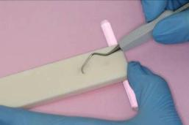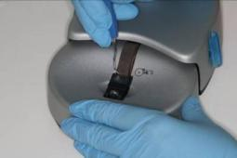
A B
Image A shows sharpening of a hand instrument using a sharpening stone. Image B shows sharpening of a hand instrument using a powered instrument sharpener.
RECOMMENDATIONS
- Keep hand instruments sharp and discard those which have reached the end of their useful life.
- Follow the manufacturer’s instructions for maintenance of sonic and ultrasonic instruments.
- Do not place ultrasonic inserts in an ultrasonic bath as there is risk of damage to the stack.
- Discard sonic and ultrasonic tips which show visible signs of wear.
Treatment Duration
The actual time required to adequately instrument each tooth will depend on the level of deposits, the tooth type, the depth of the pocket, whether there is furcation involvement, the presence of challenging anatomy and the location in the mouth. It can take several minutes of instrumentation to effectively debride the root surface adjacent to a deep pocket around a single tooth.
Anaesthesia
Some patients experience pain during RSI due to root surface sensitivity and also because the base of pockets can be inflamed and painful. In some cases, supra-gingival plaque and calculus removal and improvement in oral hygiene can result in reduced inflammation and allow for less painful RSI at the following appointment. Tissue trauma can occur during RSI, causing pain during and after the treatment. The use of local anaesthesia can make patients more tolerant of treatment, especially when using ultrasonic instruments where the cold water required to cool the tip can cause sensitivity. Pain can also be reduced by using a proper instrumentation technique. Self-medication with analgesics prior to and following treatment can be useful.
There is some evidence to suggest that intra-pocket anaesthesia is not as effective as injection anaesthesia at controlling pain during instrumentation, although some patients may prefer to receive anaesthesia via the topical route.⁴⁹
Appointment Planning
Multiple appointments may be required to instrument adequately all affected root surfaces.
EVIDENCE SUMMARY
Treatment over one or two long appointments can be as effective as spreading the treatment over several shorter appointments⁵⁰⁻⁵² (usually no more than one week apart). Operator and patient fatigue, as well as the patient’s preferences, need to be considered when planning appointments. Further discussion of the evidence relevant to this topic is provided in Section 10.8.
It is not advised to adopt a process of removing some deposits from all root surfaces at one appointment, with the intention to revisit and remove remaining deposits at subsequent appointments. This is because initial healing, after the gross deposits have been removed, can make re-accessing the pocket more difficult and partial removal of deposits leaves behind rough areas which are ideal for bacterial proliferation. It is advised that the clinician concentrates on as many teeth, sextants or quadrants as can be thoroughly instrumented in the time available.
RECOMMENDATION
- Assess the level of deposits, extent of disease and patient preference to determine the number and length of appointments required for thorough debridement.

5.2 Management of Local Plaque-retentive Factors
Local plaque-retentive factors, such as mal-positioned teeth, overhanging restorations, crown and bridgework, partial dentures and fixed and removable orthodontic appliances can increase the risk of periodontal disease and can also prevent successful treatment and resolution of associated pockets (see figure 5.5). Where large amounts of supra-gingival calculus are present, removal of these deposits will also be necessary for effective personal oral hygiene to be achieved.
RECOMMENDATIONS
- Explain to patients with local factors such as crowded teeth, partial dentures, bridgework and orthodontic appliances, the importance of plaque removal in these areas.
- Give instruction on how to clean adequately around fixed restorations and fixed appliances and how to clean removable prostheses.
- Ensure that fixed and removable appliances are well-designed and that they are a good fit.
- Modify overhanging or poorly contoured restorations or replace the restoration.
- Consider orthodontic treatment or extraction for mal-positioned teeth.
Figure 5.5 Local plaque-retentive factors
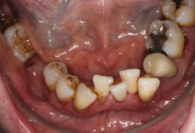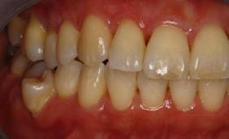
A B
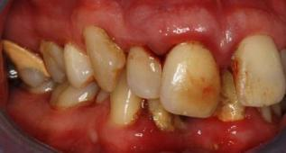
C
Image A shows crowded lower anterior teeth with supra-gingival calculus and staining. Image B shows a patient with generally good oral hygiene but visible plaque on the buccally positioned 45. Image C shows significant supra-gingival calculus on 16 and the lower anterior teeth.

5.3 Antimicrobial Medication
Full Mouth Disinfection
EVIDENCE SUMMARY
Full mouth disinfection is a treatment protocol which consists of instrumentation of all periodontal pockets in two visits within 24 hours in combination with the adjunctive use of chlorhexidine mouthwash and gel to disinfect any bacterial reservoirs in the oral cavity. It is proposed that this approach prevents the re-clonisation of recently instrumented pockets by bacteria from untreated pockets or other oral niches. However, a review of current evidence⁵⁰⁻⁵³ indicates that the use of disinfectants during root surface instrumentation does not result in any additional gains in terms of clinical outcomes compared with root surface instrumentation alone. Further discussion of the evidence relevant to this topic is provided in Section 10.9.
Local Antimicrobials
EVIDENCE SUMMARY
Local antimicrobials, including disinfectants such as chlorhexidine and locally-delivered antibiotics, have been proposed as both a stand alone therapy for the the treament of chronic periodontitis and as adjuncts to root surface instrumentation. Numerous delivery systems and formulations are available. A review of current evidence⁵⁴⁻⁵⁹ indicates that the use of local antimicrobials to manage chronic periodontitis in primary care does not result in improved clinical outcomes compared with those achieved by root surface instrumentation alone. Further discussion of the evidence relevant to this topic is provided in Section 10.10.
Systemic Antibiotics
EVIDENCE SUMMARY
Systemic antibiotics, prescribed as an adjunct to root surface instrumentation, have been proposed to act by suppressing the bacterial species responsible for biofilm growth, leading to a less pathogenic oral environment. Due to the increasing incidence of bacterial resistance and the numerous side effects associated with antibiotic therapy, antibiotics should only be prescribed where there is clear evidence that patients will benefit from them. A review of current evidence⁶⁰⁻⁶⁴ indicates that the adjunctive use of systemic antibiotics to treat chronic periodontitis in primary care does not result in clinically significant improvements to patient outcomes compared with those achieved by root surface instrumentation alone. There is also insufficient current evidence to support the use of antibiotics in the treatment of patients with periodontitis who smoke.⁶⁵
Systemic antibiotics may be appropriate in the management of aggressive periodontitis as an adjunct to meticulous self-care and professional instrumentation.⁶⁶ However, if a diagnosis of aggressive disease is made, the patient should be referred to a specialist. Further discussion of the evidence relevant to this topic is provided in Sections 10.11 and 10.12.
RECOMMENDATIONS
- Prescribing local antimicrobials is not recommended for the treatment of chronic periodontitis.
- Prescribing systemic antibiotics is not recommended for the treatment of chronic periodontitis.
- Refer patients with a diagnosis of aggressive periodontitis to a specialist.

5.4 Host Modulation Therapy
Host modulation therapy aims to modify the destructive aspects of the host’s immune-inflammatory response to the microbial biofilm by utilising the anti-inflammatory properties of sub-antimicrobial doses of the tetracyclines. Although it is suggested that the low antibiotic doses utilised by this treatment regime are not associated with the development of antibiotic resistance, host modulation therapy requires patients to take medication over long periods of time (e.g. nine months) and this may impact on compliance. The cost effectiveness of the therapy is also unclear.
EVIDENCE SUMMARY
A review of current evidence^{67,68} indicates that the use of host modulation therapy does not result in clinically significant improvements to patient outcomes compared to those achieved by root surface instrumentation alone. Further discussion of the evidence relevant to this topic is provided in Section 10.13.
RECOMMENDATION
- Prescribing host modulation therapy is not recommended for the treatment of chronic periodontitis.

5.5 Anti-plaque Mouthwashes
The best way for patients to remove supra-gingival plaque is effective use of a toothbrush and interdental cleaning aids. Anti-plaque mouthwashes have bacteriostatic and bacteriocidal activity and can inhibit the development of gingivitis. However, they have a much reduced effect on established plaque and cannot prevent the progression of periodontitis. There is also no evidence that sporadic use has any benefit to patients.
Anti-plaque mouthwashes can be used as a temporary primary oral hygiene measure or as an adjunct to toothbrushing and interdental cleaning for acute conditions where toothbrushing is painful. Chlorhexidine gluconate has been shown to completely inhibit supra-gingival plaque formation in a clean mouth when used as prescribed: rinsing with 10 ml of a 0.2% solution for one minute twice daily.⁶⁹ Other mouthwashes have been found to be less effective at reducing plaque⁷⁰⁻⁷² and some can also contain high levels of alcohol.
Chlorhexidine can cause staining of the teeth and tongue and some patients report a burning sensation in the mouth during, and following, use. As such, the use of chlorhexidine should be restricted to short term treatment of specific problems. It can also be diluted 1:1 with water with no loss of efficacy providing that the whole dose is administered. Sodium lauryl sulphate, a detergent found in most toothpastes, inhibits the action of chlorhexidine. For this reason patients should be advised to leave an interval of one hour between using the mouthwash and brushing.
RECOMMENDATION
- Only prescribe an anti-plaque mouthwash, such as 0.2% chlorhexidine gluconate, for patients where pain limits mechanical plaque removal (e.g. following sub-gingival instrumentation or for patients with acute conditions)ǂ.

5.6 Management of Dentine Sensitivity Following RSI
EVIDENCE SUMMARY
Some patients may experience increased dentine sensitivity following root surface instrumentation, especially those with sensitive teeth prior to treatment.⁷³ There are a large number of over-the-counter products available to patients that claim to reduce dentine sensitivity, such as toothpastes containing potassium salts, oxalates or arginine, but the efficacy of these is unclear.⁷⁴⁻⁷⁷ Further discussion of the evidence relevant to this topic is provided in Section 10.14.
RECOMMENDATIONS
- Prior to carrying out periodontal therapy, explain to the patient that his/her teeth may become more sensitive for a few weeks following therapy.
- Use the Oral Hygiene TIPPS behaviour change strategy to highlight the importance of effective plaque removal and to show the patient how he/she can achieve this (see Section 3.2).
- Advise the patient that proprietary desensitising toothpastes can be used to treat particular areas of sensitivity; a small amount is applied to the affected area with a finger last thing at night. Alternatively, a desensitising mouthwash may be of benefit. Emphasise to the patient the importance of having plaque-free dentine in order for the desensitising agent to be effective.
- Where a patient complains of acute sensitivity, consider other topical therapies in addition to desensitising toothpaste (e.g. prescribe a high fluoride toothpaste (2800 ppm) or apply fluoride varnish or a dentine bonding agent).

5.7 Management of Occlusal Trauma
Occlusal trauma associated with periodontitis should be managed by non-surgical periodontal treatment in the first instance. In cases where periodontally compromised teeth have overerupted or drifted, check the occlusion for the presence of fremitus or occlusal interference and eliminate as part of the periodontal treatment plan.

5.8 Management of Acute Conditions
Acute conditions should be managed using local measures in the first instance. Do not prescribe antibiotics unless there is evidence of spreading infection (cellulitis, lymph node involvement) or systemic involvement (fever, malaise). Where antibiotic therapy is indicated, refer to the SDCEP Drug Prescribing for Dentistry guidance for further details of drug regimens¥.
Periodontitis Associated with Endodontic Lesions
Combined perio-endo lesions occur where a patient not only has clinical attachment loss but also a tooth with a necrotic, or partially necrotic, pulp. These lesions can be difficult to diagnose, therefore a clinical examination and the use of special tests (radiographs and vitality tests) are required to assess both the periodontal (swelling, suppuration, rapid/isolated attachment loss) and endodontic (pulpal status, presence of fistula, tenderness to percussion) signs (see figure 5.6).
Figure 5.6 Radiograph showing perio-endo lesion
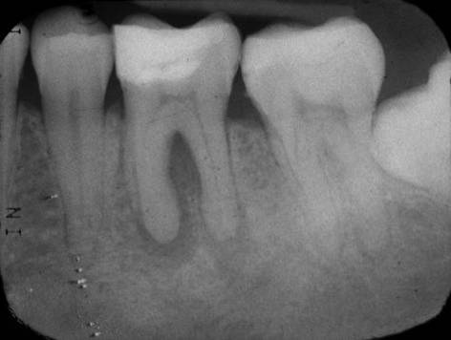
A peri-apical radiograph taken using the long cone paralleling technique shows tooth 36 with a perio-endo lesion involving both root apices and the furcation, mild horizontal bone loss of less than 10% of root length and a mesially impacted 38.
Treatment can involve both endodontic and periodontal treatment, although the endodontic source of infection must be eliminated with root canal treatment in the first instance.
RECOMMENDATIONS
- Carry out endodontic treatment of the affected tooth.
- Recommend optimal analgesia.
- Do not prescribe antibiotics unless there are signs of spreading infection or systemic involvement.
- Recommend the use of 0.2% chlorhexidine mouthwash until the acute symptoms subside.
- Following acute management of the lesion, review within ten days and carry out supra- and sub-gingival instrumentation if necessary and arrange an appropriate recall interval.
Some patients may find that a hot salt water mouthwash provides comfort.

Periodontal Abscess
Patients with periodontitis can, on occasion, present with localised pain and swelling due to non-draining infection of a periodontal pocket (see figure 5.7).
Figure 5.7 Periodontal abscess
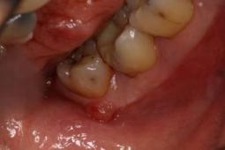
This mirror image shows a periodontal abscess on 38.
RECOMMENDATIONS
- Carry out careful sub-gingival instrumentation short of the base of the periodontal pocket to avoid iatrogenic damage; local anaesthesia may be required.
- If pus is present in a periodontal abscess, drain by incision or through the periodontal pocket.
- Recommend optimal analgesia.
- Do not prescribe antibiotics unless there are signs of spreading infection or systemic involvement.
- Recommend the use of 0.2% chlorhexidine mouthwash until the acute symptoms subside.
- Following acute management, review within ten days and carry out definitive periodontal instrumentation and arrange an appropriate recall interval.
Some patients may find that a hot salt water mouthwash provides comfort.
Necrotising Ulcerative Gingivitis and Periodontitis
Necrotising ulcerative gingivitis (NUG) is characterised by marginal gingival ulceration with loss of the interdental papillae and a grey sloughing on the surface of the ulcers (see figure 5.8). It is accompanied by a characteristic halitosis and is often painful. It is associated with anaerobic fuso-spirochaetal bacteria and is more common in patients who smoke, the immunosupressed and those with poor oral hygiene. Necrotising ulcerating periodontitis (NUP) is diagnosed in the presence of connective tissue attachment loss and bone destruction.
Figure 5.8 Necrotising ulcerative gingivitis
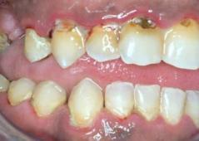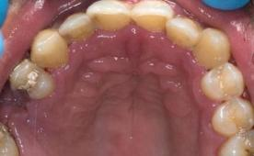
A B
Image A shows the right buccal view of a patient with necrotising ulcerative gingivitis. Image B shows the palatal view. Note the loss of the interdental papillae.
As an adjunct to local measures, metronidazole is the drug of first choice where there is systemic involvement or persistent swelling despite local measures.
RECOMMENDATIONS
- Use the Oral Hygiene TIPPS behaviour change strategy to highlight the importance of effective plaque removal and to show the patient how he/she can achieve this (see Section 3.2). Where applicable, give smoking cessation advice (see Section 3.3).
- Remove supra-gingival plaque, calculus and stain and sub-gingival deposits using an appropriate method (see Section 5.1); local anaesthesia may be required.
  - Due to the pain associated with the condition, the patient may only be able to tolerate limited supra- and sub-gingival debridement in the acute phase.
- Recommend the use of either 6% hydrogen peroxide or 0.2% chlorhexidine mouthwash until the acute symptoms subside.
- If there is evidence of spreading infection or systemic involvement, consider prescribing metronidazole¥.
- Following acute management, review within ten days and carry out further supra- and sub-gingival instrumentation as required and arrange an appropriate recall interval.
- If no resolution of signs and symptoms occurs, review the patient’s general health and consider referral to a specialist in primary or secondary care.

6 Long Term Maintenance

KEY RECOMMENDATIONS
- Ensure the patient is able to perform optimal plaque removal.
- Remove supra-gingival plaque, calculus and stain and sub-gingival deposits and ensure that local plaque retentive factors are corrected.
- Assign an individual risk level based on the patient’s medical history and oral health status and schedule recall appointments accordingly.

6.1 Long Term Maintenance
The key to successful prevention and treatment of periodontal diseases is life-long effective personal oral hygiene. Life-long preventive professional care may also be necessary for the patient to maintain healthy gingival tissues. Regular re-enforcement of the importance of effective plaque removal and, where applicable, smoking cessation advice is also required. In patients who have no previous history of periodontitis, this preventive professional maintenance regimen is termed dental prophylaxis^{ǂ}. In patients who have previously received treatment for periodontitis, the professional maintenance regimen is termed supportive periodontal therapy. Sufficient time is required at each recall appointment to carry out long term maintenance effectively and patients undergoing supportive periodontal therapy will require longer appointments than those receiving dental prophylaxis.
EVIDENCE SUMMARY
Although regular professional dental prophylaxis and supportive periodontal therapy have been shown to be effective in maintaining periodontal health, there is currently limited evidence to inform the recall interval for patients.^{36-38,40,78} The recall interval should therefore be based on each patient’s clinical history, an assessment of his/her risk and should take into account the needs and wishes of the patient. Further discussion of the evidence relevant to this topic is provided in Sections 10.15 and 10.16.
It is important to remember that periodontal assessment is only part of the holistic process of oral health assessment. The recall interval will also depend on an assessment of the patient’s risk of developing other oral diseases such as caries and oral cancer. Refer to the SDCEP Oral Health Assessment and Review⁷ guidance and Appendix 8 for more information on assessing risk.
^{ǂ}Dental prophylaxis is also appropriate for patients with periodontitis at baseline who respond successfully to non-surgical treatment and supportive periodontal therapy. Section 6.3 provides further details.

6.2 Dental Prophylaxis
In patients who have no history of periodontitis, each routine appointment should comprise assessment and, if appropriate, treatment as follows.
RECOMMENDATIONS
- Carry out an oral examination, including periodontal screening and assessment of plaque levels.
- Use the Oral Hygiene TIPPS behaviour change strategy, where necessary, to highlight the importance of effective plaque removal and to show the patient how he/she can achieve this (see Section 3.2). Where applicable, give smoking cessation advice (see Section 3.3).
- Remove supra-gingival plaque, calculus and stain and, if necessary, sub-gingival deposits using an appropriate method (see Section 5.1). Correct local plaque retentive factors - for example, remove overhanging restorations or alter denture design (see Section 5.2). Highlight to the patient areas where supra-gingival deposits are detected.
- Assign an individual risk level based on the patient’s medical history and oral health status. Explain to the patient what this means for him/her and schedule the next appointment based on the risk level.

6.3 Supportive Periodontal Therapy
Patients with periodontitis who have successfully responded to treatment, signified by marked improvement in oral hygiene, reduced bleeding on probing and a considerable reduction in probing depths from baseline, are maintained by a long term programme of supportive therapy. This is a process of continuous re-assessment and treatment (see figure 6.1). It is not appropriate to commence supportive periodontal therapy before a successful response to active treatment has been achieved.
The clinician should use his/her clinical judgement, based on the patient’s current periodontal status and risk, to determine the recall interval for supportive periodontal therapy or whether another course of intensive treatment is required. The time which has elapsed since the initial non-surgical treatment was completed should also be taken into account. Depending on the severity of the disease and response to initial treatment, a recall interval in the range of normally two to six months in the first year following active treatment is advised. If after one year of supportive therapy the patient exhibits periodontal stability then the recall interval can be extended. It should be noted that the periodontal status of a previously stable patient can deteriorate due to, for example, changes in lifestyle factors or general health. Therefore at each recall visit a fresh assessment of the patient’s periodontal status and risk level, taking these factors into account, should be used to determine the next recall interval.
Figure 6.1 Supportive periodontal therapy
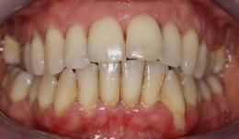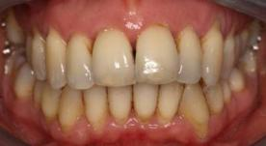
A B
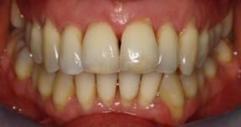
C
Image A shows a patient with generalised aggressive periodontitis at baseline. Image B shows the same patient following non-surgical treatment. Note the improvement in appearance and stabilisation of the gingival margin around 33 following treatment. Image C shows the patient 15 months later following quarterly supportive periodontal therapy. Note the recurrence of inflammation around 33 and the slight increase in recession around 21, 31 and 32. The patient required further modification of her oral hygiene technique and continued with three monthly supportive therapy.
One of the outcomes of successful non-surgical periodontal therapy is negative architecture of the papillae (see figure 6.2). A larger interdental brush may be needed to effectively clean these areas post treatment and patients should be advised to press gently into the shallow craters.
Figure 6.2 Negative architecture following successful non-surgical therapy
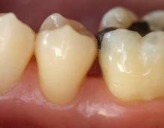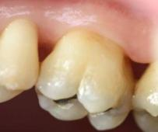
Note the healthy gingivae.
In patients who have previously received non-surgical or surgical treatment of periodontitis each recall appointment should comprise assessment and treatment as follows.
RECOMMENDATIONS
- Carry out an oral examination, including assessment of plaque and bleeding levels.
- Ensure that full mouth periodontal charting is performed annually in patients who scored BPE 4 in any sextant at baseline and in patients who scored 3 in more than one sextant at baseline. Where the patient scored BPE 3 in only one sextant, carry out full periodontal charting of that sextant.
- Review personal oral hygiene and, where necessary, use the Oral Hygiene TIPPS behaviour change strategy to highlight the importance of effective plaque removal and to show the patient how he/she can achieve this (see Section 3.2). Emphasise that due to the patient’s history of periodontitis, he/she is highly susceptible to even very small amounts of plaque. Where applicable, give smoking cessation advice (see Section 3.3).
- Remove supra-gingival plaque, calculus and stain using an appropriate method (see Section 5.1). Correct local plaque retentive factors - for example, remove overhanging restorations or alter denture design (see Section 5.2). Highlight to the patient areas where supra-gingival deposits are detected.
- Carry out root surface instrumentation at sites of ≥4 mm probing depth where sub-gingival deposits are present or which bleed on probing (see Section 5.1). For sites of <4 mm probing depth only carry out sub-gingival instrumentation where sub-gingival calculus is present. Local anaesthesia may be required for this. Refer to the most recent full periodontal charting to identify teeth which may require treatment.
- Assign an individual risk level based on the patient’s medical history and oral health status. Explain to the patient what this means for him/her and schedule the next appointment based on the risk level.
Patients with periodontitis at baseline who respond successfully to non-surgical treatment and supportive periodontal therapy (probing depths of ≤3 mm and minimal bleeding on probing) may be transferred to dental prophylaxis. These patients no longer require annual full periodontal charting but should any recurrence of disease be detected by BPE screening, further non-surgical and supportive therapy will be required.

7 Management of Patients with Dental Implants

KEY RECOMMENDATIONS
- Ensure the patient is able to perform optimal plaque removal around the dental implant(s).
- Examine the peri-implant tissues for signs of inflammation and bleeding on probing and/or suppuration and remove supra- and sub-mucosal plaque and calculus deposits and excess residual cement.
- Perform radiographic examination only where clinically indicated.

7.1 General Care of Dental Implants
EVIDENCE SUMMARY
Like the natural dentition, implant-retained or supported prostheses require regular review and also maintenance to enhance the longevity of the implant. Current evidence⁷⁹⁻⁸² regarding the best ways to maintain dental implants is inconclusive. However, effective self-performed oral hygiene and regular monitoring of the peri-implant tissues, with professional interventions such as debridement of the superstructure when required, are likely to be important components of an ongoing maintenance regime. If osseointegration is successful, implant loss is rare and, with effective personal and professional maintenance, the patient can hope to retain the implant for many years. Further discussion of the evidence relevant to this topic is provided in Section 10.17.
The maintenance recall interval for each patient should be based on an assessment of risk. Annual recall is generally recommended for all patients with implants. However, those with specific risk factors, such as smoking or poorly controlled diabetes, may require to be seen more often. Patients with a history of periodontitis may be more susceptible to peri-implant disease and the recall interval for supportive therapy should be scheduled accordingly.
Figure 7.1 Anatomical differences between tooth and implant.
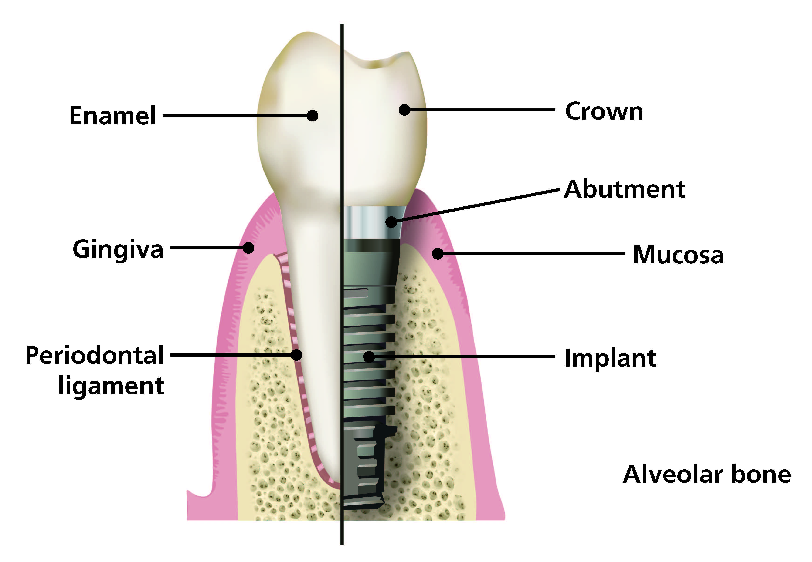
The tooth is connected to bone by the periodontal ligament and is covered by the gingiva. An implant is osseointegrated to bone and surrounded by mucosa; no periodontal ligament is present.
Clinically significant progressive loss of crestal bone around an implant may predict future implant failure. The reasons for bone loss include:
- iatrogenic factors such as incorrect surgical technique, incorrect positioning of the implant, poor prosthesis design, foreign body reaction;
- patient factors such as susceptibility to periodontitis, smoking, poorly controlled diabetes, poor oral hygiene, untreated periodontal disease, poor bone quality, bruxism, inflammation and infection of the peri-implant tissues.
Bone remodelling around the head of the implant may occur following placement and restoration. After the adaptive phase, bone levels in stable patients enter a steady state where crestal bone loss of no more than 0.2 mm annually should be expected.⁸³ A peri-apical radiograph aligned using the long cone paralleling technique should be taken at the time of superstructure connection. A further peri-apical radiograph, aligned using the long cone paralleling technique, should be taken at one year following this as a baseline for monitoring future changes in the bone level. Routine radiographic monitoring is not required unless there are clinical signs of infection and inflammation.
Like teeth, implants are susceptible to bacterial plaque and calculus formation, leading to an inflammatory response in the peri-implant tissues. The latter can also become inflamed in response to the presence of a foreign body, such as excess residual cement. The tissues surrounding implants are not connected to the implant surface in the same way as those surrounding teeth and are less resistant to probing (see figure 7.1). This, in combination with the anatomical position of the implant in relation to the bone and soft tissues, may potentially lead to deeper probing depths and bleeding in healthy sites. For this reason it is not appropriate to apply the Basic Periodontal Examination (BPE) for the assessment of implants. However, a marked increase in probing depth, together with suppuration and bleeding, suggests the presence of peri-implant inflammation and infection and with progressive bone loss, frank peri-implantitis. It may also be an indication of future bone loss but at present the evidence for this is weak. When examining the peri-implant tissues, gentle probing pressure is advised and probing depth, if recorded, should be measured from a fixed landmark. Although plastic probes are available, there is no evidence that the use of metal probes is detrimental to the tissues around the superstructure or implant.
Supra-mucosal calculus is more common around implants than sub-mucosal calculus and this is generally easier to remove than the calculus attached to teeth. However, if the implant threads are exposed, plaque and calculus removal from them can be difficult. Soft supra-mucosal deposits can be removed using a rubber cup and an implant-specific prophylactic paste or an air polisher and glycine powder. Although non-metal curettes and tips for sonic and/or ultrasonic instruments are available, the use of metallic instruments or tips is not contra-indicated and their use is not detrimental to the tissues around the superstructure or implant.
RECOMMENDATIONS
- Ensure that a baseline peri-apical radiograph of the implant, aligned using the long cone paralleling technique, is obtained one year after superstructure connection to facilitate long-term implant maintenance. Ideally this should be provided by the clinician who placed the implant.
  - Identify a stable landmark e.g. implant shoulder or implant threads to enable comparison of bone levels over time.
  - When clinically indicated, perform radiographic examination of the implant using peri-apical radiographs taken using the long cone paralleling technique.
  - Position the x-ray head perpendicular to the long axis of the implant; this may be at a different angle to adjacent teeth.
- Assess the level of oral hygiene and, if necessary, use the Oral Hygiene TIPPS behaviour change strategy to highlight the importance of effective plaque removal and to show the patient how he/she can achieve this (see Section 3.2). Encourage the use of oral hygiene aids such as implant floss and interdental brushes (see Section 7.2). Where applicable, give smoking cessation advice (see Section 3.3).
- Assess the cleansability of the superstructure and consider replacement of the restoration if it is not readily accessible for personal and professional plaque removal.
- Examine the peri-implant tissue for signs of inflammation and the presence of bleeding on probing and/or suppuration.
- Probe gently around the superstructure to feel for excess residual cement, sub-mucosal plaque and calculus deposits. Measure baseline peri-implant probing depths using fixed landmarks, from which to measure future changes.
N.B. The BPE is not appropriate for the assessment of dental implants.
- Remove supra-mucosal and sub-mucosal plaque and calculus deposits, if required, using an appropriate method (see Section 5.1). Remove sub-mucosal excess residual cement if this is detected. Use this opportunity to highlight to the patient areas where supra-mucosal deposits are detected.
- Assign an individual risk level based on the patient’s previous periodontal status and other risk factors (see Appendix 8). Explain to the patient what this means for him/her and schedule the next appointment based on the risk level.

7.2 Implant-specific Oral Hygiene Methods
It is important that the patient is aware that effective oral hygiene is critical in ensuring the longevity of the implant. Patients with a single implanted crown can be encouraged to treat the implant as they would their natural dentition and to clean it with a toothbrush, interdental brushes and implant floss. It is important that interdental brushes fit snugly into the interdental space without the wire rubbing against the superstructure or adjacent tooth. Patients with an implant-supported bridge or denture may require training in the use of single tufted brushes and implant floss to clean these prostheses (see figure 7.2). It is important to stress that patients should use a gentle flossing technique and that the floss should not be forced below the peri-implant mucosal margin. Rechargeable powered toothbrushes may be useful for any patient who cannot clean effectively with a manual brush.
Figure 7.2 Implant-specific oral hygiene methods
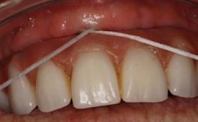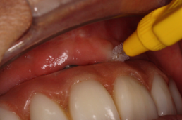
A B
Image A shows cross-over flossing of an implant supported denture. Image B shows the use of an interdental brush to clean an implant-supported denture.

7.3 Treatment of Peri-implant Mucositis
Peri-implant mucositis is defined as inflammation of the peri-implant mucosa with no evidence of progressing crestal bone loss.⁸⁴ The tissues will appear red and swollen and may bleed on gentle palpation or probing; suppuration may also be visible (see figure 7.3A).
EVIDENCE SUMMARY
Current evidence^{79,85} regarding the most effective interventions to recover soft tissue health in patients with peri-implant mucositis is inconclusive. However, the removal of plaque and calculus deposits and the re-establishment of effective personal oral hygiene are likely to be important elements of effective treatment. Further discussion of the evidence relevant to this topic is provided in Section 10.18.
Figure 7.3 Peri-implant mucositis
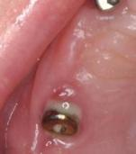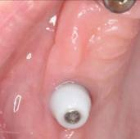
A B
Image A shows an implant in a patient presenting with peri-implant mucositis. Image B shows the same patient following treatment; the implant is covered by a healing abutment. Note the improvement in the health of the mucosa. (Images kindly provided by Dr Fran Veldhuizen)
RECOMMENDATIONS
- Exclude the presence of peri-implantitis (see Section 7.4) by carrying out a radiographic examination of the implant using peri-apical radiographs taken using the long cone paralleling technique to assess peri-implant bone levels compared with the baseline radiograph.
- Use the Oral Hygiene TIPPS behaviour change strategy to highlight the importance of effective plaque removal and to show the patient how he/she can achieve this (see Section 3.2). Encourage the use of oral hygiene aids such as implant floss and interdental brushes (see Section 7.2). Where applicable, give smoking cessation advice (see Section 3.3).
- Remove supra-mucosal and sub-mucosal plaque and calculus deposits using an appropriate method (see Section 5.1). Remove sub-mucosal excess residual cement if this is detected. Local anaesthesia may be required. Use this opportunity to highlight to the patient the areas where supra-mucosal deposits are detected.
- Re-assess at a future visit to ensure that the inflammation has settled and a stable situation has been achieved.

Case Study – Peri-implant Mucositis
A patient was referred complaining of inflammation around the lower anterior implant-supported bridge. Radiographs were taken which showed normal bone levels. The bridge was removed and revealed excess residual cement and plaque deposits around the abutments. The abutments were unscrewed for cleaning revealing healthy mucosa adjacent to the implant heads. The patient was given an oral hygiene demonstration following refitting of the abutments and bridge.
N.B Where abutments are cemented in place rather than screwed, supra- and sub-mucosal debridement can be performed using ultrasonic and/or hand scalers.
(All images kindly provided by Dr Kevin Lochhead)
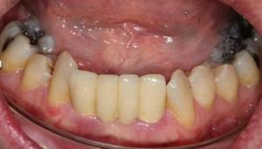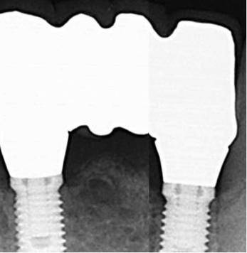
A B
Image A shows peri-implant mucositis around a lower implant-supported bridge. Image B shows peri-apical radiographs, taken using the long cone paralleling technique, which confirm normal bone levels around both implants.

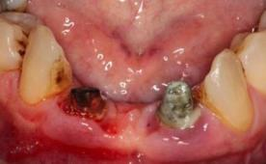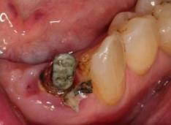
C D
Image C shows a view of the abutments with the bridge removed. Image D shows excess residual cement around the 32 abutment.
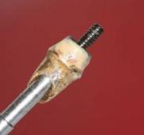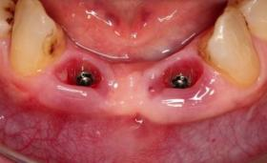
E F
Image E shows sub-mucosal plaque deposits on the unscrewed abutment. Image F shows the peri-implant mucosa following abutment removal and debridement.

7.4 Treatment of Peri-implantitis
Peri-implantitis is defined as infection with suppuration and inflammation of the soft tissues surrounding an implant, with clinically significant loss of peri-implant crestal bone after the adaptive phase.⁸⁴ The tissues will appear red and swollen, bleed on gentle palpation or probing and there will be suppuration (see figure 7.4). There may be an increase in probing depth around the implant and the implant threads may be detectable. Recession of the surrounding mucosa can occur, exposing the threads. Peri-implantitis can progress rapidly. The patient may also experience pain around the implant, however this usually only occurs during episodes of acute infection.

Figure 7.4 Failed implant with peri-implantitis
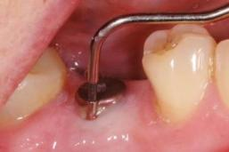
Note separation of mucosa from implant, probing depth of 8 mm and the presence of pus. (Image kindly provided by Dr Krishnakant Bhatia)
EVIDENCE SUMMARY
Current evidence⁸⁵⁻⁸⁹ regarding the most effective interventions to improve soft tissue health in patients with peri-implantitis is inconclusive. However, the re-establishment of effective self-performed oral hygiene and professional removal of supra- and sub-mucosal plaque and calculus deposits and excess residual cement are likely to be important components of treatment. There is insufficient current evidence^{87,90} to support the use of systemic or local antibiotics in the treatment of peri-implantitis. Further discussion of the evidence relevant to this topic is provided in Sections 10.19 and 10.20.
RECOMMENDATIONS
- Carry out a radiographic examination of the implant using peri-apical radiographs, taken using the long cone paralleling technique, to evaluate peri-implant bone levels compared with the baseline radiograph.
- If clinically significant progressing crestal bone loss is detected, refer back to the clinician who placed the implant. If this is not possible, carry out the following treatment.
  - Use the Oral Hygiene TIPPS behaviour change strategy to highlight the importance of effective plaque removal and to show the patient how he/she can achieve this (see Section 3.2). Encourage the use of oral hygiene aids such as implant floss and interdental brushes (see Section 7.2). Where applicable, give smoking cessation advice (see Section 3.3).
  - Remove supra-mucosal and sub-mucosal plaque and calculus using an appropriate method (see Section 5.1). Remove sub-mucosal excess residual cement if this is detected. Local anaesthesia may be required. Use this opportunity to highlight to the patient areas where supra-mucosal deposits are detected.
  - Arrange a follow-up appointment after 1-2 months to assess the outcome of treatment. Re-examine the peri-implant tissues. Where there is no improvement or in the presence of acute pain and infection, seek advice from secondary care.
  - If the inflammation has settled and a stable situation has been achieved, arrange radiographic follow-up in 6-12 months.

Case Study – Peri-implantitis
A patient with a bridge retained on six implants presented with suppuration and inflammation around implants at positions 16, 13, 23 and 26. The patient was a bruxist. Plaque deposits, pus and excess residual cement were visible on the underside of the bridge. Radiographs showed bone destruction at positions 16 and 23, indicating peri-implantitis, while the implants at positions 13 and 26 were affected by peri-implant mucositis. The mucositis at positions 13 and 26 was treated non-surgically and resolved; the implants at 16 and 23 were removed. The patient was diagnosed with type 2 diabetes shortly after non-surgical treatment.
(All images kindly provided by Dr Kevin Lochhead)
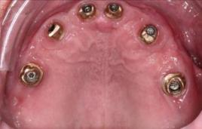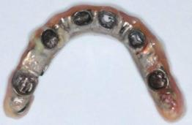
A B
Image A is a palatal view showing suppuration around implant abutments at 13, 23 and 26 and inflammation and swelling buccal of 16 and 23. Image B shows the fitting surface of the implant supported bridge with visible plaque, pus and excess residual cement at the position of the 23 implant.
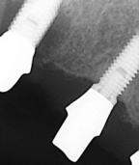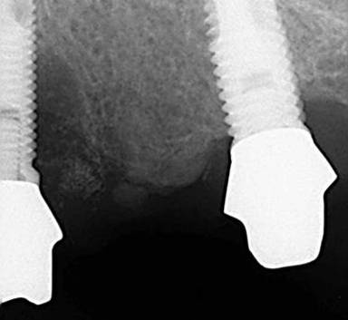
C D
Figure C shows bone loss around 16 and normal bone levels around 13. Figure D shows bone loss around 23 while bone levels around 26 were maintained from baseline.

8 Referral

KEY RECOMMENDATIONS
- Consult any locally produced referral guidelines and the BSP ‘Referral Policy and Parameters of Care’ to determine if the patient is a suitable candidate for referral.
- Carry out initial therapy to address inadequate plaque removal, smoking status (if applicable) and to remove supra- and sub-gingival deposits.
- Provide supportive periodontal therapy and monitoring for patients who have been discharged from secondary care.

8.1 Referral Criteria
In some cases it may be appropriate to refer the patient to a specialist practitioner or to secondary care for further periodontal care. These cases include patients with severe disease or where the treatment required is complex or complicated by other factors. The British Society of Periodontology has devised an index of treatment need as a guideline for referral.⁹¹ The assessment of case complexity is based on the Basic Periodontal Examination (BPE),¹⁰ with provision for modifying factors to be taken into account. Referral centres may also have local guidelines in place which will state the criteria for referrals from primary care.
In general, patients with a BPE score of 1-3 in any sextant should be treated in general dental practice. Patients with a BPE score of 4 in any sextant may receive initial non-surgical treatment in general dental practice. Those unresponsive to inital treatment, or those patients requiring surgery involving the periodontal tissues, may be accepted for referral. Patients with a BPE score of 4 in any sextant plus a modifying factor, such as a medical condition which affects the periodontal tissues or a diagnosis of aggressive periodontitis, should be referred. For more information see the British Society of Periodontology publication Referral Policy and Parameters of Care.⁹¹
- Consult any locally produced guidelines and the British Society of Periodontology Referral Policy and Parameters of Care⁹¹ to determine if the patient is a suitable candidate for referral.
- In cases where referral is considered, carry out initial therapy.
  - Use the Oral Hygiene TIPPS behaviour change strategy to highlight the importance of effective plaque removal and to show the patient how he/she can achieve this (see Section 3.2).
  - Remove supra-gingival plaque, calculus and stain and sub-gingival deposits using an appropriate method.
- If a patient smokes, discuss the benefits of stopping and refer to smoking cessation services if necessary.
Patients should be made aware that those who do not demonstrate a positive attitude to oral hygiene will not be accepted for referral.
In general, patients accepted for referral for periodontal care are expected to continue to attend their own dental practice for routine examinations and treatment, such as extractions or restorations.

8.2 Formal Referral
- Make referrals formally in writing. It can also often be helpful to make an initial telephone call to discuss the case.
- Keep a copy of the referral letter with the patient’s clinical notes.
- Record in the patient’s notes the date of the referral and the reason for the referral.
- Include in the referral letter:
Referrer details:
  - Name of referring General Dental Practitioner;
  - Address of referring practice;
  - Date of referral;
  - Telephone number.
Patient details:
  - Full forename, surname and title;
  - Full postal address including post code;
  - Gender;
  - Date of Birth;
  - Age;
  - Home telephone and mobile telephone numbers;
  - CHI Number (if known);
  - Details of the patient’s General Medical Practitioner.
Medical History:
  - Medical history, including details of any current medication.
Social History
  - Smoking history;
  - Information regarding special/social circumstances (does the patient have hearing, visual, mental health difficulties or mobility impairment? Is an interpreter needed?).
Clinical Information:
  - Reason for referral;
  - Details of periodontal treatment previously carried out, including oral hygiene demonstration;
  - Relevant recent radiographs and periodontal charts.

8.3 Continuing Care of Referred Patients
RECOMMENDATION
- Provide supportive periodontal therapy for referred patients who have been discharged from specialist or secondary care. Good communication with the secondary care provider or specialist is vital to ensure the success of the treatment and long term maintenance.

9 Record Keeping

KEY RECOMMENDATIONS
- Record the results of the periodontal examinations (basic and/or full) carried out and the current standard of oral hygiene.
- Record the diagnosis, suggested treatment plan and details of costs.
- Document any discussions you have with the patient, for example, treatment options, risks and benefits of treatment, oral hygiene advice, smoking cessation, alcohol consumption and/or other lifestyle factors.

9.1 General Principles
Good record keeping underpins the provision of quality patient care.⁹² Increasingly, the care of patients is shared among dental team members and between other professionals. Therefore, it is important to practise good record keeping to ensure that all relevant information is available to facilitate the provision of effective, long-term shared care of patients. If carried out consistently for each patient, it will also save time in the long run for the dental team and will provide a permanent record of the care provided, which is essential for medico-legal reasons.
RECOMMENDATIONS
- Ensure all records are:
  - specific to the patient;
  - accurate;
  - dated;
  - confidential;
  - secure;
  - contemporaneous (update at each appointment);
  - comprehensive (note which elements of assessment and treatment have been completed at a given appointment; include positive results and any concerns of the patient or clinician);
  - legible and written in language that can be read and understood by others to enable effective shared care (using computerised systems avoids problems with legibility, however, avoid inappropriate use of autotext).
- Do not remove any entries from records.
- Ensure patient data are recorded and processed in accordance with the eight data protection principles detailed under the Data Protection Act 1998,⁹³⁻⁹⁵ and note that patients have a right under the Data Protection Act 1998 to access their dental records.
N.B. The SDCEP Practice Support Manual¹⁵ has additional information on record keeping (e.g. systems and storage of record keeping) and the Data Protection Act 1998. The SDCEP Oral Health Assessment and Review⁷ guidance also covers general principles of record keeping.

9.2 Information Specific to Periodontal Diseases
A significant number of complaints, claims or referrals to the General Dental Council (GDC) are due to allegations of undiagnosed and untreated periodontitis. Good record keeping is vital to show that each patient has received regular periodontal screening and, where necessary, the further charting, advice, treatment and monitoring appropriate to his/her level of disease. The patient’s clinical notes should also record any risk factors for periodontal disease that have been identified, as well as more general aspects such as medical and previous dental histories. The treatment plan is also part of the patient’s medico-legal record and it is important that it is individualised and specific to each patient.
It is important to record any discussions you have with a patient regarding the nature and extent of his/her periodontal disease, treatment options and likely outcomes. It is also important to gauge the level of understanding of the patient and adjust your communication style and method to suit him/her.

RECOMMENDATIONS
- For each patient, record:
  - personal details;
  - dental history, including previous dental experience;
  - medical history, including details of any medications (contact the patient’s general medical practitioner if clarification is required);
  - social history, including smoking status and alcohol consumption;
  - family history of periodontitis;
  - perceived motivation.
- At each review appointment, ensure that all details of the patient’s history are up to date.
- Record any specific complaints that the patient may have regarding his/her periodontal health, for example, gums which bleed on brushing or flossing or teeth which feel loose. Note whether these issues are recent or are recurrent.
- Record the patient’s self-reported oral hygiene habits.
- Record the results of the Basic Periodontal Examination and the standard of oral hygiene.
- For patients who require a full periodontal examination (see Section 2.4), record:
  - probing depths and measurement of gingival recession as appropriate;
  - presence or absence of bleeding on probing;
  - details of any furcation involvement;
  - tooth mobility;
  - plaque and gingivitis charts.
- Record in the notes any provisional diagnosis and follow up with a definitive diagnosis once any special investigations have been performed.
- Keep any radiographs taken as part of the patient’s record. Ensure that these are justified, authorised and clinically evaluated, with the findings documented in the patient’s notes.
- Record the suggested treatment plan and details of costs.
- Document discussion of the options, risks and benefits of treatment, including the ‘no treatment’ option. If treatment is declined, record this in the notes.
- Record the details of any treatment carried out, including any discussion of oral hygiene using the Oral Hygiene TIPPS behaviour change strategy. Record any discussions on smoking cessation, alcohol consumption or other lifestyle factors.
- Record details of referrals, including a copy of the referral letter and any response from the referral centre (see Section 8.1).
- Note in the clinical records the appropriate recall period.
- Where appropriate, record compliance with advice, for example, oral hygiene demonstration or smoking cessation advice.

10 Evidence into Practice
There is an increasing acceptance within healthcare that clinical care and treatment should be based on an evidence-based approach where possible. Clinicians are expected to use the best, most up-to-date research evidence available, in consultation with the patient, to make decisions about the patient’s care. It is the role of those who develop guidance to search out and appraise the relevant evidence and then formulate recommendations which facilitate clinicians’ decision making. A key aim of SDCEP is to evaluate the best available evidence that is relevant to dentistry and to translate it into a form that members of the dental profession will be able to interpret easily and implement.
Within many areas of dentistry there is a lack of the type of high-quality scientific evidence that usually informs the recommendations within conventional clinical guidelines. However, periodontology is one area in which a significant amount of primary research has been performed⁹⁶ and numerous systematic reviews on this topic are available. Unfortunately, many periodontology systematic reviews are inconclusive, with reviewers stating that the poor quality of the primary studies, both in terms of methodology and reporting, prevents them from drawing definitive conclusions. This was highlighted in a systematic review by Montenegro et al.⁹⁷, which stated that ‘RCTs in periodontology frequently do not meet current recommendations on study quality’. Additionally, it has been reported that the quality of many systematic reviews in dentistry could be improved,⁹⁸⁻¹⁰⁰ with search strategy, quality assessment of primary studies, examination of heterogeneity and reporting of publication bias amongst those identified as areas of weakness.
For the development of this guidance, the guidance development group used the PICO (population, intervention, control, outcome) framework to formulate a list of 20 key clinical questions related to the scope of the guidance. A systematic literature database search strategy was employed to identify the best research evidence to address these key questions. An overview of the literature search and the process used to assess the evidence can be found in Appendix 1 of this guidance. In general, the guidance development group agreed that very few of the relevant primary studies appeared to be high quality, due to methodological issues such as risk of bias, small sample sizes, inadequate follow-up periods, inappropriate study populations and settings and non-reporting of confounding factors such as smoking. The guidance development group also raised concerns about the quality of some of the systematic reviews, many of which had methodological issues, although more recent reviews appear to have improved in terms of methodological quality.
A summary of the evidence retrieved for each key clinical question and a critical appraisal of the quality of the evidence is presented here. The relevant recommendation(s) made by the guidance development group are also included.

- In the general dental patient population, does the provision of oral hygiene instruction, compared with no instruction, result in improved clinical outcomes, such as plaque levels and gingival health?
Summary of the evidence and quality appraisal
The evidence, based on six systematic reviews,¹⁶⁻²¹ suggests that one-to-one chair-side oral hygiene instruction (OHI) can result in improved oral hygiene, although the results may be short term. The evidence is considered low quality due to methodological deficiencies in the primary studies. The risk of bias in some studies was high, some studies included inappropriate populations and in some instances the follow-up periods were insufficient. The systematic reviews themselves did not always adhere to accepted reporting guidelines.
Considered judgement and guidance recommendation
A one-to-one chair-side discussion about the causes of gum disease, the importance of good oral hygiene and a demonstration of effective oral hygiene techniques is acknowledged best practice in preventing periodontal disease and maintaining periodontal health following treatment. The available evidence, although low quality, supports this, particularly when the evidence supporting the provision of oral hygiene instruction in conjunction with supra-gingival debridement is considered (see Section 10.5). The guidance development group recommend that clinicians use the Oral Hygiene TIPPS behaviour change strategy for patients who have inadequate oral hygiene.

- In the general dental patient population, are rechargeable powered toothbrushes, compared to manual toothbrushes, more effective at reducing levels of plaque and gingivitis?
Summary of the evidence and quality appraisal
The evidence, based on one systematic review,²⁹ suggests that powered rotation oscillation toothbrushes are more effective at reducing plaque and gingivitis indices than manual toothbrushes. No other powered designs were as consistently superior to manual toothbrushes. The evidence is considered low quality due to the majority of studies judged to be at unclear or high risk of bias and weaknesses in other methodological areas. Another systematic review which compared different types of powered toothbrushes³⁰ could not recommend any particular type of powered brush due to a lack of relevant studies.
Considered judgement and guidance recommendation
Regular, effective removal of plaque is vital in the prevention of periodontal diseases in susceptible individuals and for the long term maintenance of the periodontal tissues following treatment. Studies which investigate the use of powered toothbrushes to remove plaque suggest that rotation oscillation brushes are more effective at reducing plaque and gingivitis indices than manual brushes. No other types of powered brushes showed this effect. The group note that the sub-analysis of the rotation oscillation brushes included many more studies than the sub-analyses of other types of powered toothbrushes. This may explain why this is the only type of powered toothbrush shown to be consistently superior to manual brushes. The group also note that the clinical significance of the reductions in plaque and gingival indices is unknown. The group agree that effective plaque removal can also be achieved using a manual toothbrush. The group recommend that patients should be advised to regularly clean their teeth, using either a manual or rechargeable powered toothbrush, and that an effective technique should be employed.

- In the general dental patient population, is the use of floss and/or interdental brushes in addition to toothbrushing, compared to each other and toothbrushing alone, more effective at reducing plaque levels and gingivitis?
Summary of the evidence and quality appraisal
The evidence, based on one systematic review,²⁵ suggests that the use of floss in addition to toothbrushing reduces gingivitis at one, three and six months compared to toothbrushing alone. There was insufficient evidence to determine the efficacy of floss to reduce plaque levels. The evidence is considered low quality due to poor reporting in the primary studies, with all studies judged to be at high or unclear risk of bias.
The evidence, based on three systematic reviews,²⁶⁻²⁸ suggests that using interdental brushes in addition to toothbrushing is more effective at reducing plaque and gingivitis than flossing plus toothbrushing, at those sites which can accommodate an interdental brush. The evidence is considered low quality due to inconsistencies in findings across reviews. There were a limited number of primary studies and the risk of bias in most was judged to be high or unclear.
There is very low quality evidence, based on one primary study judged to be at high risk of bias, that using interdental brushes in addition to toothbrushing is more effective at reducing plaque and gingivitis than toothbrushing alone.²⁸
Considered judgement and guidance recommendation
Toothbrushing is the most common method for removing dental plaque. However, toothbrushes cannot effectively remove plaque from the interdental areas. Studies which investigate the use of dental floss in these areas suggest that floss is more effective at reducing levels of gingivitis compared to toothbrushing alone but the effect on plaque levels is less clear. The effectiveness of interdental brushes to remove plaque from these areas, compared to toothbrushing alone, is also uncertain due to a lack of studies in this area. Studies which compare interdental brushes to floss suggest that the former are more effective at reducing levels of plaque and gingivitis in interdental spaces which will accommodate them. The group agree that the quality of evidence supporting interdental cleaning is low, and the group also note that the clinical significance of the reductions in plaque and gingival indices is unknown. However, due to the importance of effective plaque removal in the prevention of periodontal diseases, especially for susceptible individuals, and because toothbrushing does not adequately clean the approximal tooth surfaces, the group recommend that patients be advised to clean interdentally once a day.

- In the general dental patient population, are triclosan/copolymer-containing toothpastes, compared to non-triclosan/copolymer-containing toothpastes, more effective at reducing plaque levels and gingivitis?
Summary of the evidence and quality appraisal
The evidence, based on one systematic review,³¹ suggests that fluoride toothpastes which also contain triclosan/copolymer are more effective at reducing plaque indices, both in terms of plaque levels and plaque severity, and gingivitis indices, both in terms of inflammation and bleeding, than fluoride toothpastes which do not contain triclosan/copolymer. Reductions were evident regardless of initial plaque and gingivitis levels. The evidence is considered to be moderate quality due to the consistency in results observed both across studies and in a sensitivity analysis of high quality studies. No publication bias was detected.
Considered judgement and guidance recommendation
Triclosan is a broad-spectrum anti-bacterial which, in combination with a copolymer, has been proposed to inhibit the formation of dental plaque. Studies which investigate the use of fluoride toothpastes which also contain triclosan/copolymer suggest that these are more effective at reducing plaque and gingivitis indices than toothpastes which contain fluoride only. The group agree that the clinical relevance of these reductions in plaque and gingivitis indices is unclear. The group notes that the majority of studies in the review were funded by industry and are concerned that this could be a major source of bias. As a consequence, the group are unable to make a specific recommendation on the use of triclosan/copolymer-containing toothpastes.

- In the general dental patient population, is routine supra-gingival debridement, compared with no treatment, effective in preventing periodontal diseases? Is there any evidence to suggest the best time interval between treatments?
Summary of the evidence and quality appraisal
The evidence, based on two systematic reviews,^{36,37} suggests that provision of routine supra-gingival debridement may result in a reduction in plaque levels and gingival bleeding. The evidence is considered low quality due to risk of bias, risk of confounding, inconsistent results and a lack of well-conducted/well-reported RCTs.
The evidence indicates that provision of supra-gingival debridement in combination with oral hygiene instruction may result in improved clinical outcomes such as plaque and gingival bleeding. The evidence for this is considered to be of moderate quality due to a consistency of findings both within and between studies.
The evidence indicates that more frequent treatment may result in improved clinical outcomes, including plaque levels and gingival bleeding, although it is not possible to specify an optimal frequency for treatment.
Considered judgement and guidance recommendation
The evidence suggests that supra-gingival debridement is effective in reducing plaque levels and gingival bleeding and is more effective when provided in conjunction with oral hygiene instruction. The guidance development group recommends that supra-gingival debridement is carried out where required and that clinicians also use the Oral Hygiene TIPPS behaviour change strategy for patients who have inadequate oral hygiene.
The guidance development group cannot make a recommendation on the optimal frequency of treatment as the evidence which addresses this is currently insufficient.

- In patients with chronic periodontitis, is sub-gingival instrumentation, compared with supra-gingival debridement or no treatment, effective in improving periodontal health?
Summary of the evidence and quality appraisal
The evidence, based on three systematic reviews^{38,39,41} and one review of systematic reviews,⁴⁰ indicates that provision of sub-gingival instrumentation may result in better clinical outcomes (both in terms of statistical significance and clinical significance) than either supra-gingival debridement or no treatment, particularly for areas where probing depths are greater than 3 mm in depth. The evidence is considered to be of moderate quality due to the volume of mostly low-quality studies which show consistent findings.
The evidence indicates that areas with shallow probing depths (less than 3 mm in depth) may have worse clinical outcomes, particularly where sub-gingival instrumentation is rigorous, and these may be more effectively treated by supra-gingival debridement.
The evidence also suggests that effective oral hygiene instruction given concurrently is required for optimal results. The evidence for this is considered low quality due to poor study designs, poor reporting and the possibility of bias.
Considered judgement and guidance recommendation
The evidence suggests that sub-gingival instrumentation of probing depths greater than 3 mm is effective in improving periodontal health. The guidance development group recommends supra-gingival debridement and root surface instrumentation for probing depths of ≥4 mm where sub-gingival deposits are present or which bleed on probing. Where probing depths are less than or equal to 3 mm, the guidance development group agrees that sub-gingival instrumentation is only appropriate where calculus deposits are present. The guidance development group recommend that clinicians use the Oral Hygiene TIPPS behaviour change strategy for patients who have inadequate oral hygiene.

- In patients with chronic periodontitis, is power driven root surface instrumentation (RSI), compared with hand RSI, more effective in improving periodontal health?
Summary of the evidence and quality appraisal
The evidence, based on three systematic reviews,^{26,47,53} suggests that power driven RSI and hand RSI are equally effective in terms of improved clinical outcomes. The evidence is considered low quality due to concerns about the design of the primary studies, inadequate reporting of data and the possible risk of bias.
The evidence suggests that power driven RSI is more efficient, taking 37% less time than hand RSI.
Considered judgement and guidance recommendation
Current evidence suggests that both instrumentation methods are equally effective at improving periodontal health. The guidance development group recommends that instrumentation should always be performed to a high standard and that a combination of methods can be used; the choice of method should be based on clinician/patient preferences and access to the site/s to be treated.

- In patients with chronic periodontitis, is full mouth debridement more effective than quadrant debridement in improving periodontal health?
Summary of the evidence and quality appraisal
The evidence, based on three systematic reviews,⁵⁰⁻⁵² indicates that both full mouth and quadrant debridement are effective in the treatment of periodontitis, providing that the debridement is thorough. The evidence is considered low quality due to the diversity of the primary study designs, which made comparison of data across studies difficult, the variability of the findings and the possibility of bias.
There is no evidence of a difference between the two treatment modalities in terms of clinical outcomes. However, in some studies, more adverse effects (pain, increased temperature) were observed where full mouth debridement was conducted.

Considered judgement and guidance recommendation
There is currently no evidence of a difference in effectiveness between full mouth and quadrant debridement and both are therefore suitable for the treatment of chronic periodontitis. The guidance development group recommends that the choice of treatment modality should be made on an individual basis, taking into account patient and clinician preferences.

- In patients with chronic periodontitis, does the use of disinfectants during sub-gingival instrumentation, compared with sub-gingival instrumentation alone, result in improved periodontal health?
Summary of the evidence and quality appraisal
The evidence, based on four systematic reviews,⁵⁰⁻⁵³ indicates that use of disinfectants during sub-gingival instrumentation does not result in any additional gains in terms of clinical outcomes compared with sub-gingival instrumentation alone. The evidence is considered low quality due to concerns about the quality of the primary studies, the heterogeneity in both the treatments studied and the design of the studies and the possible risk of bias.
Considered judgement and guidance recommendation
The evidence does not support the adjunctive use of disinfectants during sub-gingival instrumentation and the guidance development group does not recommend this for the routine treatment of chronic periodontitis.

- In patients with chronic periodontitis, does the use of local antimicrobial therapy, either as a primary therapy or as an adjunct to root surface instrumentation (RSI), compared with RSI alone, result in improvements in clinical parameters such as probing depth and clinical attachment level?
Summary of the evidence and quality appraisal
The evidence, based on three systematic reviews,⁵⁵⁻⁵⁷ does not indicate that local antimicrobials as primary periodontal therapies are more effective at reducing probing depth and improving clinical attachment level than root surface instrumentation, and in fact may be less effective than RSI. The evidence is considered low quality due to the number of different antimicrobials and delivery systems studied and methodological issues with the primary studies.
The evidence, based on six systematic reviews,⁵⁴⁻⁵⁹ indicates that local antimicrobials used as an adjunct to root surface instrumentation can result in additional statistically significant reductions in probing depth and gains in clinical attachment level. However the clinical significance of these differences is unclear. The evidence is considered low quality due the number of different antimicrobials and delivery systems studied and methodological issues with the primary studies.
Considered judgement and guidance recommendation
Current evidence does not support the use of local antimicrobials as a primary treatment for chronic periodontitis. There is also little evidence that the use of adjunctive local antimicrobials results in clinically significant improvements compared with RSI alone. The inappropriate use of antibiotics may contribute to bacterial resistance and, although locally delivered antibiotics have a smaller risk of side effects compared with those delivered systemically, some adverse events were reported.
Following consideration of these factors, the guidance development group does not recommend the use of local antimicrobials for the routine care and management of patients with chronic periodontitis.

- In patients with chronic periodontitis, does the use of systemic antibiotic therapy as an adjunct to root surface instrumentation (RSI), compared with RSI alone, result in improvements in clinical outcomes such as probing depth and clinical attachment level?
Summary of the evidence and quality appraisal
The evidence, based on five systematic reviews,⁶⁰⁻⁶⁴ indicates that the use of systemic antibiotics as an adjunct to RSI results in statistically significant improvements in probing depth and clinical attachment level. However the clinical significance of these improvements is unclear. The evidence is considered to be of moderate quality due to the number of studies which show consistent results, although there are concerns about the methodological quality and possible risk of bias in the primary studies and the diverse antibiotic regimes which were studied.
The evidence, based on one systematic review,⁶⁶ indicates that systemic antibiotics, specifically a regime consisting of a combination of amoxicillin and metronidazole, may be effective in treating serious, complex, aggressive cases of periodontitis.
The evidence does not indicate which antibiotic is most effective, the most effective dose or duration of treatment.
The evidence does not adequately address the threat of antibiotic resistance and the side effects which can accompany systemic antibiotic therapy.
Considered judgement and guidance recommendation
The evidence suggests that adjunctive systemic antibiotic therapy may lead to statistically significant improvements in outcomes such as probing depth and clinical attachment level when compared with RSI alone. However, the clinical significance of these improvements, and the extent to which they may be influenced by the quality of the concurrent RSI, is unclear. Also, there is no evidence to suggest which antibiotic is most effective and the most effective dose.
The guidance development group agrees that given the high proportion of the population likely to suffer from chronic periodontitis, the threat of antibiotic resistance and the potential side effects of antibiotic therapy must be taken into account when considering recommendations for treatment. They also express concern that none of the included studies were performed in primary care. In light of these issues, the guidance development group does not recommend the use of systemic antibiotics for the routine care and management of patients with chronic periodontitis.
The guidance development group agrees that systemic antibiotic therapy may be appropriate for the management of patients with serious, complex or aggressive periodontitis. However, the group recommends that these patients should be referred directly to secondary care for treatment.

- In patients with chronic periodontitis who smoke, does the use of antibiotic therapy (local or systemic) as an adjunct to root surface instrumentation (RSI), compared with RSI alone, result in improvements in clinical parameters such as probing depth and clinical attachment level?
Summary of the evidence and quality appraisal
The evidence, based on one systematic review,⁶⁵ suggests that the adjunctive use of antibiotics in patients with chronic periodontitis who smoke may lead to statistically significant improvements in probing depth and clinical attachment level. However the clinical significance of these improvements is unclear. The evidence is considered to be low quality due to a high risk of bias in all studies and the review itself may be subject to publication bias, including language bias.
There is no evidence to suggest that the benefits observed are any greater than those observed in non-smokers.
Considered judgement and guidance recommendation
There is insufficient evidence to support the routine use of antibiotics as an adjunct to RSI in periodontitis patients who smoke.
The guidance development group does not recommend the use of systemic or local antibiotics for the routine care and management of any patients with chronic periodontitis (see also Sections 10.10 and 10.11).

- In patients with chronic periodontitis, does the use of adjunctive host modulation therapy in conjunction with root surface instrumentation (RSI), compared with RSI alone, result in improvements in clinical outcomes such as probing depth and clinical attachment level?
Summary of the evidence and quality appraisal
The evidence, based on two systematic reviews,^{67,68} suggests that host modulation therapy may have long term benefits as an adjunctive treatment to RSI. The evidence is considered low quality due to methodological issues associated with some of the primary studies such as smoking status as a confounder and a possible high risk of bias. It is also debatable whether one of the reviews fulfils the definition of a systematic review as no search strategy was reported.
Patient compliance, potential for bacterial resistance and cost effectiveness should be taken into account when considering this therapy.
Considered judgement and guidance recommendation
There is currently insufficient evidence to support the use of host modulation therapy as an adjunct to RSI in patients with chronic periodontitis. The guidance development group does not recommend host modulation therapy as an adjunct to non-surgical periodontal treatment in patients with chronic periodontitis.

- In patients with chronic periodontitis, what treatments are effective in reducing dentine sensitivity following root surface instrumentation?
Summary of the evidence and quality appraisal
The evidence, based on four systematic reviews,⁷⁴⁻⁷⁷ suggests that interventions to reduce dentine sensitivity, such as physical and chemical occlusion, may be effective. However, the evidence is considered low quality due to the poor quality of the primary studies and issues such as low patient numbers, short follow-up periods and variation in the methods to assess dentine sensitivity. A placebo effect was also observed in some studies.
Considered judgement and guidance recommendation
Current evidence is insufficient to determine the most effective treatment for dentine sensitivity. The guidance development group note that advising patients to apply a desensitising toothpaste to the affected area is common practice and that there is no evidence that this is harmful. Desensitising mouthwashes may also be of benefit. For patients with acute sensitivity, other topical therapies such as high fluoride toothpaste, fluoride varnish or a dentine bonding agent may be useful.

- In all patients is there evidence that the success of either dental prophylaxis or supportive periodontal therapy is influenced by the recall interval, including quarterly versus annual treatment?
Summary of the evidence and quality appraisal
The evidence, based on two systematic reviews^{37,38} and a review of systematic reviews,⁴⁰ suggests that more frequent treatment may result in improved outcomes. However there is no clear evidence regarding the most effective frequency of treatment or whether the observed improvements are clinically relevant. The evidence is considered low quality due to the poor quality of the primary studies which, in some cases, were at high risk of bias.
Considered judgement and guidance recommendation
Current evidence is insufficient to determine the most effective recall interval for dental prophylaxis or supportive periodontal therapy. The guidance development group recommends that clinical judgement, including an assessment of the patient’s risk, should be used to determine the recall interval for dental prophylaxis or supportive periodontal therapy, taking into account the wishes of the patient.

- In patients with a history of chronic periodontitis who are undergoing supportive periodontal therapy, is periodic sub-gingival instrumentation more effective than supra-gingival prophylaxis in maintaining the health of the periodontal tissues?
Summary of the evidence and quality appraisal
The evidence, based on one systematic review,⁷⁸ suggests that supportive periodontal therapy regimens involving either supra-gingival prophylaxis or sub-gingival instrumentation are comparable in regard to probing depth and attachment level outcomes. The evidence is considered low quality due to the poor quality of the primary studies.
Considered judgement and guidance recommendation
There is currently insufficient evidence to determine the most effective regimen for supportive periodontal therapy. The guidance development group recommends that clinicians actively monitor plaque and inflammation levels and the quality of the patient’s oral hygiene at each recall appointment. The Oral Hygiene TIPPS behaviour change strategy is recommended for patients whose oral hygiene is inadequate and supra-gingival debridement and sub-gingival instrumentation should be performed where required.

- In patients with dental implants, does implant specific supportive therapy, compared with no therapy, result in improved/sustained soft tissue health?
Summary of the evidence and quality appraisal
The evidence based on four systematic reviews,⁷⁹⁻⁸² does not identify any supportive therapy regimen as being the most effective for maintenance of soft tissue health around dental implants. The evidence is considered low quality due to a lack of well conducted or well reported studies; those which are reported are mainly non-controlled, small scale, or at high risk of bias and include significant heterogeneity in the outcomes measured.
Considered judgement and guidance recommendation
There is very little evidence to recommend any specific supportive therapy regime for patients with dental implants. However, there is no evidence that current practice is ineffective. The guidance development group recommends that the peri-implant soft tissue, plaque levels and inflammation levels are regularly monitored, with supra-mucosal debridement and sub-mucosal instrumentation of the implant surface where required. The Oral Hygiene TIPPS behaviour change strategy is recommended for patients whose oral hygiene is inadequate. Regular radiographs are not recommended unless clinically indicated.

- In patients with peri-implant mucositis, is there evidence to support a specific intervention to recover soft tissue health?
Summary of the evidence and quality appraisal
The evidence, based on two systematic reviews,^{79,85} does not identify the most effective treatment for peri-implant mucositis. The evidence is considered low quality due to the primary studies being mainly short term, small scale, or at risk of bias.
Considered judgement and guidance recommendation
There is currently very little evidence on which to base a recommendation for the treatment of peri-implant mucositis. However, there is no evidence that self-performed oral hygiene measures plus professional instrumentation to remove plaque and calculus deposits do not improve the health of peri-implant soft tissues. The guidance development group recommends supra-mucosal debridement and sub-mucosal instrumentation of the implant surface. The Oral Hygiene TIPPS behaviour change strategy should be used to address inadequate oral hygiene. The guidance development group do not recommend the use of mouthwash or irrigation to treat peri-implant mucositis.

- In patients with peri-implantitis, is there evidence to support a specific intervention to recover soft tissue health?
Summary of the evidence and quality appraisal
The evidence, based on five systematic reviews,⁸⁵⁻⁸⁹ does not identify the most effective treatment for peri-implantitis. The evidence is considered low quality as the primary studies identified by the reviews were mainly small, often with comparisons to baseline rather than between groups and follow-up periods were short.
Considered judgement and guidance recommendation
There is currently very little evidence on which to base a recommendation for the treatment of peri-implantitis. However, there is no evidence that currently used treatment regimes are ineffective. These may include oral hygiene demonstration and professional instrumentation. The guidance development group recommends that patients with suspected peri-implantitis should ideally be referred back to the clinician who placed the implant. If this is not possible, the guidance development group recommends supra-mucosal debridement and sub-mucosal instrumentation of the implant surface plus the Oral Hygiene TIPPS behaviour change strategy to address inadequate oral hygiene. The condition should be monitored by the primary care dentist and if no improvement is observed then secondary care should be consulted for advice.

- In patients with peri-implant mucositis or peri-implantitis, does the use of antibiotic therapy as an adjunct to peri-implant therapy, compared with peri-implant therapy alone, result in improved soft tissue health?
Summary of the evidence and quality appraisal
The evidence, based on two systematic reviews,^{87,90} is insufficient to determine if adjunctive antibiotic therapy is effective in the treatment of peri-implant mucositis or peri-implantitits. The evidence is considered low quality as the primary studies identified by the reviews were small scale and short term.
Considered judgement and guidance recommendation
Current evidence is insufficient to determine if adjunctive antibiotic therapy is effective in the treatment of peri-implant mucositis or peri-implantitis in primary dental care. The guidance development group does not recommend the routine use of antibiotics for the treatment of peri-implant mucositis or peri-implantitis in primary care.

11 Recommendations for Future Research
The practice of evidence-based dentistry is research led but within many areas of dentistry there is a lack of high-quality scientific evidence to inform clinical decision-making. Periodontology is one area in which a significant amount of primary research has been performed. However, a systematic review of the quality of RCTs in periodontology,⁹⁷ published in 2002, found that most of the primary studies did not meet recommended quality criteria, with randomisation method, allocation concealment and blinding of participants very seldom judged adequate by the reviewers. In many cases this was due to poor reporting, as insufficient information regarding these important aspects was provided by the primary study authors.
Many of the systematic reviews cited in this publication highlight other specific weaknesses with individual primary studies in periodontology including:
- inconsistent definition of periodontitis;
- inconsistent primary outcome measures;
- use of only outcomes of secondary importance (rather than, for example, patient-centred outcomes and tooth loss);
- imprecise description of treatment regimes;
- non-reporting of important risk/confounding factors such as smoking status;
- inconsistent and inadequate follow-up periods;
- paucity of studies based in primary care;
- risk of bias;
- lack of appropriate analytical statistics;
- small sample sizes.
Such weaknesses make it difficult to draw definitive conclusions about the most effective interventions from the research evidence. It is recommended that future reporting of clinical trials should adhere to the appropriate CONSORT (Consolidated Standards of Reporting Trials) statement (for more information see the EQUATOR network www.equator-network.org). Consideration of these recommendations at the outset, as well as the points listed above, may also improve trial design.
A systematic review assessing the quality of systematic reviews in dentistry,¹⁰⁰ published in 2003, found weaknesses in the methodology of many reviews, with search strategy, quality assessment, data pooling and examination of heterogeneity and interpretation of findings identified as areas for improvement. Similarly many of the periodontology reviews cited in this guidance publication were found to have methodological weaknesses, such as limited search strategy, exclusion of non-English language studies, inadequate assessment of primary study quality and non-reporting of possible publication bias. It should be noted that more recent reviews tended to be of higher methodological quality, although this trend was moderate and inconsistent. It is recommended that future reviews address clinically relevant, focused questions, follow a transparent, well designed protocol and adhere to the QUORUM statement for reporting of systematic reviews.
There is a need for high-quality research carried out within an appropriate governance framework to improve the evidence base in the following areas:
- barriers and facilitators to the delivery of oral hygiene interventions in primary care;
- behaviour change interventions to improve inadequate oral hygiene;
- optimal timescales for provision of routine supra-gingival debridement (dental prophylaxis) and supportive periodontal therapy;
- effectiveness of supportive periodontal therapy regimens;
- effectiveness of supportive therapy regimens to maintain peri-implant tissues;
- effectiveness of interventions to treat peri-implant mucositis and peri-implantitis.
Consensus is urgently required on the importance and validity of surrogate periodontal outcomes (e.g. bleeding on probing, changes in clinical probing depth and clinical attachment level and bone levels) and their relationship to true outcomes (e.g. tooth loss and patient-centred outcomes) so that consistency can be achieved across studies. There is also a need for independent research into the effectiveness of oral hygiene tools such as toothbrushes, interdental aids, toothpastes and mouthwashes and gels containing antibacterial agents.

Appendix 1 Guidance Development

The Scottish Dental Clinical Effectiveness Programme
The Scottish Dental Clinical Effectiveness Programme (SDCEP) is an initiative of the National Dental Advisory Committee (NDAC) in partnership with NHS Education for Scotland (NES).
The NDAC comprises representatives of all branches of the dental profession and acts in an advisory capacity to the Chief Dental Officer. It considers issues that are of national importance in Scottish dentistry and also provides feedback to other bodies within the Scottish Government on related, relevant healthcare matters.
SDCEP was established in 2004 under the direction of the NDAC to give a structured approach to providing clinical guidance for the dental profession. Since then, SDCEP has become established within the Dental Directorate of NES and provides an important link between best practice guidance and dental education and training. The programme’s primary aim is to develop guidance that supports dental teams to provide quality patient care. SDCEP brings together the best available information that is relevant to priority areas in dentistry, and presents guidance on best practice in a form that can be interpreted easily and implemented. The guidance recommendations may be based on a variety of sources of information, including research evidence, guidelines, legislation, policies and expert opinion as appropriate to the subject.
SDCEP guidance takes a variety of forms to suit the diverse topics being addressed.
Recognising that publication of guidance alone is likely to have a limited influence on practice, SDCEP also contributes to the research and development of interventions to enhance the translation of guidance recommendations into practice through its participation in the TRiaDS (Translation Research in a Dental Setting) collaboration (www.triads.org.uk).
SDCEP is funded by the NHS Education for Scotland and has made important contributions to the implementation of the Scottish Government’s Dental Action Plan, which aims to both modernise dental services and improve oral health in Scotland.

The Programme Development Team
The Programme Development Team operates within NHS Education for Scotland and is responsible for the methodology of guidance development. Working with members of Guidance Development Groups, the team facilitates all aspects of guidance development by providing project management and administrative support, searching and appraising information and evidence, conducting research, liaising with external organisations, editing the guidance, and managing the publication and dissemination of guidance materials.
Jan Clarkson* | Programme Director
Douglas Stirling* | Programme Manager – Guidance and Programme Development
Samantha Rutherford* | Research and Development Manager – Guidance Development and lead for Prevention and Treatment of Periodontal Diseases in Primary Care
Linda Young | Research and Development Manager – Evaluation of Implementation
Steve Turner* | Senior Research Fellow
Michele West | Research and Development Manager – Guidance Development
Gillian Forbes* | Research Fellow
Jill Farnham | Administrator
Liz Payne* | Administrator
Trish Graham | Administrator

*directly involved in the development of this guidance

The Guidance Development Group
A Guidance Development Group, comprising individuals from a range of branches of the dental profession with an interest in management of periodontal diseases, was convened to develop and write this guidance.
Penny Hodge (Chair) | Specialist Periodontist; Honorary Senior Lecturer, University of Glasgow Dental Hospital and School
Dean Barker | Consultant/Honorary Clinical Senior Lecturer, University of Aberdeen Dental School and Hospital
David Chong Kwan | General Dental Practitioner, Dunfermline
Maxine Lee | BSc Programme Lead, Oral Health Sciences, Dundee Dental Hospital
Isobel Madden | Assistant Director of Postgraduate GDP Education, NHS Education For Scotland
Ian Needleman | Professor of Restorative Dentistry and Evidence-Based Healthcare, UCL Eastman Dental Institute, London; Representative of the British Society of Periodontology
Philip Preshaw | Professor of Periodontology, School of Dental Sciences and Institute of Cellular Medicine, Newcastle University; Representative of the British Society of Periodontology
Trish Riley | Tutor Hygienist/Therapist, Dundee Dental Hospital
Sam Rollings | Specialist Registrar in Restorative Dentistry, Department of Restorative Dentistry, University of Aberdeen Dental School and Hospital
Terry Simpson | General Dental Practitioner and Associate Dento-legal Adviser, Dental Protection
Brian Stevenson | Consultant/Honorary Senior Clinical Lecturer in Restorative Dentistry, Dundee Dental Hospital
Debbie Wearn | Patient Representative

The Guidance Development Group would like to thank Anne Littlewood, Trials Search Co-ordinator, Cochrane Oral Health Group, for performing the initial literature searches that underpin this guidance and Joseph Liu for his contribution to the evidence appraisal.
The Guidance Development Group would also like to thank the staff of Edinburgh Dental Specialists and Angus Bremner photography.

Guidance Development Methodology
SDCEP endeavours to use a methodology for guidance development that mirrors that used to develop high quality guidelines. It aims to be transparent, systematic and to adhere as far as possible to international standards set out by the Appraisal of Guidelines Research and Evaluation (AGREE) Collaboration (www.agreetrust.org).
Following the TRiaDS framework for translating guidance recommendations into practice,¹⁰¹ the views of general dental practitioners, dental therapists and dental hygienists on current practice, attitudes to the management of patients with periodontal disease and preferred content of the guidance were obtained via telephone interviews and questionnaire surveys. These were used to inform both the scope of the guidance and the strategy for identifying evidence.
The guiding principle for developing guidance within SDCEP is to first source existing guidelines, policy documents, legislation or other recommendations. Similarly, relevant systematic reviews are also initially identified. These documents are appraised for their quality of development, evidence base and applicability to the remit of the guidance under development. In the absence of these documents or when supplementary information is required, other published literature and unpublished work may be sought.
For the development of this guidance SDCEP used the AMSTAR checklist to assess the methodological quality of eligible articles.¹⁰² AMSTAR is a simple and validated instrument and provides a methodological quality score for each systematic review, ranging from 0 (very poor) to 11 (excellent).
For this guidance, a comprehensive search of Medline, Embase, Cinahl, the Cochrane Database of Systematic Reviews, the Cochrane Database of Abstracts of Reviews of Effects, Best Practice (Guidelines) and Web of Science Proceedings was conducted on 6th November 2012. A total of 1641 records, following de-duplication, were retrieved. An article was considered potentially eligible if it met all of the following criteria:
- The article is a systematic review (SR) or a guideline. A SR is defined as an article which includes a methods section, a search of one or more electronic databases and a table of included studies.
- The article dealt with an aspect of periodontal diseases relevant to the scope of the guidance i.e. assessment, diagnosis and treatment.
- The article was in English.
Potentially eligible articles were identified separately by two reviewers from the list of titles and abstracts retrieved by the comprehensive search. This yielded 519 articles, with good agreement between reviewers.
A list of clinical questions related to the scope of the guidance was compiled by the Guidance Development Group (GDG) and eligible articles which were potentially relevant were identified. A reviewer assessed the full text of each article and extracted the information applicable to the clinical question. The methodological quality of each article was then assessed using the AMSTAR checklist. Summary tables, detailing the background, methods, main findings and conclusions reached by the authors of the synthesised evidence, were assembled for each clinical question. A structured summary of the available evidence was then drafted by the reviewer, with reference to the applicability, generalisability, consistency and clinical impact of the synthesised evidence. This was used by the GDG to inform both their considered judgements and the guidance recommendations. Additional sources of evidence and other references identified by GDG members at any point in the guidance development process were also considered, taking relevance and methodological quality into account. The guidance text was drafted by the Programme Development Team, with input from the GDG. Where authoritative evidence was unavailable, the GDG was asked to make recommendations based on current best practice.
A consultation draft of this guidance was sent to individuals and bodies with a specific interest in the management of patients with periodontal diseases and to those involved in the organisation of dental services and education in Scotland. To obtain feedback from the end-users of the guidance, dentists, dental therapists and dental hygienists in Scotland were notified that the consultation draft was available on the SDCEP website or on request, and invited to comment. Following completion of the consultation period, all comments were reviewed and considered to inform further development of the guidance prior to peer review. The literature search was also repeated to identify any relevant articles published between November 2012 and October 2013. Peer review took place in early 2014. Comments received during peer review were considered carefully by the Guidance Development Group and further amendments were made to the guidance before publication.
Further information about the methodology used to develop this guidance is available on our website: www.sdcep.org.uk.
Declarations of interest are made by all contributors to SDCEP. Details are available on request.

Review and Updating
A review of the context of this guidance (regulations, legislation, trends in working practices and evidence) will take place three years after publication and, if this has changed significantly, the guidance will be updated accordingly.

Steering Group
The Steering Group oversees all the activities of the SDCEP and includes representatives of guidance development groups and the dental institutions in Scotland.
Jeremy Bagg (Chair) | Chairman of the National Dental Advisory Committee; Head of Glasgow Dental School and Professor of Clinical Microbiology, University of Glasgow
Graham Ball | Consultant in Dental Public Health, South East Scotland
Jan Clarkson | Director, Scottish Dental Clinical Effectiveness Programme; Professor of Clinical Effectiveness, University of Dundee
Tony Anderson | Director of Postgraduate GDP Education, South East Region, NHS Education for Scotland
Alice Miller | General Dental Practitioner, Duns, Borders; Vocational Training Adviser, NHS Education for Scotland
Abdul Haleem | General Dental Practitioner, Paisley; Dental Practice Advisor, NHS Greater Glasgow and Clyde
Penny Hodge | Specialist Periodontist; Honorary Senior Lecturer, University of Glasgow Dental Hospital and School
Derek Richards | Specialist Advisor to the Programme Development Team; Consultant in Dental Public Health, South East Scotland; Director of the Centre for Evidence-Based Dentistry
Nigel Robb | Reader and Honorary Consultant in Restorative Dentistry, School of Oral and Dental Sciences, University of Bristol
Mark Hector | Dean for Dentistry and Professor of Oral Health of Children, University of Dundee
Alan Whittet | Dental Adviser, Practitioner Services, NHS National Services Scotland
David Wray | Dean and Professor of Oral Medicine, Dubai School of Dental Medicine

Appendix 2 Treatment Prescription for Hygienists and Therapists
Where dental hygienists and therapists provide treatment under the direction of a dentist, the referring dentist must provide a treatment prescription. The treatment prescription can be simple or complex depending on the level of treatment required. A simple pro-forma can be useful but patient-specific information should be provided along with this. The referring dentist can ask the hygienist/therapist to set the recall interval following reassessment.
Example of a simple treatment prescription for supportive therapy in a stable patient.
Treatment Prescription
- Please monitor and provide supportive therapy on a three monthly basis:
  - Use the Oral Hygiene TIPPS behaviour change strategy;
  - Carry out supra-gingival and sub-gingival instrumentation where required.
- Recall with referring dentist in 12 months.
Example of a complex treatment prescription for initial therapy in a patient with active disease.
Treatment Prescription
- Baseline indices to record plaque and gingivitis; full periodontal charting.
- Use the Oral Hygiene TIPPS behaviour change strategy.
- Remove supra-gingival plaque, calculus and stain. Carry out root surface instrumentation of all sites with probing depths ≥4 mm with bleeding on probing and/or the presence of sub-gingival deposits.
- Use local anaesthesia as required for the above sites (Lidocaine 2% with Epinephrine 1:80000), maximum four cartridges per visit.
- Post-treatment indices eight weeks following treatment.
- Review with referring dentist as soon as possible.

Appendix 3 Brief Intervention Flowchart
The flowchart below details the structure of a brief intervention to encourage smoking cessation. Brief interventions are defined as opportunistic discussions where healthcare professionals deliver advice, encouragement and referral to more intensive treatment where appropriate and are commonly used in many areas of health promotion. It is appropriate to adapt this to suit the circumstances of each individual patient.

(Adapted from www.healthscotland.com/uploads/documents/19844-HelpingASmokerToStopSmokingBriefInterventionsFlowchart.pdf)

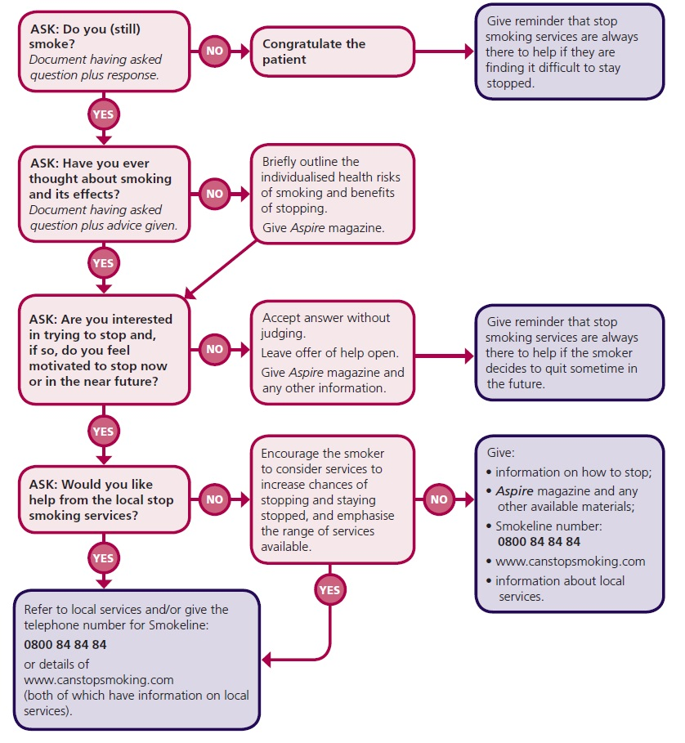

Appendix 4 Points to Cover in Smoking Cessation Discussion
As part of a brief intervention to encourage your patient to consider giving up smoking, you may wish to discuss with the patient the effect smoking can have on his/her, and other people’s, health.³²
- One cigarette contains >4000 chemicals, including carcinogenic substances like tar.
- Cigarette smoke contains carbon monoxide, a poisonous gas that lowers the blood’s ability to transport oxygen around the body.
- Nicotine is an extremely addictive drug which increases the heart rate and central nervous system’s activity.
- Smoking is related to lung cancer, coronary heart disease, stroke, chronic obstructive pulmonary disease (COPD), oral cancer, gum disease, fertility problems, skin problems, wrinkles and bad breath.
- People who smoke have a reduced sense of taste and smell compared with non-smokers.
- Children exposed to second-hand smoke are at increased risk of asthma, ear infections, respiratory infections and Sudden Infant Death Syndrome (SIDS).
- Non-smoking adults exposed to second-hand smoke have an increased risk of heart disease and lung cancer.
You may also wish to highlight the benefits of stopping smoking:
- Within days of stopping smoking the heart rate drops, carbon monoxide and oxygen levels return to levels similar to those seen in non-smokers, nicotine levels in blood disappear and the patient’s sense of taste and smell will sharpen.
- Within weeks: the patient’s lung function will begin to improve, coughing and shortness of breath will decrease and their complexion will improve.
- Over the longer term symptoms of chronic bronchitis improve, the risks of developing gastric and duodenal ulcers drops, the risks of developing lung and other cancers and cardiovascular disease, including stroke, decrease.
- Stopping smoking can lead to substantial savings; a patient who smokes 20 cigarettes daily, at a pack price of £7.00, spends approximately £2500 per year on cigarettes.
Other smoking cessation resources are available.
- Smokeline (0800 84 84 84) is a free, confidential helpline staffed by trained advisors who give advice and guidance to those that want to stop smoking as well as giving details of how to access local specialist services.
- Aspire magazine is produced by NHS Health Scotland and is aimed at people who smoke who are contemplating giving up. Copies of the magazine can be ordered from your health board or can be downloaded from www.healthscotland.com/documents/313.aspx.
- The Can Stop Smoking website (www.canstopsmoking.com) is an online resource for smokers who are contemplating giving up.

Appendix 5 Alcohol Units and Questionnaires

Units of Alcohol
Alcohol Beverage | Strength | Volume | Units
Normal strength beer, cider, lager | 4% | 1 pint | 2.2
Medium strength beer, cider, lager | 5% | 1 pint | 2.8
Alcopop | 5% | 275 ml | 1.4
Wine | 12.5% | 175 ml | 2.2
Fortified wine | 17% | 50 ml | 0.9
Spirits | 40% | 25 ml | 1.0

Various screening tools have been developed to gain an objective measure of alcohol consumption, for example AUDIT-PC (Alcohol Use Disorders Identification Test – Primary Care) and FAST (Fast Alcohol Screening Test). Further details are available from the alcohol learning centre (www.alcohollearningcentre.org.uk).

Appendix 6 Patients with Diabetes
Good long-term control of blood sugar levels is important in the management of both type 1 and type 2 diabetes and in preventing complications associated with the disease, including retinopathy, coronary heart disease and renal failure. As well as daily testing by patients, blood glucose levels should be regularly assessed by the patient’s physician. Testing to determine the level of glycated haemoglobin (HbA1c) gives an indication of the average blood glucose level in the previous 8 to 12 week period. HbA1c levels of between 48 and 58 mmol/mol indicate that the patient has good control of their condition, with levels greater than 58 mmol/mol being associated with an increased risk of diabetes-related complications. There is evidence that patients with poorly controlled diabetes have a higher risk of periodontal disease. There is also evidence that periodontal treatment of such patients can lead to improved glycaemic control.
- Ensure that you have an up-to-date medical history for all patients.
  - If a patient states he/she has diabetes, ask the patient if it is Type 1 or Type 2 and how his/her diabetes is controlled.
- Explain to patients who have diabetes that poorly controlled blood sugar levels increase the risk of developing periodontal disease. Also explain that periodontal treatment, where required, may improve blood sugar control.
- Ask patients who have diabetes:
  - “Is your diabetes well controlled?”
  - “What was your last HbA1c reading?”
- Ensure that patients with diabetes understand the need for effective oral hygiene.
- Consider contacting the GMP of patients with diabetes who also have periodontal disease.

Appendix 7 Advice For Medical Practitioners
Periodontal (gum) disease is a group of related conditions, both acute and chronic, characterised by inflammation of the periodontal tissues in response to the presence of dental plaque. Periodontal disease leads to irreversible damage to the soft tissue and bone support for the teeth which can lead to loss of teeth, reduced function and impaired nutrition and quality of life. Several medical conditions and medications are also associated with the development of periodontal disease. The most commonly encountered are detailed below.
Diabetes
Patients with type 1 and type 2 diabetes have a higher risk of developing periodontal (gum) disease. This is particularly true for patients whose diabetes is poorly controlled. There is also evidence that periodontal treatment of patients with diabetes can lead to improved glycaemic control. Patients with diabetes need to maintain good oral hygiene to both minimise their risk of periodontal disease and help control their diabetes.
- Advise patients with diabetes:
  - that their condition is associated with a higher risk of periodontal (gum) disease;
  - to make an appointment with a dentist as soon as possible for a full oral assessment;
  - to tell their dentist that they have diabetes.
N.B. A patient leaflet, which provides information about the link between diabetes and oral health, can be downloaded at www.sdcep.org.uk.
Drug-induced Gingival Enlargement
Certain types of medication can lead to gingival enlargement in some patients. These include the calcium channel blockers, phenytoin and ciclosporin. Good oral hygiene can minimise the risk of gingival enlargement in these patients. However, in severe cases, the patient’s dentist may contact you to discuss modification of the drug regimen.
- Advise patients taking these medications:
  - that a possible side effect of the medication is gingival enlargement;
  - to make an appointment with a dentist as soon as possible for a full oral assessment;
  - to tell their dentist that they are taking the medication.
Pregnancy Gingivitis
The changes in hormone levels and to the immune response associated with pregnancy have been implicated in the development or worsening of gingivitis. In most patients this can be managed with adequate oral hygiene. Most cases will resolve on delivery of the baby, although breastfeeding can extend the duration of the condition.
- Advise pregnant patients:
  - that they may experience red, swollen and bleeding gums during their pregnancy;
  - to make an appointment with a dentist as soon as possible for a full oral assessment.
N.B. Gingivitis is commonly observed in pre-teens and young teenagers where the increased inflammatory response to plaque is thought to be aggravated by the hormonal changes associated with puberty. Gingival enlargement may also be observed in susceptible individuals.
If needed, information about how to find a dentist can be found at www.scottishdental.org, or by contacting the local NHS Health Board.

Appendix 8 Assessment of Risk and Modifying Factors
Assigning a Risk Level for the Development of Periodontal Diseases.
The diagram below is from the SDCEP Oral Health Assessment and Review guidance⁷ and shows a simplified illustration of the risk assessment process.
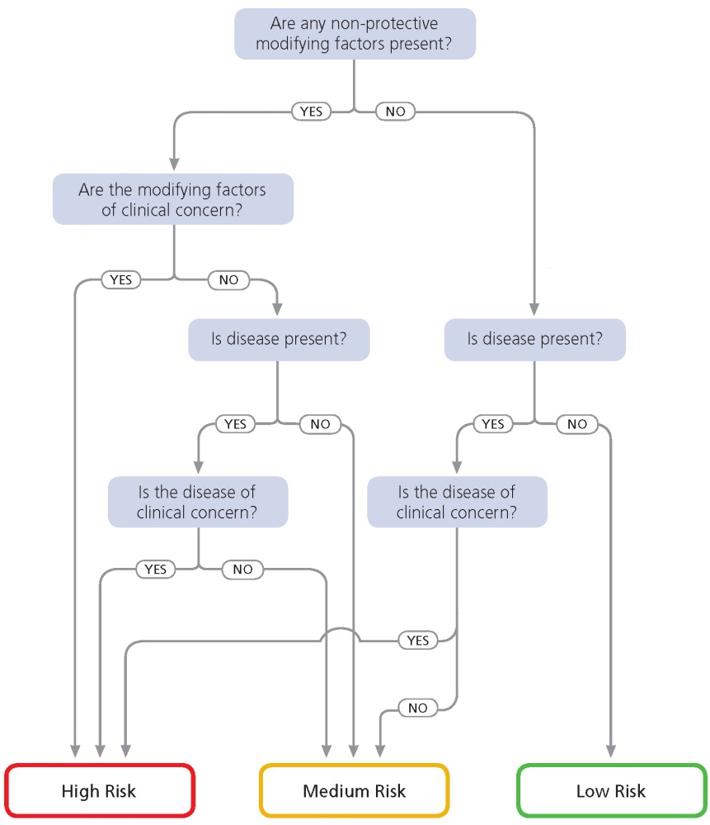

Modifying Factors for Periodontal Diseases
These modifying factors are associated with the development of periodontal diseases and should be considered when determining the risk-based frequency of recall for dental prophylaxis or supportive periodontal therapy.
- Bone loss observed on sequential radiographs;
- BPE scores of 3, 4, or * in patients under 35 years of age;
- Concurrent medical factor that is directly affecting the periodontal tissues (e.g. diabetes, stress, certain medications);
- Evidence of generalised chronic gingivitis;
- Family history of chronic or aggressive (early onset/juvenile) periodontitis;
- Family history of early tooth loss due to periodontal disease;
- High percentage of sites which bleed on probing in relation to a low plaque index;
- Poor level of oral hygiene;
- Presence of plaque-retentive factors;
- Previous history of treatment for periodontal disease;
- Rapid periodontal breakdown >2 mm attachment loss per year;
- Root morphology that affects prognosis;
- Smoking 10+ cigarettes a day.

References
1-
4
1. Steele J, O’Sullivan I. Adult Dental Health Survey 2009. The Health and Social Care Information Centre; 2011.
(www.hscic.gov.uk/pubs/dentalsurveyfullreport09)
2. Walker A, Cooper I. Adult Dental Health Survey: Oral Health in the United Kingdom, 1998.: Office for National Statistics; 2000.
(http://collection.europarchive.org/tna/20080107220102/
http://www.statistics.gov.uk/downloads/theme_health/AdltDentlHlth98_v3.pdf)
3. Dental statistics - NHS fees and treatments. Information Services Division, National Services Scotland; 2013.
(https://isdscotland.scot.nhs.uk/Health-Topics/Dental-Care/Publications/2013-06-25/2013-06-25-Dental-Report.pdf?61373537779)
4. Sharpe G, Durham JA, Preshaw PM. Attitudes regarding specialist referrals in periodontics. British Dental Journal. 2007;202(4):E11.
5. Harvie H. Periodontal Disease. Summons (MDDUS Membership Journal). Spring 2007(Spring 2007):14-15.
6. Young Practitioners Guide to Periodontology. 2nd ed: British Society of Periodontology; 2012.
(www.bsperio.org.uk/publications/downloads/37_162847_ypg-2nd-version-nov-12.pdf)
7. Oral Health Assessment and Review. Scottish Dental Clinical Effectiveness Programme; 2011.
(www.sdcep.org.uk)
8. Chambrone L, Preshaw PM, Rosa EF, et al. Effects of smoking cessation on the outcomes of non-surgical periodontal therapy: a systematic review and individual patient data meta-analysis. Journal of Clinical Periodontology. 2013;40(6):607-615.
9. Simpson TC, Needleman I, Wild SH, Moles DR, Mills EJ. Treatment of periodontal disease for glycaemic control in people with diabetes. Cochrane Database of Systematic Reviews 2010;Issue 5: Art. No.: CD004714. DOI: 10.1002/14651858.CD004714.pub2.
10. Basic Periodontal Examination (BPE). British Society of Periodontology; 2011.
(www.bsperio.org.uk/publications/downloads/39_143748_bpe2011.pdf)
11. Guidelines for Periodontal Screening and Management of Children and Adolescents Under 18 Years of Age. British Society of Periodontology; British Society of Paediatric Dentistry; 2012.
(www.bsperio.org.uk/publications/downloads/54_090016_bsp_bspd-perio-guidelines-for-the-under-18s-2012.pdf)
12. Hamp S-E, Nyman S, Lindhe J. Periodontal treatment of multi rooted teeth. Journal of Clinical Periodontology. 1975;2(3):126-135.
13. Miller SC. Textbook of Periodontia. 3rd ed. Philadelphia: The Blakestone Company; 1950.
14. Horner K, Eaton KA, eds. Selection Criteria for Dental Radiography. 3rd ed: Faculty of General Dental Practice (UK), The Royal College of Surgeons Of England; 2013.
15. Practice Support Manual: Dental Guidance. Scottish Dental Clinical Effectiveness Programme; 2014.
(www.psm.sdcep.org.uk)
16. Gray D, McIntyre G. Does oral health promotion influence the oral hygiene and gingival health of patients undergoing fixed appliance orthodontic treatment? A systematic literature review. Journal of Orthodontics. 2008;35(4):262-269.
17. Hujoel PP, Cunha-Cruz J, Loesche WJ, Robertson PB. Personal oral hygiene and chronic periodontitis: a systematic review. Periodontology 2000. 2005;37:29-34.
18. Kay E, Locker D. A systematic review of the effectiveness of health promotion aimed at improving oral health. Community Dental Health. 1998;15(3):132-144.
19. Kay EJ, Locker D. Is dental health education effective? A systematic review of current evidence. Community Dentistry and Oral Epidemiology. 1996;24(4):231-235.
20. Renz A, Ide M, Newton T, Robinson PG, Smith D. Psychological interventions to improve adherence to oral hygiene instructions in adults with periodontal diseases. Cochrane Database of Systematic Reviews. 2007;Issue 2: Art. No.: CD005097. DOI: 10.1002/14651858.CD005097.pub2.
21. Watt RG, Marinho VC. Does oral health promotion improve oral hygiene and gingival health? Periodontology 2000. 2005;37:35-47.
22. Jonsson B, Ohrn K, Oscarson N, Lindberg P. The effectiveness of an individually tailored oral health educational programme on oral hygiene behaviour in patients with periodontal disease: a blinded randomized-controlled clinical trial (one-year follow-up). Journal of Clinical Periodontology. 2009;36(12):1025-1034.
23. Sniehotta FF, Araujo Soares V, Dombrowski SU. Randomized controlled trial of a one-minute intervention changing oral self-care behavior. Journal of Dental Research. 2007;86(7):641-645.
24. Clarkson JE, Young L, Ramsay CR, Bonner BC, Bonetti D. How to influence patient oral hygiene behavior effectively. Journal of Dental Research. 2009;88(10):933-937.
25. Sambunjak D, Nickerson JW, Poklepovic T, et al. Flossing for the management of periodontal diseases and dental caries in adults. Cochrane Database of Systematic Reviews 2011;Issue 12: Art. No.: CD008829. DOI: 10.1002/14651858.CD008829.pub2.
26. Slot DE, Dörfer CE, Van der Weijden GA. The efficacy of interdental brushes on plaque and parameters of periodontal inflammation: a systematic review. International Journal of Dental Hygiene. 2008;6(4):253-264.
27. Imai PY, X.; MacDonald, D. Comparison of interdental brush to dental floss for reduction of clinical parameters of periodontal disease: A systematic review. Canadian Journal of Dental Hygiene. 2012;46(1):63-78.
28. Poklepovic T, Worthington HV, Johnson TM, et al. Interdental brushing for the prevention and control of periodontal diseases and dental caries in adults. Cochrane Database of Systematic Reviews 2013; Issue 12; Art. No.: CD009857. DOI: 10.1002/14651858.CD009857.pub2.
29. Robinson P, Deacon SA, Deery C, et al. Manual versus powered toothbrushing for oral health. Cochrane Database of Systematic Reviews. 2005;Issue 2:Art. No.: CD002281. DOI: 10.1002/14651858.CD002281.pub2.
30. Deacon SA, Glenny AM, Deery C, et al. Different powered toothbrushes for plaque control and gingival health. Cochrane Database of Systematic Reviews 2010;Issue 12:Art. No.: CD004971. DOI: 10.1002/14651858.CD004971.pub2.
31. Riley P, Lamont T. Triclosan/copolymer containing toothpastes for oral health. Cochrane Database of Systematic Reviews. 2013;Issue 12:Art. No.: CD010514. DOI: 10.1002/14651858.CD010514.pub2.
32. A guide to smoking cessation in Scotland 2010. NHS Health Scotland; 2010.
(www.healthscotland.com/documents/4661.aspx)
33. The management of harmful drinking and alcohol dependence in primary care. Scottish Intercollegiate Guidelines Network; 2004.
(www.sign.ac.uk/guidelines/fulltext/74/index.html#)
34. Alcohol and oral health: Understanding risk, raising awareness and giving advice. NHS Health Scotland; 2012.
(www.healthscotland.com/documents/6124.aspx)
35. Oral health and nutrition guidance for professionals. NHS Health Scotland; 2012.
(www.healthscotland.com/documents/5885.aspx)
36. Needleman I, Suvan J, Moles DR, Pimlott J. A systematic review of professional mechanical plaque removal for prevention of periodontal diseases. Journal of Clinical Periodontology. 2005;32 (Suppl 6):229-282.
37. Beirne P, Worthington HV, Clarkson JE. Routine scale and polish for periodontal health in adults. Cochrane Database of Systematic Reviews. 20013;Issue 11:Art. No.: CD004625. DOI: 10.1002/14651858.CD004625.pub4.
38. Elley K, Gold L, Burls A, Gray M. Scale and polish for chronic periodontal disease. A West Midlands Development and Evaluation Service Report;2000. 074421739.
39. Hung HC, Douglass CW. Meta-analysis of the effect of scaling and root planing, surgical treatment and antibiotic therapies on periodontal probing depth and attachment loss. Journal of Clinical Periodontology. 2002;29(11):975-986.
40. Suvan JE. Effectiveness of mechanical nonsurgical pocket therapy. Periodontology 2000. 2005;37:48-71.
41. Van der Weijden GA, Timmerman MF. A systematic review on the clinical efficacy of subgingival debridement in the treatment of chronic periodontitis. Journal of Clinical Periodontology. 2002;29 (Suppl 3):55-71.
42. Axelsson P, Nystrom B, Lindhe J. The long-term effect of a plaque control program on tooth mortality, caries and periodontal disease in adults. Results after 30 years of maintenance. Journal of Clinical Periodontology. 2004;31(9):749-757.
43. Carnevale G, Cairo F, Tonetti MS. Long-term effects of supportive therapy in periodontal patients treated with fibre retention osseous resective surgery. I: recurrence of pockets, bleeding on probing and tooth loss. Journal of Clinical Periodontology. 2007;34(4):334-341.
44. Tonetti MS, Muller-Campanile V, Lang NP. Changes in the prevalence of residual pockets and tooth loss in treated periodontal patients during a supportive maintenance care program. Journal of Clinical Periodontology. 1998;25(12):1008-1016.
45. Paulander J, Axelsson P, Lindhe J, Wennstrom J. Intra-oral pattern of tooth and periodontal bone loss between the age of 50 and 60 years. A longitudinal prospective study. Acta Odontologica Scandinavica 2004;62(4):214-222.
46. Paulander J, Wennstrom JL, Axelsson P, Lindhe J. Some risk factors for periodontal bone loss in 50-year-old individuals. A 10-year cohort study. Journal of Clinical Periodontology. 2004;31(7):489-496.
47. Tunkel J, Heinecke A, Flemmig TF. A systematic review of efficacy of machine-driven and manual subgingival debridement in the treatment of chronic periodontitis. Journal of Clinical Periodontology. 2002;29(s3):72-81.
48. Lea SC, Landini G, Walmsley AD. The effect of wear on ultrasonic scaler tip displacement amplitude. Journal of Clinical Periodontology. 2006;33:37-41.
49. van Steenberghe D, Bercy P, De Boever J, et al. Patient evaluation of a novel non-injectable anesthetic gel: a multicenter crossover study comparing the gel to infiltration anesthesia during scaling and root planing. Journal of Periodontology. 2004;75(11):1471-1478.
50. Eberhard J, Jervoe-Storm PM, Needleman I, Worthington H, Jepsen S. Full-mouth treatment concepts for chronic periodontitis: a systematic review. Journal of Clinical Periodontology. 2008;35(7):591-604.
51. Farman M, Joshi RI. Full-mouth treatment versus quadrant root surface debridement in the treatment of chronic periodontitis: a systematic review. British Dental Journal. 2008;205(9):E18.
52. Lang NP, Tan WC, Krahenmann MA, Zwahlen M. A systematic review of the effects of full-mouth debridement with and without antiseptics in patients with chronic periodontitis. Journal of Clinical Periodontology. 2008;35(8 Suppl):8-21.
53. Hallmon WW, Rees TD. Local anti-infective therapy: mechanical and physical approaches. A systematic review. Annals of Periodontology. 2003;8(1):99-114.
54. Bonito AJ, Lux L, Lohr KN. Impact of local adjuncts to scaling and root planing in periodontal disease therapy: a systematic review. Journal of Periodontology. 2005;76(8):1227-1236.
55. Hanes PJ, Purvis JP. Local anti-infective therapy: pharmacological agents. A systematic review. Annals of Periodontology. 2003;8(1):79-98.
56. Pavia M, Nobile CG, Angelillo IF. Meta-analysis of local tetracycline in treating chronic periodontitis. Journal of Periodontology. 2003;74(6):916-932.
57. Pavia M, Nobile CG, Bianco A, Angelillo IF. Meta-analysis of local metronidazole in the treatment of chronic periodontitis. Journal of Periodontology. 2004;75(6):830-838.
58. Cosyn J, Wyn I. A systematic review on the effects of the chlorhexidine chip when used as an adjunct to scaling and root planing in the treatment of chronic periodontitis. Journal of Periodontology. 2006;77(2):257-264.
59. Matesanz-Perez P, Garcia-Gargallo M, Figuero E, Bascones-Martinez A, Sanz M, Herrera D. A systematic review on the effects of local antimicrobials as adjuncts to subgingival debridement, compared with subgingival debridement alone, in the treatment of chronic periodontitis. Journal of Clinical Periodontology. 2013;40(3):227-241.
60. Elter JR, Lawrence HP, Offenbacher S, Beck JD. Meta-analysis of the effect of systemic metronidazole as an adjunct to scaling and root planing for adult periodontitis. Journal of Periodontal Research. 1997;32(6):487-496.
61. Haffajee AD, Socransky SS, Gunsolley JC. Systemic anti-infective periodontal therapy. A systematic review. Annals of Periodontology. 2003;8(1):115-181.
62. Herrera D, Sanz M, Jepsen S, Needleman I, Roldan S. A systematic review on the effect of systemic antimicrobials as an adjunct to scaling and root planing in periodontitis patients. Journal of Clincal Periodontology. 2002;29 (Suppl 3):136-159.
63. Sgolastra F, Gatto R, Petrucci A, Monaco A. Effectiveness of systemic amoxicillin/metronidazole as adjunctive therapy to scaling and root planing in the treatment of chronic periodontitis: a systematic review and meta-analysis. Journal of Periodontology. 2012;83(10):1257-1269.
64. Zandbergen D, Slot DE, Cobb CM, Van der Weijden FA. The clinical effect of scaling and root planing and the concomitant administration of systemic amoxicillin and metronidazole: a systematic review. Journal of Periodontology. 2013;84(3):332-351.
65. Angaji M, Gelskey S, Nogueira-Filho G, Brothwell D. A systematic review of clinical efficacy of adjunctive antibiotics in the treatment of smokers with periodontitis. Journal of Periodontology. 2010;81(11):1518-1528.
66. Sgolastra F, Petrucci A, Gatto R, Monaco A. Effectiveness of systemic amoxicillin/metronidazole as an adjunctive therapy to full-mouth scaling and root planing in the treatment of aggressive periodontitis: a systematic review and meta-analysis. Journal of Periodontology. 2012;83(6):731-743.
67. Preshaw PM, Hefti AF, Bradshaw MH. Adjunctive subantimicrobial dose doxycycline in smokers and non-smokers with chronic periodontitis. Journal of Clinical Periodontology. 2005;32(6):610-616.
68. Sgolastra F, Petrucci A, Gatto R, Giannoni M, Monaco A. Long-term efficacy of subantimicrobial-dose doxycycline as an adjunctive treatment to scaling and root planing: a systematic review and meta-analysis. Journal of Periodontology. 2011;82(11):1570-1581.
69. Loe H, Schiott CR. The effect of mouthrinses and topical application of chlorhexidine on the development of dental plaque and gingivitis in man. Journal of Periodontal Research. 1970;5(2):79-83.
70. Gunsolley JC. A meta-analysis of six-month studies of antiplaque and antigingivitis agents. Journal of the American Dental Association. 2006;137(12):1649-1657.
71. Hase JC, Edwardsson S, Rundegren J, Attström R, Kelty E. 6-month use of 0.2% delmopinol hydrochloride in comparison with 0.2% chlorhexidine digluconate and placebo (II). Effect on plaque and salivary microflora. Journal of Clinical Periodontology. 1998;25(11):841-849.
72. Lang NP, Hase JC, Grassi M, et al. Plaque formation and gingivitis after supervised mouthrinsing with 0.2% delmopinol hydrochloride, 0.2% chlorhexidine digluconate and placebo for 6 months. Oral Diseases. 1998;4(2):105-113.
73. von Troil B, Needleman I, Sanz M. A systematic review of the prevalence of root sensitivity following periodontal therapy. Journal of Clinical Periodontology. 2002;29(Supplement 3):173-177.
74. Poulsen S, Errboe M, Lescay Mevil Y, Glenny AM. Potassium containing toothpastes for dentine hypersensitivity. Cochrane Database of Systematic Reviews. 2006;Issue 3:Art. No.: CD001476. DOI: 10.1002/14651858.CD001476.pub2.
75. Cunha-Cruz J, Stout JR, Heaton LJ, Wataha JC, Northwest P. Dentin hypersensitivity and oxalates: a systematic review. Journal of Dental Research 2011;90(3):304-310.
76. Lin PY, Cheng YW, Chu CY, Chien KL, Lin CP, Tu YK. In-office treatment for dentin hypersensitivity: a systematic review and network meta-analysis. Journal of Clinical Periodontology 2013;40(1):53-64.
77. Sharif MO, Iram S, Brunton PA. Effectiveness of arginine-containing toothpastes in treating dentine hypersensitivity: a systematic review. Journal of Dentistry. 2013;41(6):483-492.
78. Heasman PA, McCracken GI, Steen N. Supportive periodontal care: the effect of periodic subgingival debridement compared with supragingival prophylaxis with respect to clinical outcomes. Journal of Clinical Periodontology. 2002;29 (Suppl 3):163-172;.
79. Grusovin MG, Coulthard P, Worthington HV, George P, Esposito M. Interventions for replacing missing teeth: maintaining and recovering soft tissue health around dental implants. Cochrane Database of Systematic Reviews. 2010;Issue 8:Art. No.: CD003069. DOI: 10.1002/14651858.CD003069.pub4.
80. Hultin M, Komiyama A, Klinge B. Supportive therapy and the longevity of dental implants: a systematic review of the literature. Clinical Oral Implants Research. 2007;18:50-62.
81. Ong CT, Ivanovski S, Needleman IG, et al. Systematic review of implant outcomes in treated periodontitis subjects. Journal of Clinical Periodontology. 2008;35(5):438-462.
82. Quirynen M, Abarca M, Van Assche N, Nevins M, van Steenberghe D. Impact of supportive periodontal therapy and implant surface roughness on implant outcome in patients with a history of periodontitis. Journal of Clinical Periodontology. 2007;39(9):805-815.
83. Jemt T, Johansson J. Implant treatment in the edentulous maxillae: a 15-year follow-up study on 76 consecutive patients provided with fixed prostheses. Clinical Implant Dentistry and Related Research. 2006;8(2):61-69.
84. Albrektsson T, Buser D, Chen ST, et al. Statements from the Estepona consensus meeting on peri-implantitis, February 2-4, 2012. Clinical Implant Dentistry and Related Research.14(6):781-782.
85. Renvert S, Roos-Jansaker AM, Claffey N. Non-surgical treatment of peri-implant mucositis and peri-implantitis: a literature review. Journal of Clinical Periodontology. 2008;35(8 Suppl):305-315.
86. Esposito M, Grusovin MG, Worthington HV. Interventions for replacing missing teeth: treatment of peri-implantitis. Cochrane Database of Systematic Reviews. 2012;Issue 1:Art. No.: CD004970. DOI: 10.1002/14651858.CD004970.pub5.
87. Klinge B, Gustafsson A, Berglundh T. A systematic review of the effect of anti-infective therapy in the treatment of peri-implantitis. Journal of Clinical Periodontology. 2002;29 (Suppl 3):213-225.
88. Kotsovilis S, Karoussis IK, Trianti M, Fourmousis I. Therapy of peri-implantitis: a systematic review. Journal of Clinical Periodontology. 2008;35(7):621-629.
89. Muthukuru M, Zainvi A, Esplugues EO, Flemmig TF. Non-surgical therapy for the management of peri-implantitis: a systematic review. Clinical Oral Implants Research. 2012;23 Suppl 6:77-83.
90. Heitz-Mayfield LJ, Lang NP. Antimicrobial treatment of peri-implant diseases. International Journal of Oral & Maxillofacial Implants. 2004;19 (Special Suppl):128-139.
91. Referral Policy and Parameters of Care. British Society of Periodontology; 2011.
(www.bsperio.org.uk/publications/downloads/28_143801_parameters_of_care.pdf)
92. Pendlebury ME, Horner K, Eaton KA, eds. Clinical Examination and Record Keeping. Good Practice Guidelines. 2nd ed: Faculty of General Dental Practice (UK); 2009. .
93. Data Protection Act. 1998.
(www.legislation.gov.uk/ukpga/1998/29/contents)
94. Getting it right: A brief guide to data protection for small businesses. Information Commissioner's Office 2008.
(www.ico.org.uk/for_organisations/sector_guides/~/media/documents/library/Data_Protection/Practical_application/getting_it_right_a_brief_guide_to_data_protection_for_smes.ashx)
95. Getting it right: Small business checklist. Information Commissioner's Office; 2008.
(www.ico.org.uk/for_organisations/sector_guides/~/media/documents/library/Data_Protection/Practical_application/getting_it_right_-_how_to_comply_checklist.ashx)
96. Niederman R, Chen L, Murzyn L, Conway S. Benchmarking the dental randomised controlled literature on MEDLINE. Evidence-based Dentistry. 2002;3(1):5-9.
97. Montenegro R, Needleman I, Moles D, Tonetti M. Quality of RCTs in periodontology--a systematic review. Journal of Dental Research. 2002;81(12):866-870.
98. Faggion CM, Jr., Atieh MA, Park S. Search strategies in systematic reviews in periodontology and implant dentistry. Journal of Clinical Periodontology. 2013;40(9):883-888.
99. Faggion CM, Jr., Giannakopoulos NN. Critical appraisal of systematic reviews on the effect of a history of periodontitis on dental implant loss. Journal of Clinical Periodontology. 2013;40(5):542-552.
100. Glenny AM, Esposito M, Coulthard P, Worthington HV. The assessment of systematic reviews in dentistry. European Journal of Oral Sciences. 2003;111(2):85-92.
101. Clarkson JE, Ramsay CR, Eccles MP, et al. The translation research in a dental setting (TRiaDS) programme protocol. Implementation Science. 2010;5:57.
102. Shea BJ, Bouter LM, Peterson J, Boers M, Andersson N, Ortiz Zea. External validation of a measurement tool to assess systematic reviews (AMSTAR). PLOS ONE. 2007;2(12):e1350.

§ A Patient Group Direction (PGD) is a written instruction which allows listed healthcare professionals to sell, supply or administer named medicines in an identified clinical situation without the need for a written, patient-specific prescription from an approved prescriber.
ǂ Refer to the SDCEP Drug Prescribing for Dentistry guidance for further details.
¥ The antibiotic doses recommended in Drug Prescribing for Dentistry are based on the doses recommended by the British National Formulary (BNF). Dentists should be aware that local formulary recommendations may differ.
¥ Refer to the SDCEP Drug Prescribing for Dentistry guidance for further details of drug regimens.

