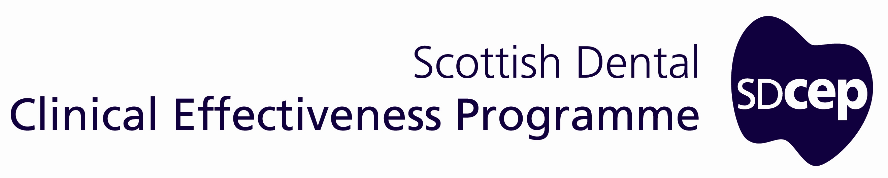
Managing Decontamination in Dental Practice
Dental Clinical Guidance

Decontamination Into Practice: Part 3

Last reviewed January 2016
No substantive changes to the legislation, regulations or generic national guidance on which the current SDCEP Decontamination Into Practice is based were found. This guidance remains unchanged and extant until the next review.

October 2014

October 2014

© Scottish Dental Clinical Effectiveness Programme
SDCEP operates within NHS Education for Scotland. You may copy or reproduce
the information in this document for use within NHS Scotland and for non-commercial
educational purposes.
Use of this document for commercial purpose is permitted only with written permission.
ISBN 978 1 905829 22 4
First published October 2014

Scottish Dental Clinical Effectiveness Programme
Dundee Dental Education Centre, Frankland Building, Small’s Wynd, Dundee DD1 4HN

Email scottishdental.cep@nes.scot.nhs.uk
Tel 01382 425751 / 425771
Website www.sdcep.org.uk

Introduction
Ensuring effective decontamination of reusable instruments is complex and, as illustrated here, relies on the integration of several key elements:
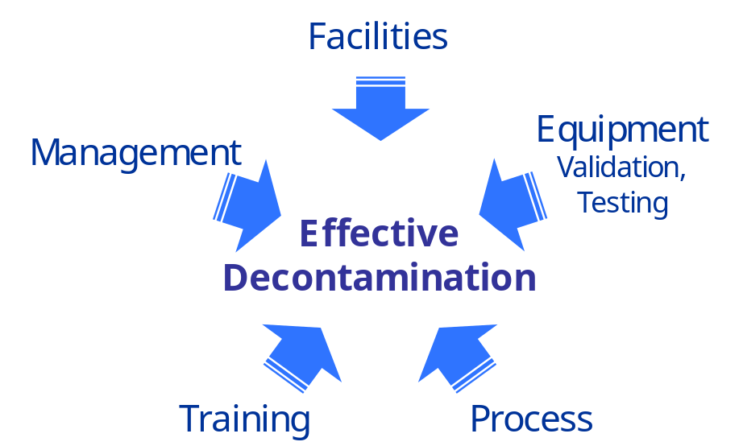

- Facilities: these need to be fit for purpose, well-organised and maintained.
- Equipment, Validation, Testing: the correct equipment must be available and be validated and tested to ensure that it is functioning correctly.
- Process: a standard decontamination process must be established and followed.
- Training: staff need to know their specific roles and be fully trained to carry out their duties effectively.

In addition, an effective system for management of the process is necessary to enable the practice to demonstrate, both to its staff and externally, that it meets national standards for decontamination in primary care, can consistently deliver these standards and can identify any improvements required. This includes:
- documenting how the practice sets out to achieve effective decontamination in the form of policy statements and procedures for each part of the process;
- recording and retaining relevant information to show that each part of the process has been effective;
- regular audit and review to monitor whether processes are up to date, are being followed and to implement any changes required.

The requirements for decontamination management are detailed in guidance from Health Protection Scotland and many of these requirements are specified within the NHSScotland Combined Practice Inspection.

Managing Decontamination in Dental Practice (MDDP) has been developed specifically for the needs of dental practices following a review of earlier generic approaches to decontamination management. MDDP aims to help dental practices create the documentation that underpins a decontamination management system by supplementing the documents that the practice already has.

There is considerable overlap between decontamination management and general health and safety management within a dental practice. Consequently, some of the documentation is common to both of these activities.

MDDP comprises a checklist for reviewing the current status of decontamination documentation and a collection of templates and forms that the practice can adapt for its own use as required. These documents are all available online via SDCEP’s Practice Support Manual (www.psm.sdcep.org.uk).

Note that there is no requirement to use the MDDP documents. Instead, they are provided to illustrate what a practice needs to include in its own documentation.

For further advice on requirements for decontamination management, refer to Local Decontamination Units: Guidance on the Requirements for Equipment, Facilities and Management (2007) or Health Facilities Scotland’s Decontamination Documentation System.

How to Use MDDP
The MDDP Checklist, templates and forms are all available online via SDCEP’s Practice Support Manual (www.psm.sdcep.org.uk).

Many of the MDDP documents are templates for policies and procedures.
- A policy states what the practice sets out to do.
- A procedure is a more detailed guide for what to do to put the policy into practice.

While for most activities both a policy statement and procedure are appropriate, for some either a policy or procedure is sufficient.
- To begin using MDDP to develop your decontamination management system, first familiarise yourself with the MDDP Checklist and the template documents cited in it.
- Use the MDDP Checklist to note which items are included in your current documentation.

If you already have similar documents in use in your practice:
- Refer to the documents cited in the MDDP Checklist to confirm whether you have included all the necessary elements to cover the processes, equipment and products used for decontamination.
- Update your documents as necessary.

If you are just at the stage of setting up your decontamination management system:
- Use the MDDP Checklist as the basis for compiling the necessary documents and establishing processes.

Practices are likely to differ in the way that they store documentation (e.g. electronically or printed). It is recommended that some items, such as certain procedures, are readily available for staff to consult routinely.

By using the MDDP documents as described, you should find that when a practice inspection approaches, it is more straightforward to produce the necessary documentation to demonstrate that you are achieving the national standards for decontamination as expected of a modern primary care dental practice.

