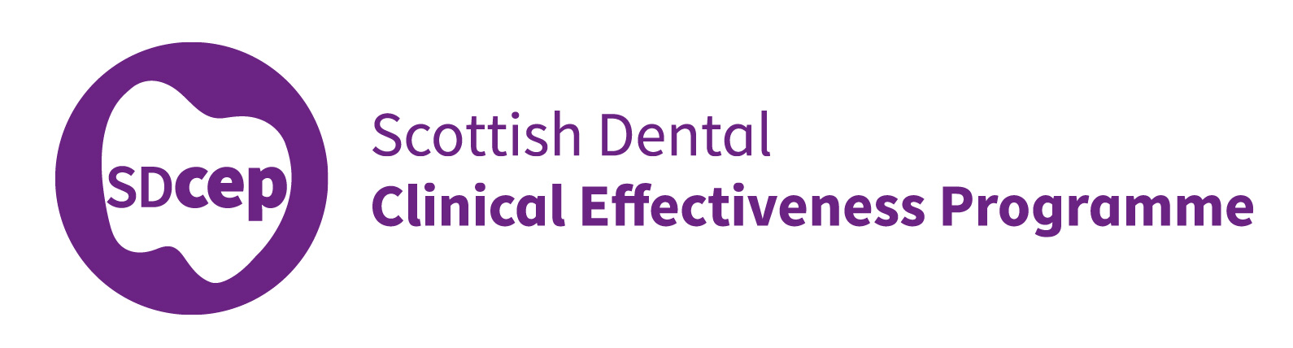

Oral Health Management of Patients
at Risk of Medication-related Osteonecrosis of the Jaw

Guidance in Brief

March 2017

For further details, please refer to the full guidance, available at www.sdcep.org.uk

©Scottish Dental Clinical Effectiveness Programme
SDCEP operates within NHS Education for Scotland. You may copy or reproduce the information in this document for use within NHSScotland and for non-commercial educational purposes.
Use of this document for commercial purposes is not permitted.
First published 2017

Scottish Dental Clinical Effectiveness Programme
Dundee Dental Education Centre, Frankland Building, Small’s Wynd, Dundee DD1 4HN
Email scottishdental.cep@nes.scot.nhs.uk
Tel 01382 425751 / 425771
Website www.sdcep.org.uk

Introduction
Oral Health Management of Patients at Risk of Medication-related Osteonecrosis of the Jaw is designed to assist and support primary care dental teams in providing appropriate care for patients prescribed anti-resorptive or anti-angiogenic drugs. The guidance aims to support the dental team to:
- assess a patient’s individual MRONJ risk level;
- optimise the patient’s oral health during the initial phase of drug treatment;
- continue to provide routine dental care for this patient group in the primary care setting.
The main elements of Oral Health Management of Patients at Risk of Medication-related Osteonecrosis of the Jaw are included in this guidance in Brief. For a full appreciation of the recommendations and further advice on following them, refer to the full guidance. Management of these patients is not difficult or onerous and, in most cases, can be carried out successfully in primary care.
The full guidance is available at www.sdcep.org.uk.

Drugs associated with MRONJ Prescribed in the United Kingdom*
DrugType | Drug name | Trade name(s)
Bisphosphonate | alendronic acid | Binosto®, Fosamax®, Fosavance®
Bisphosphonate | risedronate sodium | actonel®, actonel Combi®
Bisphosphonate | zoledronic acid | aclasta®, Zometa®
Bisphosphonate | ibandronic acid | Bondronat®, Bonviva®, Iasibon®  Quodixor®
Bisphosphonate | pamidronate disodium | aredia®
Bisphosphonate | sodium clodronate | Bonefos®, Clasteon®, Loron®
RANKL Inhibitor | denosumab | Prolia®, Xgeva®
anti-angiogenic | bevacizumab | avastin®  Sutent®  Zaltrap®
anti-angiogenic | sunitinib | Sutent®
anti-angiogenic | aflibercept | Zaltrap®
*Correct at the time of publication. This list is not exhaustive. Be aware that drug trade names can change and new drugs may be released that may be implicated in MRONJ. Consult the SDCEP website (www.sdcep.org.uk) for an up-to-date list of the drugs with an MHRA Drug Safety Update for risk of MRONJ.

Risk assessment
Assess whether a patient taking anti-resorptive or anti-angiogenic drugs is at low risk or higher risk of developing MRONJ based on their medical condition, type and duration of drug therapy and any other complicating factors and record this in the patient’s clinical notes.
- Ask about past, current, or possible future use of anti-resorptive or anti-angiogenic drugs when taking or confirming a medical history.
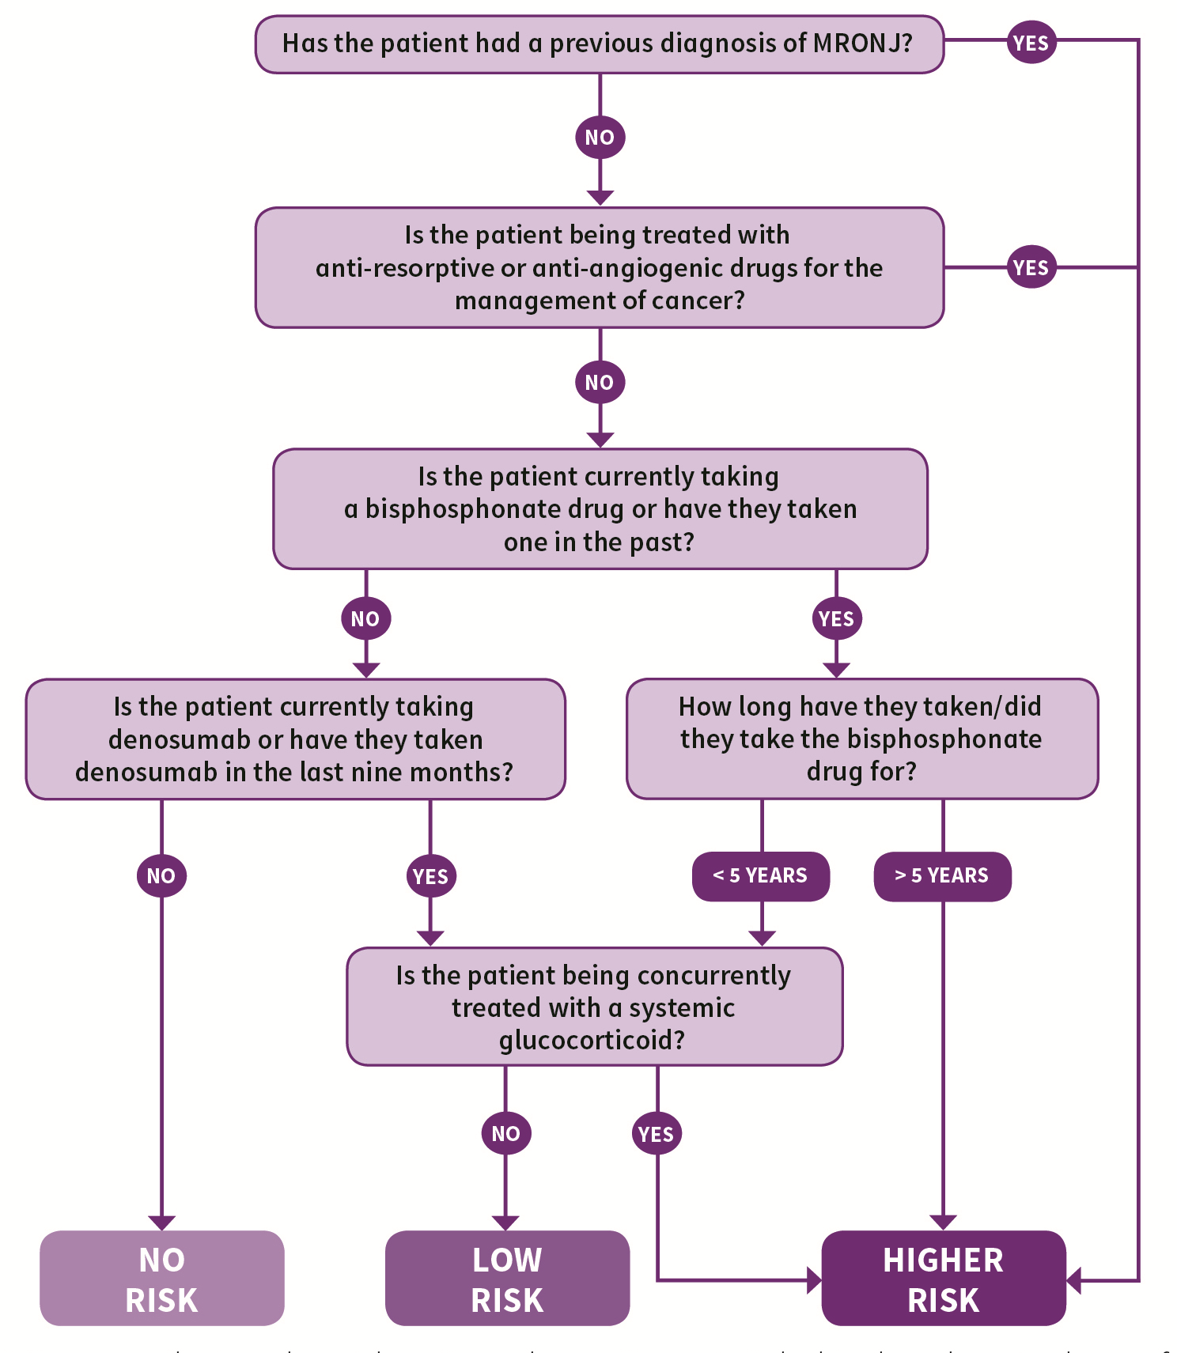

Initial Management
Before commencement of anti-resorptive or anti-angiogenic drug therapy, or as soon as possible thereafter, aim to get the patient as dentally fit as feasible, prioritising preventive care.
Higher risk cancer patients should preferably undergo a thorough dental assessment, with remedial dental treatment where required, prior to commencement of the drug therapy.
- Advise the patient (or carer, where appropriate) that there is a risk of developing MRONJ but ensure they understand that the risk is small so that they are not discouraged from taking their medication or from undergoing dental treatment. Record that this advice has been given.
- Give personalised preventive advice to help the patient optimise their oral health, emphasizing the importance of:
- having a healthy diet and reducing sugary snacks and drinks;
- maintaining excellent oral hygiene;
- using fluoride toothpaste and fluoride mouthwash;
- stopping smoking;
- limiting alcohol intake;
- regular dental checks;
- reporting any symptoms such as exposed bone, loose teeth, non-healing sores or lesions, pus or discharge, tingling, numbness or altered sensations, pain or swelling as soon as possible.
- Prioritise care that will reduce mucosal trauma or may help avoid future extractions or any oral surgery or procedure that may impact on bone:
- consider obtaining appropriate radiographs to identify possible areas of infection and pathology;
- undertake any remedial dental work;
- extract any teeth of poor prognosis without delay;
- focus on minimising periodontal/dental infection or disease;
- adjust or replace poorly fitting dentures to minimise future mucosal trauma;
- consider prescribing high fluoride toothpaste.
- For medically complex patients for whom you would normally seek advice, including higher risk patients who are being treated with anti-resorptive or anti-angiogenic drugs for the management of cancer, consider consulting an oral surgery/special care dentistry specialist with regards to clinical assessment and treatment planning.

Continuing Management
Carry out all routine dental treatment as normal and continue to provide personalised preventive advice in primary care.
Do not prescribe antibiotic or antiseptic prophylaxis following extractions or other bone-impacting treatments specifically to reduce the risk of MRONJ.
- Treat routinely for scale and polish, simple restorations, recall and radiological review.
- If an extraction or any oral surgery or procedure that impacts on bone is necessary, discuss the risk of the procedure with the patient (or carer, where appropriate) to ensure valid consent and follow the recommended management strategy based on their allocated risk group.
Low Risk | Higher Risk
- Perform straightforward extractions and procedures that may impact on bone in primary care. | - Explore all possible alternatives to extraction where teeth could potentially be retained e.g. retaining roots in absence of infection.
- Do not prescribe antibiotic or antiseptic prophylaxis unless required for other clinical reasons. | - If extraction remains the most appropriate treatment, proceed as for low risk patients.

- Advise the patient to contact the practice if they have any concerns, such as unexpected pain, tingling, numbness, altered sensation or swelling in the extraction area.
- Review healing. If the extraction socket is not healed at 8 weeks and you suspect that the patient has MRONJ, refer to an oral surgery/special care dentistry specialist as per local protocols.
- If you suspect a patient has spontaneous MRONJ, refer to an oral surgery/special care dentistry specialist as per local protocols.

Overview of the Oral Health Management of Patients at Risk of MRONJ

