Prevention and Treatment of Periodontal Diseases in Primary Care
Guidance in Brief

June 2014

© Scottish Dental Clinical Effectiveness Programme
SDCEP operates within NHS Education for Scotland. You may copy or reproduce the information in this document for use within NHS Scotland and for non-commercial educational purposes.
Use of this document for commercial purpose is permitted only with written permission.
Published June 2014

Scottish Dental Clinical Effectiveness Programme
Dundee Dental Education Centre, Frankland Building, Small’s Wynd, Dundee DD1 4HN

Email scottishdental.cep@nes.scot.nhs.uk
Tel 01382 425751 / 425771
Website www.sdcep.org.uk
Introduction
Prevention and Treatment of Periodontal Diseases in Primary Care is designed to assist and support primary care dental teams in providing appropriate care for patients both at risk of and with periodontal diseases. The guidance aims to support the dental team to:
• manage patients with periodontal diseases in primary care appropriately;
• improve the quality of decision making for referral to secondary care;
• improve the overall health of the population.
Overview
The main elements of the Prevention and Treatment of Periodontal Diseases in Primary Care are illustrated in the diagram below and summarised within this Guidance in Brief. For a full appreciation of the recommendations and further advice on following them, refer to the sections of the full guidance indicated.
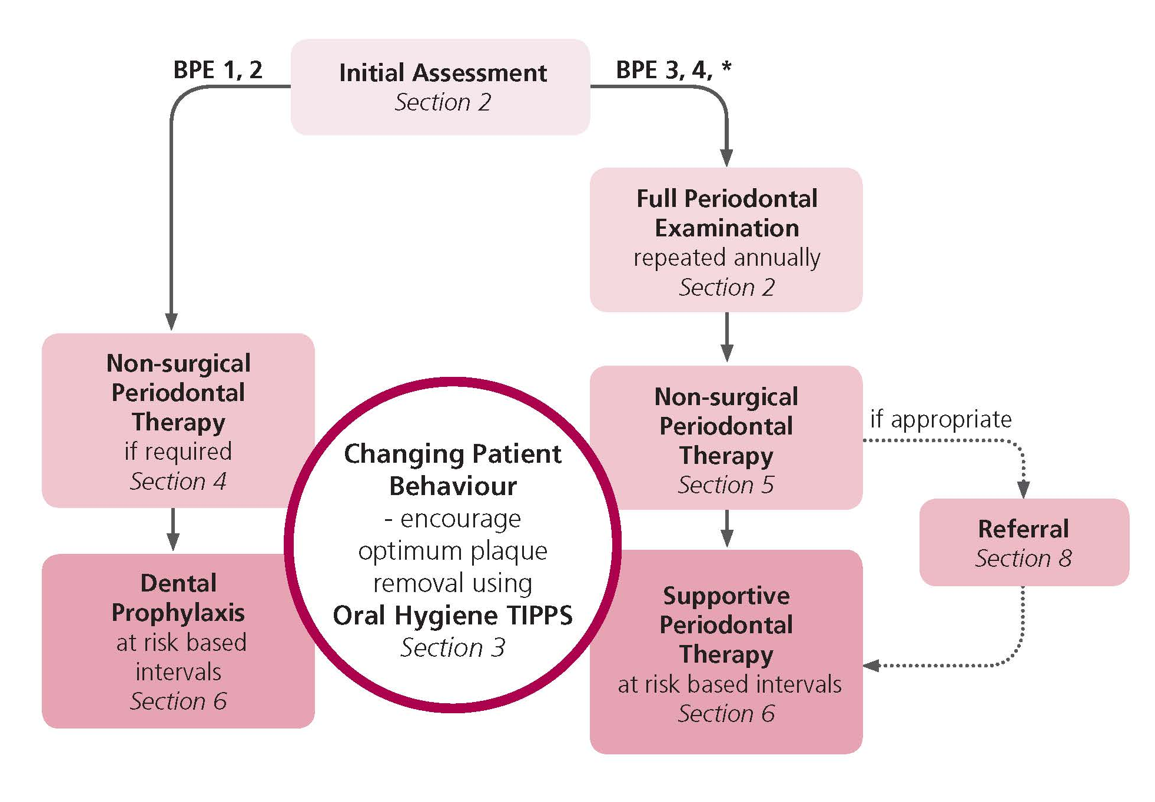
The full guidance can be downloaded from www.scottishdental.org/cep.

Assessment and Diagnosis (Refer to Section 2 of the full guidance)
Risk Factors
- Explain to patients who have known risk factors (e.g. smoking, diabetes) that they are at risk of developing periodontal disease and the steps they can take to reduce their risk.
- Ensure that patients who are pregnant are aware of their increased risk of developing pregnancy gingivitis. Highlight the need for more frequent visits for dental prophylaxis or, if required, supportive periodontal therapy during pregnancy.
Basic Periodontal Examination (BPE)
- Carry out periodontal screening of all dentate patients at every routine recall examination using the Basic Periodontal Examination (BPE).^{ǂ}
- Assign a risk level to inform future treatment and recall.
- For patients with a BPE score of 4 in any sextant or with a BPE score of 3 in more than one sextant, carry out a full periodontal examination and record the findings in the patient’s clinical notes. For patients with a BPE score of 3 in one sextant only, carry out periodontal charting of that sextant.
^{ǂ}Patients receiving supportive periodontal therapy require a full periodontal examination on an annual basis.
Full Periodontal Examination for patients with BPE 3, 4, *
- Record at least one measure of the greatest extent of gingival recession observed for both the buccal and lingual surfaces of each tooth.
- Measure probing depth at six sites around each tooth.
- Record bleeding on probing, any furcation involvement for multi-rooted teeth, any tooth mobility and any other observations, such as presence of dental caries, occlusal discrepancies and problems with restorations.
- Consider whether a radiographic examination to assess alveolar bone levels is appropriate.
- Record plaque and gingivitis scores.

Use of Radiographs
- If radiographs are indicated, take horizontal bitewing radiographs or intra-oral periapical views using the long cone paralleling technique.
- Consider taking a good quality, low dose panoramic radiograph if large numbers of intra-oral periapical radiographs are required.
- Ensure that all radiographs are assessed and the results recorded in the patient’s clinical notes.
Treatment Planning
- Provide an individualised treatment plan that is specific to the patient and ensure that it has defined therapeutic goals.
- Explain to the patient what treatment you wish to provide, what this involves and what the intended results are. Also explain what the consequences of no treatment may be.
- Explain to the patient his/her role in improving periodontal health:
  - Make clear that periodontitis is a chronic condition that needs to be managed.
  - Emphasise that management of the disease is a partnership between patient and clinician and requires a life-long commitment.
- Ensure that the patient is periodontally stable before planning any advanced or complex procedures (e.g. implant placement).
- Ensure that patients with a history of periodontitis who are considering dental implants are fully informed about the increased risk of complications due to their oral health history.

Changing Patient Behaviour (Refer to Section 3 of the full guidance)
- Use the Oral Hygiene TIPPS behaviour change strategy to highlight the importance of effective plaque removal and to show the patient how he/she can achieve this.
  - TALK with the patient about the causes of periodontal disease and discuss any barriers to effective plaque removal.
  - INSTRUCT the patient on the best ways to perform effective plaque removal.
  - Ask the patient to PRACTISE cleaning his/her teeth and to use the interdental cleaning aids whilst in the dental surgery; correct the patient’s technique if necessary.
  - Put in place a PLAN which specifies how the patient will incorporate oral hygiene into daily life.
  - Provide SUPPORT to the patient by following-up at subsequent visits.
- Raise the issue of stopping smoking where appropriate.
  - Discuss the effect smoking has on oral and general health and the benefits of stopping.
  - Offer information on local smoking cessation services.
- Encourage patients to modify other lifestyle factors which may impact on their oral and general health such as:
  - diet;
  - physical activity;
  - alcohol consumption.

Non-surgical Periodontal Therapy (Refer to Sections 4 and 5 of the full guidance)
For all patients
- Use Oral Hygiene TIPPS to address inadequate plaque removal. Where applicable, give smoking cessation advice.Explain to patients with crowded teeth, partial dentures, bridgework and orthodontic appliances, the importance of adequate plaque removal around these local risk factors. If possible, correct local plaque retentive factors.
For gingivitis and gingival enlargement
- Remove supra-gingival plaque, calculus and stain and sub-gingival deposits using an appropriate method. Highlight to the patient areas where supra-gingival deposits are detected.
- Where the gingival enlargement is drug-induced, consider consulting the patient’s physician.
- Where gingival enlargement hinders adequate plaque removal, consider referring for specialist periodontal care.
- Re-assess at a future visit to determine whether the gingivitis or gingival enlargement has resolved.
For periodontitis
- Remove supra-gingival plaque, calculus and stain. Highlight to the patient areas where supra-gingival deposits are detected. Carry out root surface instrumentation (RSI) at sites of ≥4 mm probing depth where sub-gingival deposits are present or which bleed on probing. Local anaesthesia may be required.
- Advise the patient that he/she may experience some discomfort and sensitivity following treatment and to expect some gingival recession as a result of healing.
  - Proprietary desensitising toothpastes or mouthwashes can be used to treat particular areas of dentine sensitivity following RSI.
- Carry out a full periodontal examination a minimum of 8 weeks post treatment.

Treatment of Acute Conditions (Refer to Section 5 of the full guidance)
- Manage acute conditions using local measures in the first instance.
- Do not prescribe antibiotics unless there is evidence of spreading infection or systemic involvement.
- Recommend the use of 0.2% chlorhexidine mouthwash (or 6% hydrogen peroxide for NUG and NUP) until the acute symptoms subside.
- Recommend optimal analgesia.
- Following acute management, review within ten days and carry out further supra- and sub-gingival instrumentation as required and arrange an appropriate recall interval.
For acute management of perio/endo lesions
- Carry out endodontic treatment of the affected tooth.
For acute management of periodontal abscess
- Carry out careful sub-gingival debridement short of the base of the periodontal pocket; local anaesthesia may be required.
- If pus is present in a periodontal abscess, drain by incision or through the periodontal pocket.
For acute management of necrotising ulcerative gingivitis and periodontitis
- Use Oral Hygiene TIPPS to address inadequate plaque removal. Where applicable, give smoking cessation advice.
- Remove as much supra-gingival plaque, calculus and stain and sub-gingival deposits as can be tolerated by the patient; local anaesthesia may be required.
- If there is evidence of spreading infection or systemic involvement, consider prescribing metronidazole.
- If no resolution of signs and symptoms occurs, review the patient’s general health and consider referral.

Long Term Maintenance (Refer to Section 6 of the full guidance)
For all patients
- Carry out an oral examination, including assessment of plaque levels.
- Use Oral Hygiene TIPPS to address inadequate plaque removal. Where applicable, give smoking cessation advice.
- Assign an individual risk level based on the patient’s medical history and oral health status. Explain to the patient what this means for him/her and schedule the next appointment based on the risk level.
Dental prophylaxis for patients with no history of periodontitis
- Carry out periodontal screening at every routine recall appointment.
- Remove supra-gingival plaque, calculus and stain, and if necessary sub-gingival deposits using an appropriate method.
Supportive periodontal therapy for patients with a history of periodontitis^{ǂ}
- Ensure that full mouth periodontal charting is performed annually in patients who scored BPE 4 in any sextant at baseline and in patients who scored 3 in more than one sextant at baseline.
  - Where the patient scored BPE 3 in only one sextant, carry out full periodontal charting of that sextant.
- Remove supra-gingival plaque, calculus and stain using an appropriate method. Carry out RSI at sites of ≥4 mm probing depth where sub-gingival deposits are present or which bleed on probing. Local anaesthesia may be required.

^{ǂ}Patients with periodontitis who respond successfully to non-surgical treatment and supportive periodontal therapy (probing depths of ≤3 mm and minimal bleeding on probing) may be transferred to dental prophylaxis. These patients no longer require annual full periodontal charting but should any recurrence of disease be detected by BPE screening further non-surgical and supportive therapy will be required.

Management of Patients with Dental Implants (Refer to Section 7 of the full guidance)
- Ensure that a baseline peri-apical radiograph of the implant, aligned using the long cone paralleling technique, is obtained one year after superstructure connection to facilitate long-term implant maintenance.
- Assess the level of oral hygiene and, if necessary, use Oral Hygiene TIPPS to address inadequate plaque removal. Where applicable, give smoking cessation advice.
- Examine the peri-implant tissue for signs of inflammation and bleeding on probing and/or suppuration. Probe gently around the superstructure to feel for excess residual cement and sub-mucosal plaque and calculus. Measure baseline probing depths using fixed landmarks.
N.B. The BPE is not appropriate for the assessment of dental implants.
- Remove supra-mucosal and sub-mucosal plaque and calculus deposits using an appropriate method. Remove sub-mucosal excess residual cement if this is detected. Local anaesthesia may be required.
- Assign a risk level and schedule recall appointments accordingly.
Peri-implant mucositis
- Where there are signs of peri-implant mucositis:
  - Exclude the presence of peri-implantitis by carrying out a radiographic examination to assess peri-implant bone levels compared with the baseline radiograph.
  - Treat as described above.
  - Re-assess at a future visit to ensure that the inflammation has settled and a stable situation has been achieved.
Peri-implantitis
- Where there are signs of peri-implantitis:
  - Carry out a radiographic examination to evaluate peri-implant bone levels compared with the baseline radiograph.
  - If clinically significant progressing crestal bone loss is detected, refer back to the clinician who placed the implant. If this is not possible, treat as described previously plus:
  - Arrange a follow-up appointment after 1-2 months to assess the outcome of treatment. Where there is no improvement, seek advice from secondary care.
  - If the inflammation has settled and a stable situation has been achieved, arrange radiographic follow-up in 6-12 months.

Referral (Refer to Section 8 of the full guidance)
- Consult any local guidelines and the BSP ‘Referral Policy and Parameters of Care’ǂ to determine if the patient is a suitable candidate for referral.
- Where referral is considered, use Oral Hygiene TIPPS to address inadequate plaque removal and carry out initial therapy to remove supra- and sub-gingival deposits. Where applicable, give smoking cessation advice.
- Make referrals formally in writing and keep a copy of the referral letter with the patient’s clinical notes.
- Provide supportive periodontal therapy for patients who have been discharged from secondary care.

Record Keeping (Refer to Section 9 of the full guidance)
- Record in the patient’s notes:
  - specific periodontal complaints e.g. bleeding gums, loose teeth;
  - self-reported oral hygiene habits;
  - the results of the BPE and the standard of oral hygiene;
  - the results of the full periodontal examination (if performed);
  - a provisional diagnosis and follow up with a definitive diagnosis once any special investigations have been performed;
  - the suggested treatment plan and details of costs;
  - the details of any treatment;
  - the details of any discussions of oral hygiene (using Oral Hygiene TIPPS), smoking cessation or other lifestyle factors and, where appropriate, record compliance with advice given;
  - details of referrals;
  - the appropriate recall interval.
- Document the discussion of the options, risks and benefits of treatment, including the ‘no treatment’ option. If treatment is declined, record this in the notes.

About the Guidance
A Guidance Development Group, comprising individuals from a range of branches of the dental profession with an interest in management of periodontal diseases, was convened to develop and write this guidance. This group worked closely with the Programme Development Team, which facilitates all aspects of guidance development. Draft guidance was subject to wide consultation and Peer Review before publication.
The recommendations in this guidance have been developed to assist in clinical decision making and are based on critical evaluation of the available body of evidence and expert opinion. The full guidance describes in more detail the guidance development methodology and evidence appraisal process. Supporting tools to assist the dental team deliver appropriate care are provided in the full guidance and via the SDCEP website www.sdecp.org.uk.
This guidance has resulted from a careful consideration of available evidence, expert opinion, current legislation and professional regulations. It should be taken into account when making decisions regarding treatment in discussion with the patient and/or carer.
As guidance, the information presented here does not override the clinician’s right, and duty, to make decisions appropriate to each patient with their consent.

ǂ www.bsperio.org.uk/publications/downloads/28_143801_parameters_of_care.pdf

